6

i) general questions:

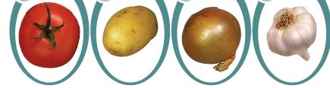
A). Choose the correct answer:

2) What are you doing ? | 1) What is the matter ?
a- I'm fine.  b- I'm doing homework.  c- I'm hungry. | a- I'm thirsty.  b- My name is Maha.  c- She is wearing pink.

. B) Match the questions in ( A ) with the correct answer in ( B ):

(A) | (B)
1- Whose book is this? | ( ) speaking
2- How are you ? | ( ) it's mine.
3- Can I speak to Loura? | ( ) He is reading a book.
4- What's your dad doing? | ( ) I'm hungry
 | ( ) I'm great, thanks.
English Language Final Exam |  | Kingdom of Saudi Arabia
The First Term, 1444 |  | Ministry of Education
The Fifth Grade |  | General Directorate of Education in …….
Time: 1 hour & a half |  | …….. Education Office
No. of pages: 3 |  | ……… Elementary School
مستعينة بالله أجيبي عن الأسئلة التالية:

ii) controlled writing:

5

A). Complete the ordinal numbers:
fourth - second - seventh - fifth
…………………… , third , …………………. , ……………..…. , sixth , …………………..

. B) Rearrange the words (to form a sentence):
1 playing / I / football / am . ……………………………………………………..
2 green / She / wearing / is . ……………………………...……………………..
3 to meet / you / nice / It's . ……………………………...……………………..
4 I / your / like / hat . ……………………………...……………………..

.

To be continued
Iii) reading short sentences:

4

A). Tick the correct sentence:
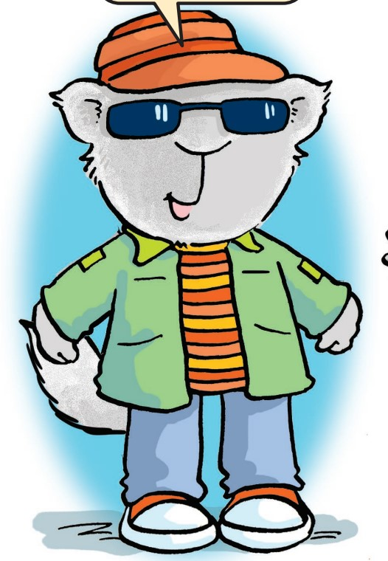
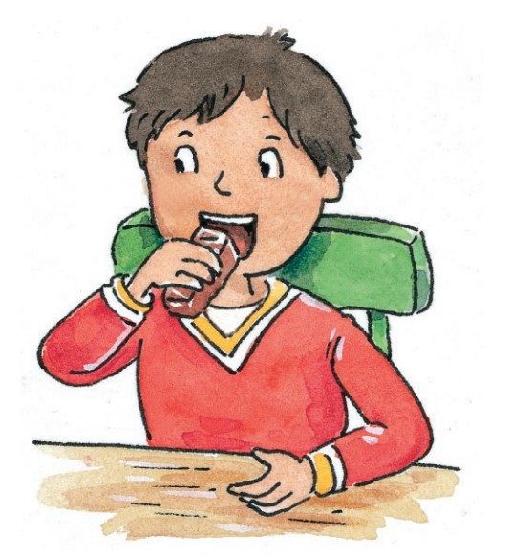  (1)  He is eating .  He is doing karate. | (2)  I am wearing a skirt  I am wearing sunglasses.



. B) Choose ( T ) true or ( F ) false :
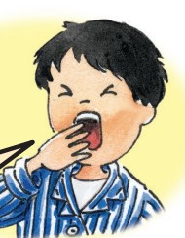1- He is sleepy.  ( T )  ( F ) | 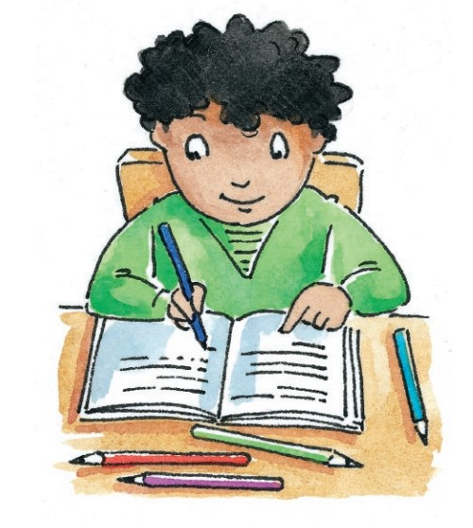2- I am watching TV  ( T )  ( F )

.

iv) grammar:

5

A). Choose the correct word to answer:

1- This is ( my - mine - me ) jacket.

2- She ( is - am - are ) playing football.

3- ( She - He - You ) are welcome.

4- What are you ( do - does - doing ) ?

B) . Complete using ( Whose ) or ( Who's ) :

1- …………….. wearing blue today ?

2- …………….. hat is this ?

C) . Correct the mistake :

1- He am playing .
…………………………………………………………………………………..
To be continued
v) Vocabulary:

6

A). Write the correct number under each picture:
(1) hot | (2) T-shirt | (3) time | (4) glasses | (5) yellow | ( 6) phone
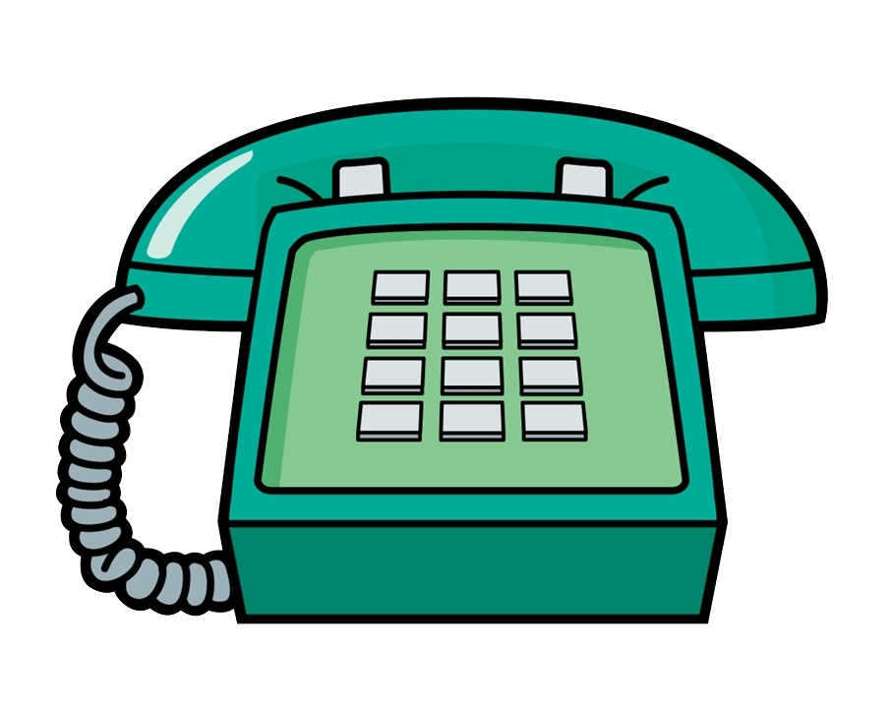  ( ….. ) | 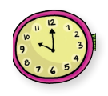  ( ….. ) | 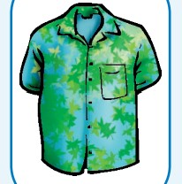  ( ….. ) | 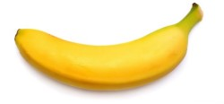  ( ….. ) | 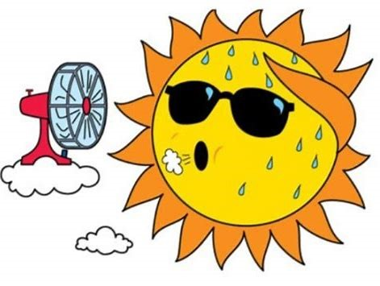  ( ….. ) | 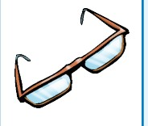  ( ….. )

B). Choose the correct word:
1- I am ( playing - doing - eating ) basketball.

2- The boy is wearing a ( skirt - blouse - jacket ).

3- I am ( thirsty – sleepy - scared ) I need water.

4- Deena is doing ( games - homework - snacks ).

5- Sarah is watching ( snacks - TV – homework ).

6- The apple is ( black - blue - red ).
v) spelling:

4

A). Choose the correct letter:

m s l
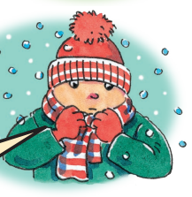  (1) I feel co ……..d.  n s r | 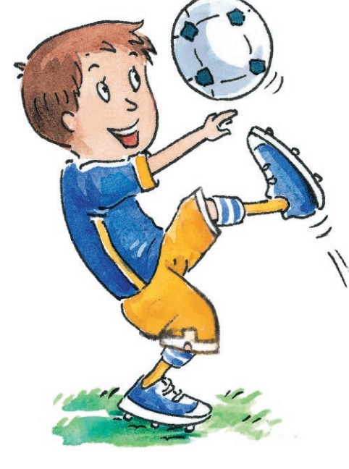  (2) He is playing foot……..all.  b v l
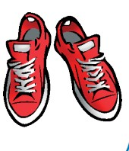  (3) I like your shoe ……... | 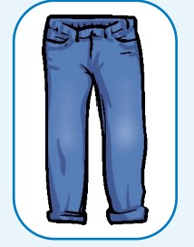  (4) She is wearing jea ……..s.  r n k
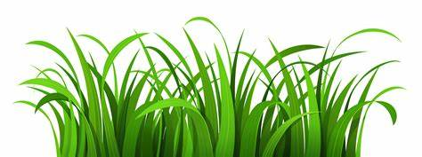
B). Fill in the space with the missing letter:


- I like green g…..ass .
n | k | s | r

- She is wearing a s….irt.

- I am eating s….acks. .

- (A) is the fir….t letter of the alphabets.
End of the questions تمت الأسئلة بحمد الله و دعواتي لكم بالتوفيق
Good Luck teacher, ………………….

