**I – Listening :**

**A- Choose:**

**1- The robbery happened about ……………………………………**

a- half past three b- three o'clock c- five thirty d- one o'clock

**2- The man with dark hair was about ………………….years old.**

a- Twenty b- Twenty eight c-thirty d- ten

**3- …………………….went into the kitchen.**

a- the short man b-both men c-the tall d-none

**4- she lost …………………………dollars.**

a-50 b-150 c- 5 d-15

**B- True √ or False ×:**

1-They said 'they from water company. ( )

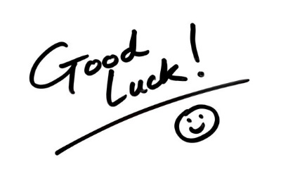2- The blond man about fourteen . ( )

3-They took the woman's wallet . ( )

4-She didn’t ask them about their identification. ( )

**End**