





1- Match :

English

Lan. ,g.. „ .. ,”

## S nrre : / fO

Tornado — Locomotive Train — Bull — Volcano

2 Flll i th I In I tte

M teorite

1. Match :

Ho se rash Sk

* 1. excuse me ( ) sign of high social standing
  2. Gee ! ( ) a way to start a conversation
  3. beats me ! ( ) an exclamation to express surprise
  4. you never know ( ) I have no idea 
* I had not ( eat — ate — eaten ) at the restaurant before .
* My friends had never ( go — gone - went ) to France .
* Had you ( cleaned — clean — cleans ) up the mess † .
* What had they ( say — said — says ) to him ?
  1. Complete the sentences with ( can’t - must - might )
* You haven't eaten all day. You
* Pat’s joking. She be serious.
* Ahmed has been studying all day. He
* I can’t find my keys anywhere. I

be starving.

## be tired by now. have lost them







### 1- Match •



2 Fi iewe te

La Engidb

# Aorr: /f0

## Ma or

### 3- Match :

Re orter Profes Dr

### A tor

1. proof ( ) make the effort

### candidate ( ) get an image with a computer 3- scan ( ) evidence

4- bother ( ) person trying to be elected

1. Report these sentences :
   * I have a brother and a sister .

. . ..........

* + I'm talking to my friend .
  + I learned English in Canada .

1. Make agreements to the following :

I had lunch last week at the new restaurant .

# I won't go to school tomorrow .



1- Match :

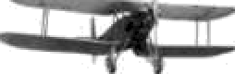

h2unFi i

R und

1. Match :
2. Choose :

Wheel — AÏFplane — Oil — Electricity





le t

S ape Distan e

A B

1. oil ( ) uard
2. hair ( ) well
3. electric ( ) style
4. security ( ) bulb

Srore : ...... / J0



### Gaso_ ine

* I should ( has - have — had ) said I was sorry .
* If I ( has — have — had ) studied harder , I would have passed .
* We ( move — moves — moved ) to Abha three years ago .
* She ( didn't - doesn•t — don•t ) call her mother last night .

1. Fill in with ( can — could — may ) :
2. Ahmed, you (help) me with this box, please?
3. Excuse me, may I open the window† Yes, you
4. We (not/meet) tomorrow afternoon. I'm going to the dentist.
5. Mr. Sawyer (noVsee ) you now. I' m afraid he's very busy.
6. Match :

Car Engine — Faucet — Tire — Screen

1. Filt in the missin letters :

### pe

1. Match :

Bat ery

utton

Sho

2- a bottle of 3- a meat

) stroller

) dryer

Ik

1. Fill in :

* Turn th

cleaned — sewn waiting — off

* 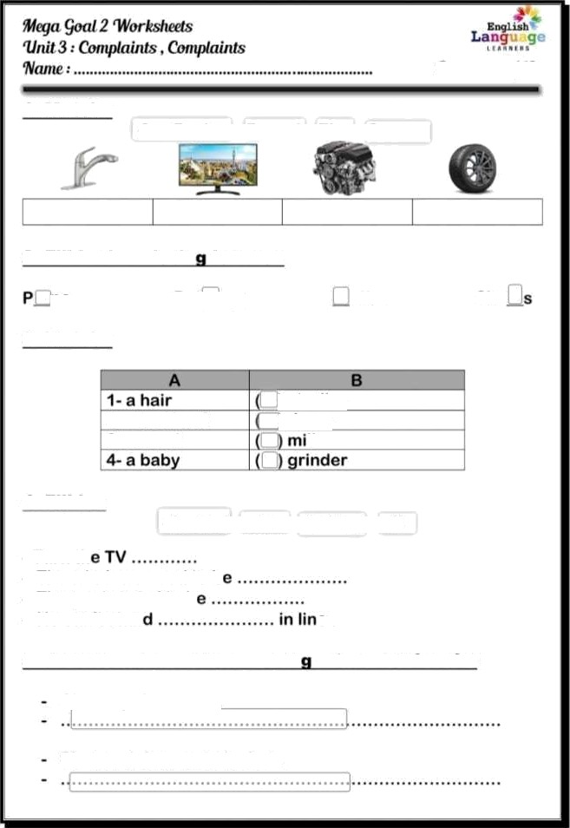The windows need to b
* The pants need to b
* He can't stan e.

1. Rewrite each sentence usin a two-word verb :

# Cleen up this mess .

Please pick up your jacket .