**Choose the correct answer** :

1-The rooms need to be ( **clean – cleans - cleaned – cleaning ).**

2I **( has – have – having – had )** my hair cut yesterday-.

3-Has he ( **driven – drove – drive – driving )** the car

4-I'm going to be at home today .Please call ( **him – them – us – me** ).

**Correct the mistake:**

. The mechanic fixed the **( damage**) ……………………………………… car .

I haven't done my homework ( **just** )…………………………………………

**Rewrite the sentence differently :**

" Clean up this mess"

………………………………………………………………………………

**Fill in the blanks with suitable words** : **( torn - stained – crashed)**

1- The sleeve of the jacket is …………………………… . I will have it sewn.

2- This computer …………………………… I'll have a technician look at it .

**Match the words with their meanings :**

1-it sounds like …… a)Event

2-episode …… b)it seems to be

3-filthy …… c)Causing great fear

d)very dirty

**Write the words under the right pictures:**

**( hair dryer – coins – doorknob )**

Bonus Q

+1

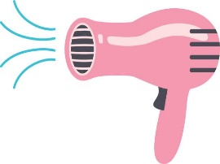

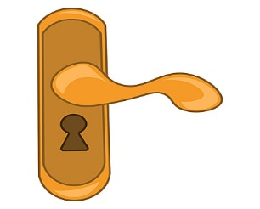

**Correct the mistake:**

I stop **(play)** tennis.

……………………………………………………..