**M.G. 1.3 Unit-3- Revision**

**If It Hadn't Happened**

**Grammar**

**A- Choose the correct answers:**

1- She should have [ focused- focus -focusing] .

2-If I hadn’t [found -find-finds] my wallet, I would have been in trouble .

3-If I had [worn-wear- wore ] a mask, I would have been in safe.

4-If she had left work earlier, she might have[avoid- avoids- avoided] traffic.

5-Have they [invent- invented-inventing] flying cars yet?

6- When [ did-does-do] IBM introduce the first PC?

7- If I had studied chemistry, I would [ be-been-\ ] able to discover a new drug.

8-In 1908, a small asteroid [has exploded-exploded-exploding] over Siberia.

9- A small asteroid [has exploded-exploded-exploding] over Siberiasince 1990.

10-Aramco [has drilled-drilling-drilled] the ground for 4 years.

**B- Do as shown between brackets:**

1- She **has guessed** the result a month ago…………………………………………. [Correct ]

2- *without -went – He- any money* - *downtown* [Unscrambled the words]

------------------------------------------------------------------------------------------------

3-If Wright brothers had discovered air planes, people would have been ………………………..to fly.

[Complete with a correct answer]

4- **Has** he **discovered** the antibiotic? [Answer ]

………………………………………………………………………………

**Vocabulary**

============================================

C- Classify the verbs:

drilled- have guessed-crashed-has checked-repainted- sewed-has sharpened-purchased- have refrained-gathered-penetrated-has teased

|  |  |
| --- | --- |
| **Past Simple** | **Present Perfect Tense** |
| ……………………………………………………  ………………….……………………………………  …………………………………………………  …………………..………………………………  ……………….………….………………………  ………………..……………………………  ………………………………………………  …………………..………………………... | ……………………………………………………  ………………….……………………………………  ………………..……………………………………  …………………………………………………  ……………….…………..………………………  …………………..……………………………  ………………….……………………………  ……………….…………………………... |

1-Match words with their pictures:

|  |  |  |  |  |
| --- | --- | --- | --- | --- |
| 5-candle | 4- immature | 3- oil well | 2- embarrassed | 1- penicillin |

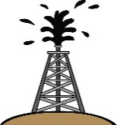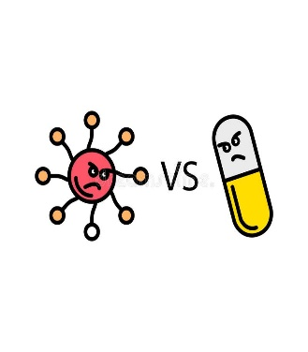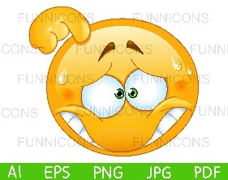

|  |  |  |  |
| --- | --- | --- | --- |
|  |  |  |  |

2- -Match words with their meanings:

|  |  |
| --- | --- |
| ( ) shine, bright | 1- drill |
| ( ) contagion | 2- regret |
| ( ) found over a large area or number of people | 3- incandescent |
| ( ) dig | 4- widespread |
| ( ) feel sad or disappointed | 5- devastated |
| ( ) ruined | 6- infection |

3- Fill in the blanks with correct answers:

Commercial- immature- as for me- you mean-load

1- What if I had said no? “ About the apartment, …………………………… ?”

2- I admire that ………………………………………..advertisement

3- He is 30 years old but behaves as child . He is ……………………………..

4- …………………………………………, I studied technology in the future .

4- Give the antonym's

a-immature#........................ b-advantages#.....................

c-heavy#...................................

5- Circle the odd words'

a- Oil- computer - airplanes- smart phone

b-be on good mood- course- fall out with-miss an opportunity.



**M.G. 1.3 Unit-3- Revision**

**If It Hadn't Happened**

**Grammar**

**A- Choose the correct answers:**

1- She should have [ focused- focus -focusing] .

2-If I hadn’t [found -find-finds] my wallet, I would have been in trouble .

3-If I had [worn-wear- wore ] a mask, I would have been in safe.

4-If she had left work earlier, she might have[avoid- avoids- avoided] traffic.

5-Have they [invent- invented-inventing] flying cars yet?

6- When [ did-does-do] IBM introduce the first PC?

7- If I had studied chemistry, I would [ be-been-\ ] able to discover a new drug.

8-In 1908, a small asteroid [has exploded-exploded-exploding] over Siberia.

9- A small asteroid [has exploded-exploded-exploding] over Siberiasince 1990.

10-Aramco [has drilled-drilling-drilled] the ground for 4 years.

**B- Do as shown between brackets:**

1- She **has guessed** the result a month ago……… **guessed**. [Correct ]

2- *without -went – He- any money* - *downtown* [Unscrambled the words]

He went downtown without any money

3-If Wright brothers had discovered air planes, people would have been ……able…..to fly.

[Complete with a correct answer]

4- **Has** he **discovered** the antibiotic? [Answer ]

…Yes, he has/ No, he has not

**Vocabulary**

============================================

C- Classify the verbs:

drilled- have guessed-crashed-has checked-repainted-sewed-has sharpened-purchased- have refrained-gathered-penetrated-has teased

|  |  |
| --- | --- |
| **Past Simple** | **Present Perfect Tense** |
| drilled  crashed  repainted  sewed-  purchased  gathered  penetrated- | have guessed-  has checked  has sharpened  have refrained  has teased |

1-Match words with their pictures:

|  |  |  |  |  |
| --- | --- | --- | --- | --- |
| 5-candle | 4- immature | 3- oil well | 2- embarrassed | 1- penicillin |



|  |  |  |  |
| --- | --- | --- | --- |
| embarrassed | penicillin | oil well | candle |

2- -Match words with their meanings:

|  |  |
| --- | --- |
| ( 3 ) shine, bright | 1- drill |
| ( 6 ) contagion | 2- regret |
| ( 4 ) found over a large area or number of people | 3- incandescent |
| ( 1 ) dig | 4- widespread |
| ( 2 ) feel sad or disappointed | 5- devastated |
| ( 5) ruined | 6- infection |

3- Fill in the blanks with correct answers:

Commercial- immature- as for me- you mean-load

1- What if I had said no? “ About the apartment, …………………………… ?”

2- I admire that ………………………………………..advertisement

3- He is 30 years old but behaves as child . He is ……………………………..

4- …………………………………………, I studied technology in the future .

4- Give the antonym's

a-immature#........................ b-advantages#.....................

c-heavy#...................................

5- Circle the odd words'

a- Oil- computer - airplanes- smart phone

b-be on good mood- course- fall out with-miss an opportunity.

