NAMES : …………………………………………………………………………………………………………………………….

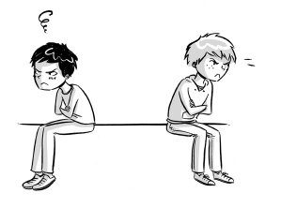

1-What did the writer lend his friend ? ……………………………………………………………………………………………………

2- What did the writer's friend want to buy ? ……………………………………………………………………………………………

3-what did the writer need to buy ? ……………………………………………………………………………………………………….

4- The writer lent his friend 20 $ ( ) ( T OR F ) ?

5- What happened when the writer asked his friend some of the money ?

……………………………………………………………………………………………………………………………………………………..

6- The writer is really sad because he lost his best friend ( ) ( T OR F ) ?

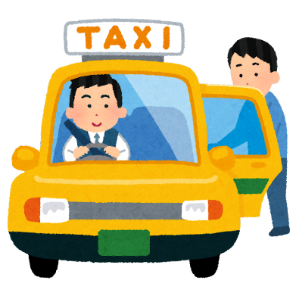

1-The writers job is taxi driver ( ) ( T OR F ) ?

2- What did people leave in the driver's car ? …………………………………………………………………………………………..

3- Last Saturday night he picked up a rich man at his hotel ( ) ( T OR F ) ?

4- What did the driver find in his car ? ………………………………………………………………………………

5- The driver called the hotel where the man was staying ( ) ( T OR F ) ?

6- How much money did the taxi driver get ? …………………………………………………….

7- Did the driver taxi regret getting the watch back to the man ?

………………………………………………………………………………………………………………….