

Name: …………………………..…………………………………… Class:……………..

***Q1-Choose the correct answer :***

***( A ) Vocabulary :***

1. **It sounds like means :**

a ) It seems to be b ) without worry c ) clothing

1. **Refund means :**

a ) broken b ) get one’s payment back c ) housing

1. **The sleeve of the jacket is …………………………… . I will have it sewn.**

a ) clean b ) electronic products c ) torn

1. **Match the word with a suitable picture**

broken doorknob – leaky pipe – Broken windowpane

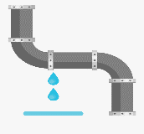 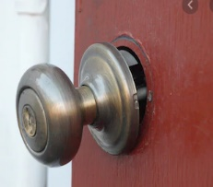

A- ( …………………….……………………..…….. )

B- ( …………………….……………………..…….. )

***Q2-Choose the correct answer :***

***( B ) Grammar :***

**1- The rooms need to be………………………………………………………………..**

a ) clean b ) cleaning c ) cleaned

**2- I had my hair………………………………………………………yesterday .**

a ) cuts b ) cutting c ) cut

**3- I have………………………………………………………….. my homework.**

a ) finished b ) finish c ) finishing

**4- He enjoys…………………………………………………………stories.**

a ) read b ) reads c ) reading

**5- I know…………………………………………………well.**

a ) he b) him c ) his

**All The Best ☺**