**Underline the correct option .**

1 . Noor was ( satisfied - satisfying ) with her English exam result .

2 . Calling someone by the wrong name is ( embarrassed - embarrassing ) .

3 . The food was ( such - so ) spicy that it burned my mouth .

4 . The ( fast - faster - fastest ) you walk , the sooner you will arrive .

Do as shown in parentheses.

1-question / is / embarrassing / This / an /. _( Rearrange )

………………………………………………………………………………………………………………………………………………

2-. The more sleep I get, the ( good ) I feel . ……………………………………. ( Correct )

**Choose the correct word** .

1. A ( snail - penguin - parrot ) is a bird that can imitate human speech .

2. His jokes really ( tell - cheer - blow ) me away .

3. Ahmed was ( juxtaposed - gratified - remarkable ) by his success .

4-He feels a bit down . He is ( south - deep – unhappy )

**Choose as directed below**

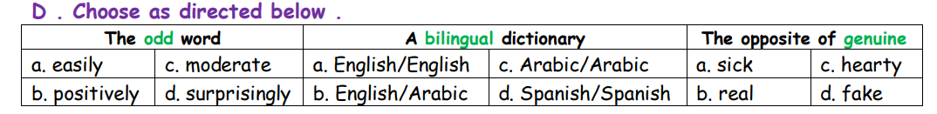

**Read the following passage and answer the questions below:**

Muhammad Yunus is a Bangladeshi banker and economist. Formerly, a professor of economics, he is most famous for his successful application of the concept of microcredit, the extension of small loans to entrepreneurs too poor to qualify for traditional bank loans. He is the founder of Grameen Bank, and he and the bank were jointly awarded the Nobel Peace Prize for their efforts to create economic and social development among the poor people.

During his visits to the poorest households in the village of Jobra near Chittagong University, Yunus discovered that very small loans could make a disproportionate difference to a poor person . He made a loan of **USD 27.00** from his own pocket to **42** women in the village, who made a net profit of **USD 0.02** each on the loan. He eventually managed to secure a loan from the Janata Bank to lend it to the poor in Jobra in December **1976**.

**Answer these question:**

1 – Who is the founder of the Grameen Bank ?

……………………………………………………………………………………………………………………………………………………

2 - Which prize did Muhammad Yunus award ?

…………………………………………………………………………………………………………………………………………………

**C- Choose the right answer :**

1. He made a loan of………………………………….. from his own pocket to **42** women in the village,

**a**- USD 6.38 b- USD 27.00 c- USD 0.02

2. Muhammad Yunus is a :

a- politician b- economist

Name--------------------------------------------- Class-----------------------