

Kingdome of Saudi Arabia Super Goal 4 Exam 1

Ministry of Education First Period
English Language Department Year _____ H

Name : …………………………………………………. | Class : ……………………. | Total : 20 /

Reading

Reading comprehension: Read the following passage:
I live in Riyadh .I have 4 children. They sleep at 8 o'clock .They keep their clothes in the closet. They brush their teeth in the bathroom. The house has a garden. My children play in the garden. They have a cat. It's name is Dan. Dan is 2 years old . The cat is naturally safe and sweet .
A-answer the following questions:
1-Where do they live ?
................................................................................................
2-How many children does she have ? ............................................................................
B-Choose (True √ ) or ( False ×)
1- They brush their teeth in the kitchen . ( )
2- They have a dog .( )
C-Choose :
1-The house has a (yard – garden – balcony – garage ).
2- Dan is( two – three – four – five ) years old .

Vocabulary

-Write the correct word under the picture: ( sunny –noisy – fall –rainforest-relaxing )



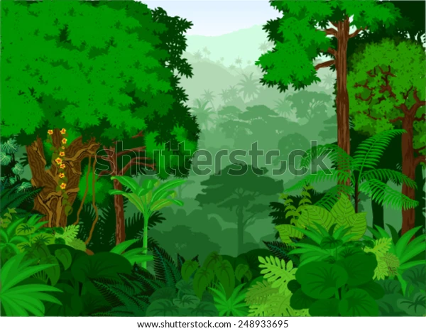



………………… …………… …………………… ………….. …………

B-Find the odd words:
- dry – hot – ball .
- winter - August – summer .
- forecast -warm – humidity .

Grammar

-A- Choose the correct answer to fill in the blank.
1- I am ( go – going – goes ) to travel to Makkah .
2- Omar drives ( slow -slows – slowly ) .
3- They ( isn’t – are – am ) going to go by plane .
4- I will ( travel -travelling – travels ) to Jeddah .
5- If you heat the weather to 100C, it ( boil -boils -boiling ).
6- What will you ( does -doing -do ) this summer ?
B -Do as shown between brackets :
1-…….will you go ? I’II go to Jordan . (use information question How -Where-What)
……………………………………………..
2 -Ali is (goes) to hang out with his friend . (correct)
……………………………………………………………………

Spelling:
-Choose the correct letter:
1- Spring is usually c_ol . ( v – o – r )
2- Scuba di_ing in the Red Sea . ( q – o – v )

Best of Wishes

