

6

**Kingdom of Saudi Arabia English Language Final Exam**

**Ministry of Education The Second Trimester,1st Session, 1443**

**General Directorate of Education in Makkah The 1.3 Secondary Grade**

**South Education Office Time: 3 hours**

**14th Secondary School No. of pages: 3**

**I- Composition**:

12

**A- Guided Composition:**

**Write an email to complain about a** **charger** you bought

**Guided words**: purchased, promotional material, returned, packaging, intact, conveying, regret, incident, refrain, retail outlet.

Anker

Customer Service Department.

231 Abdelaziz Road

Riyadh, SA 12340

4 Ramadan 1443



………………………………………………………………………………………………………………………………………………………………………………………………………………………………………………………………………………………………………………………………………………………………………………………………………………………………………………………………………………………………………………………………………………………………………………………………………………………………………………………………………………………………………………………………………………………………………………………………………………………………………………………………………………………………………………………………………………………………………………………………………………………………………………………………………………………………………………………………………………………………………………………………………………………………………………………………………………………………………………………………………………………………………………………………………………………………………………………………………………………………………………………………………………………………………………………………………………………………………………………………………………………………………………………………………………………………………………………………………………………………………………………………………………………………………………………………………………………………………………………………………………………………………………………………………………………………………………………………………………………………………………………………………………………………………………………………………………………………………………………………………………………………………………………………………………………………………………………………………………………………………………………………………………………………………………………………………..…………………………………………………………………………………………………………………………………………

Dear Sir

Your sincerely,

A displeased former customer.

6

**B- Free Composition:**

**Write an essay about (inventions) Or a ( Voyage expedition)**

…………………………………………………………………………………………………………………………………………………………………………………………………………………………………………………………………………………………………………………………………………………………………………………………………………………………………………………………………………………………………………………………………………………………………………………………………………………………………………………………………………………………………………………………………………………………………………………………………………………………………………………………………………………………………………………………………………………………………………………………………………………………………………………………………………………………………………………………………………………………………………………………………………………………………………………………………………………………………………………………………………………………………………………………………………………………………………………………………………………………………………………………………………………………………………………………………………………………

**II -Grammar:**

6

**A-Choose the correct answers:**

1- We’re **[ got- get - getting]** the rooms decorated.

2-​ The jacket needs to be **[ sew- sewed- sewn]**.

3- By the time It [ **rained- raining- rains**], we had gathered in the park.

4- A small asteroid **[has exploded- exploded- exploding**] over Siberiasince 1990.

5- When [ **did- does- do**] IBM introduce the first PC?

6- Yes, it’s a good idea.” My friend **[ assured –** **agreed – told ]** it was a good idea.

**B-Do as shown between brackets:**

1- you-want to–know-what-Don’t–happened? [**Unscramble to make a sentence**]

----------------------------------------------------------------------------------------------

2-" Is he bothering you?"

She asked me……………………………………………………………………………  **[ Report the questions ]**

3 - She **has guessed** the result a month ago…………………………………………...  **[Correct ]**

**4-** I won’t persuade my mom to come. **[Express disagreement]**

………………………………………………………………………………………………………………………………….

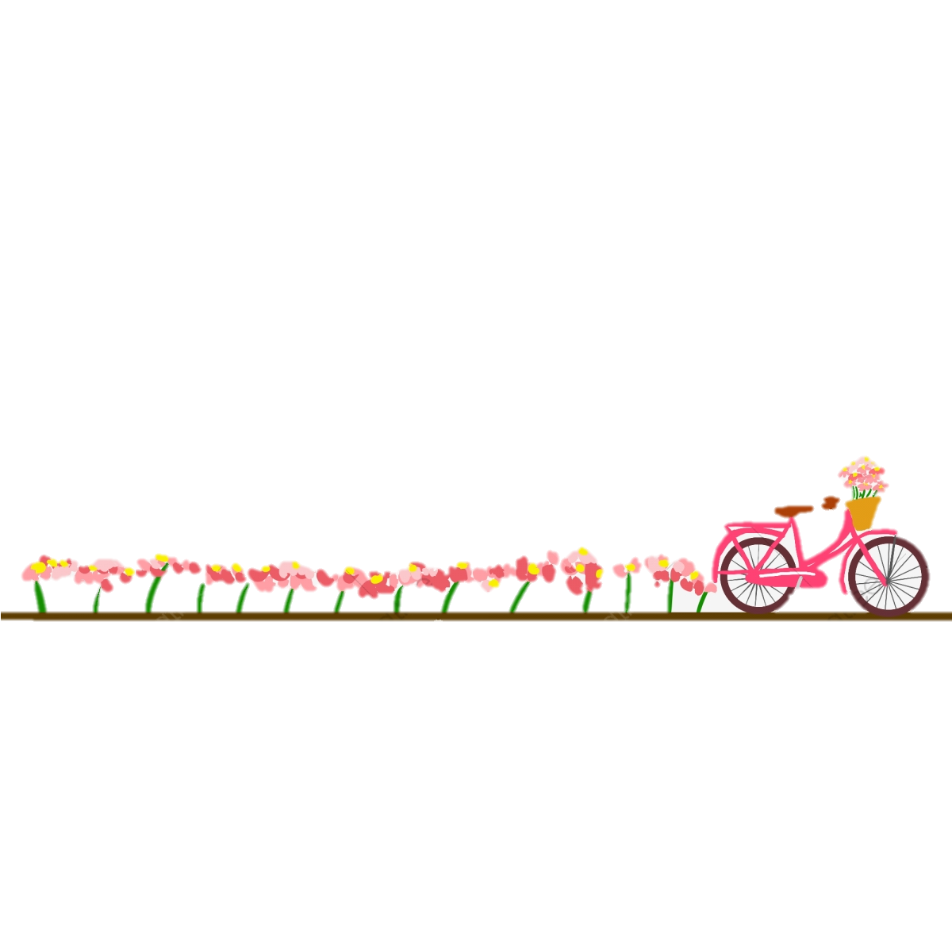

**III- Vocabulary:**

6

**A-Match between the words and their pictures:**

1-

1- stain 2- oil well **3-** Tornado **4-** candidate **5-** scan



( ) ( ) ( ) ( )

**2- Match the words with the meanings:**

|  |  |
| --- | --- |
| 1- purchase | ( ) break down |
| 2- weird | ( ) dig |
| 3- drill | ( ) very strange |
| 4- deteriorate | ( ) buy |
| 5- reschedule |  |

**3- Circle the Odd words**

a**-** Oil- computer - airplanes- smart phone

b- screen-signal-pip-dent

**4-Give the antonyms for the words:**

a-filthy #.....................................

b**-** immature #...............................

:

6

**IV-Reading**

**Read the following passage and answer the questions below:**

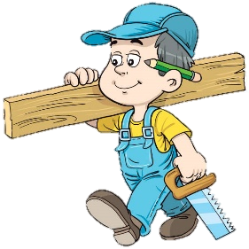An elderly carpenter was ready to retire. He told his employer-contractor of his plans to leave the house-building business to live a more leisurely life with his wife and enjoy his extended family. He would miss the paycheck each week, but he wanted to retire. They could get by.

The contractor was sorry to see his good worker go & asked if he could build just one more house as a personal favor. The carpenter said yes, but over time it was easy to see that his heart was not in his work. He resorted to shoddy workmanship and used inferior materials. It was an unfortunate way to end a dedicated career.

When the carpenter finished his work, his employer came to inspect the house. Then he handed the front-door key to the carpenter and said, "This is your house... my gift to you." The carpenter was shocked!

What a shame! If he had only known he was building his own house, he would have done it all so differently.

So it is with us. We build our lives, a day at a time, often putting less than our best into the building. Then, with a shock, we realize we have to live in the house we have built. If we could do it over, we would do it much differently.

But, you cannot go back. You are the carpenter, and every day you hammer a nail, place a board, or erect a wall. Someone once said, "Life is a do-it-yourself project." Your attitude, and the choices you make today, help build the "house" you will live in tomorrow. Therefore, Build wisely!

**A-Answer these question:**

**1 –What was carpenter plan?**

………………………………………………………………………………………………………………………………………………………………………………

**2 -What did he want?**

………………………………………………………………………………………………………………………………………………………………………………

**3-Did his employer come to inspect his house?**

……………………………………………………………………………………………………………………………………………………………………………

**B- Write [ T ] for True or [ F ] for False :**

|  |  |
| --- | --- |
| 1. His employer handed the front-door key to the carpenter |  |
| 1. An elderly carpenter was ready to retire. |  |

**C- Choose the right answer:**

1. He would have done it all so …………..

**a-** **differently. b-beautiful c-awesome**

2. Someone once said, "Life is a do-it-yourself…………"

**a-work b- project c-building**

**D-Find the antonym**:

a- fortunate**** #..................................... b-started #......................



**Kingdom of Saudi Arabia English Language Final Exam**

**Ministry of Education The Second Trimester,1st Session, 1444**

**General Directorate of Education in Makkah The 1.3 Secondary Grade**

**South Education Office Time: 3 hours**

**14th Secondary School No. of pages: 3**

12

**12**

**12**

**I- Composition**:

**A- Guided Composition:**

**Write an email to complain about a** **charger** you bought

**6**

6

**Guided words**:

Anker

Customer Service Department.

231 Abdelaziz Road

Riyadh, SA 12340

4 Ramadan 1443

****Dear Sir …………………………………………………………………………………………………………………………………………………………………………………………………………………………………………………………………………………………………………………………………………………………………………………………………………………………………………………………………………………………………………………………………………………………………………………………………………………………………………………………………………………………………………………………………………………………………………………………………………………………………………………………………………………………………………………………………………………………………………………………………………………………………………………………………………………………………………………………………………………………………………………………………………………………………………………………………………………………………………………………………………………………………………………………………………………………………………………………………………………………………………………………………………………………………………………………………………………………………………………………………………………………………………………………………………………………………………………………………………………………………………………………………………………………………………………………………………………………………………………………………………………………………………………………………………………………………………………………………………………………………………………………………………………………..…………………………………………………………………………………………………………………………………………

**Any possible answer**

**2 idea**

**2 structure**

**2 spelling**

Your sincerely,

A displeased former customer.

**6**

6

B- **Free Composition:**

**Write an essay about (inventions) Or a ( Voyage expedition)**

………………………………………………………………………………………………………………………………………………………………………………………………………………………………………………………………………………………………………………………………………………………………………………………………………………………………………………………………………………………………………………………………………………………………………………………………………………………………………………………………………………………………………………………………………………………………………………………………………………………………………………………………………………………………………………………………………………………………………………………………………………………………………………………………………………………………………………………………………………………………………………………………………………………………………………………………………………………………………………………………………………………………………………………………………………………………………………………………………………

**Any possible answer**

**2 idea**

**2 structure**

**2 spelling**

**II -Grammar**:

**6**

6

**A-Choose the correct answers: [½ for each]**

1- We’re **[got- get- getting]** the rooms decorated.

2-​ The jacket needs to be **[sew-sewed-sewn]**.

3- By the time It [ **rained- raining-rains**], we had gathered in the park.

4- A small asteroid **[has exploded-exploded-exploding**] over Siberiasince 1990.

5- When [ **did-does-do**] IBM introduce the first PC?

6- Yes, it’s a good idea.” My friend **[ assured –** **agreed – told ]** it was a good idea.

**B-Do as shown between brackets: [ (1) for each]**

1- you-want to–know-what-Don’t–happened? [**Unscramble to make a sentence**]

Don't you know what happened?

2-" Is he bothering you?"

She asked if he was bothering me. **[ Report the questions ]**

3 - She **has guessed** the result a month ago…… **guessed** ……...  **[Correct ]**

I won’t persuade my mom to come. **[Express disagreement]** 4-

I will.



**III- Vocabulary: [½ for each]**

**6**

6

**A-Match between the words and their pictures:**

1-

1- stain 2- oil well **3-** Tornado **4-** scan **5-** candidate



( 5 ) ( 3 ) ( 2 ) ( 1 )

**2- Match the words with the meanings:**

|  |  |
| --- | --- |
| 1- purchase | ( 4 ) break down |
| 2- weird | ( 3 ) dig |
| 3- drill | ( 2 ) very strange |
| 4- deteriorate | ( 1 ) buy |
| 5- reschedule |  |

**3- Circle the Odd words**

a**-** Oil- computer - airplanes- smart phone

b- screen-signal-pip-dent

:

**4-Give the antonyms for the words:**

a-filthy # clean.

b**-** immature # mature

**6**

6

**IV-Reading**

**Read the following passage and answer the questions below:**

An elderly carpenter was ready to retire. He told his employer-contractor of his plans to leave the house-building business to live a more leisurely life with his wife and enjoy his extended family. He would miss the paycheck each week, but he wanted to retire. They could get by.

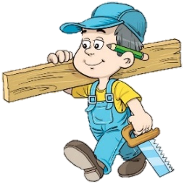The contractor was sorry to see his good worker go & asked if he could build just one more house as a personal favor. The carpenter said yes, but over time it was easy to see that his heart was not in his work. He resorted to shoddy workmanship and used inferior materials. It was an unfortunate way to end a dedicated career.

When the carpenter finished his work, his employer came to inspect the house. Then he handed the front-door key to the carpenter and said, "This is your house my gift to you." the carpenter was shocked!

What a shame! If he had only known he was building his own house, he would have done it all so differently.

So it is with us. We build our lives, a day at a time, often putting less than our best into the building. Then, with a shock, we realize we have to live in the house we have built. If we could do it over, we would do it much differently.

But, you cannot go back. You are the carpenter, and every day you hammer a nail, place a board, or erect a wall. Someone once said, "Life is a do-it-yourself project." Your attitude, and the choices you make today, help build the "house" you will live in tomorrow. Therefore, Build wisely!

**A-Answer these question:** **[ (1) for each]**

**1 –What was carpenter plan?**

**To leave the house-building business to live a more leisurely life with his wife and enjoy his extended family**

**2 -What did he want?**

He wanted to retire.

3**-Did his employer come to inspect his house**?

Yes, he did.

**B- Write [ T ] for True or [ F ] for False : [½ for each]**

|  |  |
| --- | --- |
| 1. His employer handed the front-door key to the carpenter | T |
| 1. An elderly carpenter was ready to retire. | T |

**C- Choose the right answer :**

1. He would have done it all so …………..

**a-** **differently. b-beautiful c-awesome**

2. Someone once said, "Life is a do-it-yourself…………"

**a-work b- project c-building**

**D-Find the antonym** :

a- fortunate**** **# unfortunate**  b-started #. **finished**