**MG.5 Test U. 1+2 ( A )**

**Name : ………………………………………………………….…… Class : ………………..**

1. **Choose the correct answers :**

1-Would you like ( other -another – others ) cup of coffee?

2- I ( do -did – does ) enjoy that party last night .

3- My father used to ( work - works - working ) but he is retired now .

4- I havent finished my project ( ever - yet - once )

1. **Do as shown between brackets :**

1-She looks good in the dress. ( Rewrite adding do or does )

………………………………………………………………………………………………

2- She has been teaching English …………. 15 years . ( Use for or since )

**C) correct :**

1- Sara usually ( eat ) ……………. Fish .

2-When he was a child , he would ( studies ) ……………….. very hard .:

**D ) Fill in the space with suitable word : ( – prominent – grieving - predators )**

1. Lions ,tigers and bears are example of ………………………. Animals .
2. My professor is a ………………………. Economist who is often quoted in magazines .
3. People usually wear black when they are ……………………. for some one who has died
4. **Match The words with meaning :**

|  |  |  |
| --- | --- | --- |
| 1-No sweat |  | prieceless |
| 2-Renowned |  | Known ,respect |
| 3-fear some |  | No problem |
|  |  | Causing great fear |

1. **Underline the correct word for each picture :**

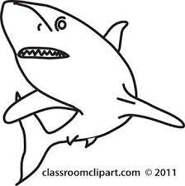 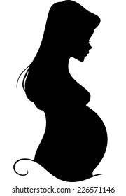 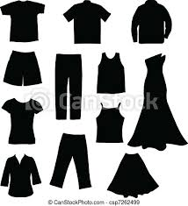 

( predator – pet) ( pregnant – surgeon ) ( clothing – finance ) ( competition – prize )

1. **Classify items into correct category :**  ( history - space - computer design - ruins - business )

|  |  |
| --- | --- |
| Archelogical | Industry |
|  |  |
|  |  |

**Best wishes : Mayadh F Abohamad**

**MG.5 Test U. 1+2 ( B)**

**Name : ………………………………………………………….…… Class : ………………..**

**A)) Choose the correct answers :**

1-He wants ( other -another – others ) book .

2- I ( do -did – does ) enjoy that party last night .

3- He is ( study - studies -studying ) now .

4- I havent finished my project ( ever - yet - once )

**B) Do as shown between brackets :**

1-I phoned you last night ( Rewrite adding do or did )

………………………………………………………………………………………………

2- She has been teaching English …………. 15 years . ( Use for or since )

**C) correct :**

1- Sara usually ( eat ) ……………. Fish .

2-He has ( exersice ) ………………………….. since september .

**D ) Fill in the space with suitable word : ( – prominent – grieving - fled)**

1-When the thief saw a policeman , he ……………………

1. My professor is a ………………………. Economist who is often quoted in magazines .
2. People usually wear black when they are ……………………. for some one who has died
3. **Match The words with opposite :**

|  |  |  |
| --- | --- | --- |
| 1-reject |  | stay |
| 2-flee |  | Urban |
| 3-rural |  | accept |
|  |  | Causing great fear |

**F)Underline the correct word for each picture :**

   

( chuckle – exile ) ( pregnant – surgeon ) ( clothing – finance ) ( shell – struggle )

**G)Classify items into correct category :**  ( history - space - computer design - ruins - business )

|  |  |
| --- | --- |
| Archelogical | Industry |
|  |  |
|  |  |

**Best wishes : Mayadh F Abohamad**

**MG.5 Test U. 1+2 ( C )**

**Name : ………………………………………………………….…… Class : ………………..**

1. **Choose the correct answers :**

1-Would you like ( other -another – others ) cup of coffee?

2- I ( do -did – does ) enjoy that party last night .

3- My father used to ( work - works - working ) but he is retired now .

4- I havent finished my project ( ever - yet - once )

**F)Underline the correct word for each picture :**

   

( chuckle – exile ) ( pregnant – surgeon ) ( clothing – finance ) ( shell – struggle )

 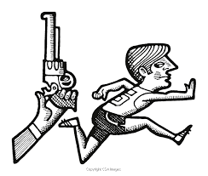 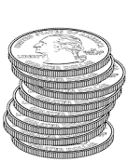  

( predator – pet) ( flee– exile) ( coins – paper money) ( competition – prize ) (amazon - apple )

**G)Classify items into correct category :**  ( history - space - computer design - ruins - business )

|  |  |
| --- | --- |
| Archelogical | Industry |
|  |  |
|  |  |

**Best wishes : Mayadh F Abohamad**