**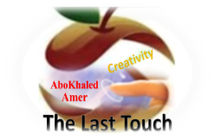****المملكة العربية السعودية**

**Model Answers نموذج اجابة**

**Kingdom of Saudi Arabia**

**Ministry of Education**

**------- Educational Directorate**

**------- Future Educational Schools**

**3rd Grade High School 2022**

**3rd Term – Final Exam**

**وزارة التعليم**

**الإدارة العامة للتعليم بن**

**مدارس م ن التعليمية**

**الصف الثالث الثانوي**

**الاختبار النهائي للفصل الدراسي الثالث1443**

|  |  |  |  |  |  |  |  |
| --- | --- | --- | --- | --- | --- | --- | --- |
| **Total**  **written** | **5**  **Vocabulary** | **4**  **Grammar** | **3**  **Free Composition** | **2**  **Guided Composition** | | **1 Comprehension** | **Q. NO.** |
|  |  |  |  |  | |  | **Mark Given** |
| **30** | **6** | **6** | **6** | **6** | | **6** | **Mark** |
| **6** | | | **Reviser** | |  | | **Corrector** |
|  | |

**زمن الاختبار: 3 ساعات**

**اسم الطالب: ------------------------------------ رقم الجلوس: ------------- الصف الثالث الثانوي**

**1)** **Comprehension**

**Read the following passage then answer the questions**

**Sheikh Sulaiman bin Abdul-Aziz Al-Rajhi, the world renowned philanthropist and winner of the 2012 king Faisal International Prize for Services to Islam, in recognition of his outstanding service to Islam, by establishing the world's largest Islamic bank and his contribution to charities and humanitarian projects, has not always been a billionaire.**

**Born in 1920, he spent his youth in Al-Qassim where he and his brother Saleh began their business changing money for pilgrims, on their way to Makkah and Madinah. Their business expanded in the 1970s during the oil bloom in Saudi Arabia. The Al-Rajhi brothers helped migrant workers from Indonesia, Pakistan and other places to send their earnings home. They were granted a permission to establish a bank, the Al-Rajhi Bank, which compiled with religious tenets such as a ban on interest.**

***A)* Answer the following questions*:*  
1. Who is this passage about?-------------------------------------------------------.**

**In Al-Qassim.**

**Sheikh Suliman bin Abdul-Aziz Al-Rajhi**

**2. When was he born? -----------------------------------------------------------.**

**He won the King Faisal International Prize for Services to Islam.**

**3. What did he win in 2012? ----------------------------------------------------------.**

**No, he hasn't**

**4. Has he been a billionaire?  --------------------------------------------------------------.**

***B)* Put ( √ ) or ( X ):  
5. Sheikh Sulaiman was born in Najran. ( X )**

**6. Sheikh Sulaiman established the world's largest Islamic bank. ( √ )**

**7. They began their business changing money for pilgrims. ( √ )**

**8. Their business expanded in the 1960s during the oil bloom. ( X )  
*C)* Complete*:*  
9. They were granted a permission to establish a --------------------------------.  
10. He has a contribution to charities and -----------------------------------.**

**humanitarian projects.**

**a bank**

**D) Choose the correct answer:**

**11. The Bank is compiled with (**social – cultural – **religious) tenets.**

**12. Sheikh Sulaiman is the world renowned and (**poet – teacher – **philanthropist)**

**2) Guided Composition**

**6**

**This is the last week for you in a high school. Next week, you will be considered in the university choosing your major for your future job.**

**Write a short paragraph about " Your Future Job"**

**(**Write not less than 150 word **(**

**Guiding words:**

(many jobs – study – choose – work hard …)

-------------------------------------------------------

--------------------------------------------------------------------------------------------------------------------------------------------------------------------------------------------------------------------------------------------------------------------------------------------------------------------------------------------------------------------------------------------------------------------------------------------------------------------------------------------------------------------------------------------------------------------------------------------------------------------------------------------------------------------------------------------------------------------------------------------------------------------------------------------------------------------------------------------------------------------------------------------------------------------------------------------------------------------------------------------------------------------------------------------------------------------------------------------------------------------------------------------------------------------------------------------------------------------------------------------------------------------------------------------------------------------------------------

**3) Free Composition**

**6**

**Choose one topic from the following to write about.**

**1. Imagine that you are a scientist who is talking about the future predictions and things that will take place in the future.**

**2. Write about a person whom you consider as your example in life**

**(**Write not less than 100 word**).**

-------------------------------------------------------

--------------------------------------------------------------------------------------------------------------------------------------------------------------------------------------------------------------------------------------------------------------------------------------------------------------------------------------------------------------------------------------------------------------------------------------------------------------------------------------------------------------------------------------------------------------------------------------------------------------------------------------------------------------------------------------------------------------------------------------------------------------------------------------------------------------------------------------------------------------------------------------------------------------------------------------------------------------------------------------------------------------------------------------------------------------------------------------------------------------------------------------------------------------------------------------------------------------------------------------------------------------------------------------------------------------------------------------

**4) Grammar**

**6**

**A: Choose the correct answer:**

**1. He is so full of burgers, so he couldn't eat (other – others – another – so).**

**2. Ali used to (drives – drive – driving – drove) his car to work.**

**3. By 2026 I will have (completed – completes – completing – complete)my studies.**

**4. Both Ahmed and Khaled (is – are – was – has) good friends.**

**5. They didn't go to school (because – since – now that – because of) the heat.**

**6. He stopped (to smoke – smoke – smoking – smokes). He doesn't smoke now.**

**Do as shown between brackets:**

**1. We go to school. We want to learn. (**Join using: in order to**)**

**We go to school in order to learn.**

-------------------------------------------------------------------------------------------------.

**2. Ali can play football. Hassan can play football. (Join using: Either)**

**Either Ali or Hassan can play football.**

-------------------------------------------------------------------------------------------------.

**3. By 2025, I will have been (study) at Najran University. (Correct the verb)**

**studying**

-------------------------------------------------------------------------------------------------.

**4. Nora is used to (cook) lunch at home. (Correct the verb)**

**cooking**

-------------------------------------------------------------------------------------------------.

**5. Ali likes eating fish. (Use emphatic do)**

**Ali does like eating fish.**

-------------------------------------------------------------------------------------------------.

**6. They used to watch games with their friends. (Make Negative)**

**They didn't use to watch games.**

-------------------------------------------------------------------------------------------------.

**5) vocabulary:**

**6**

**A- Match the words with the pictures:**

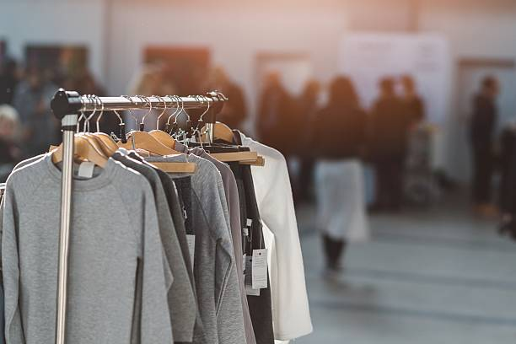**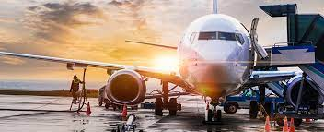****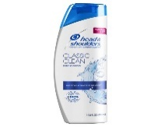shampoo – traffic – clothing – pigeon – aviation – detective**

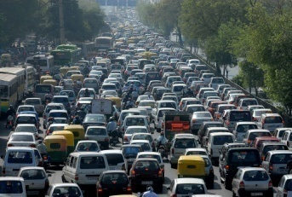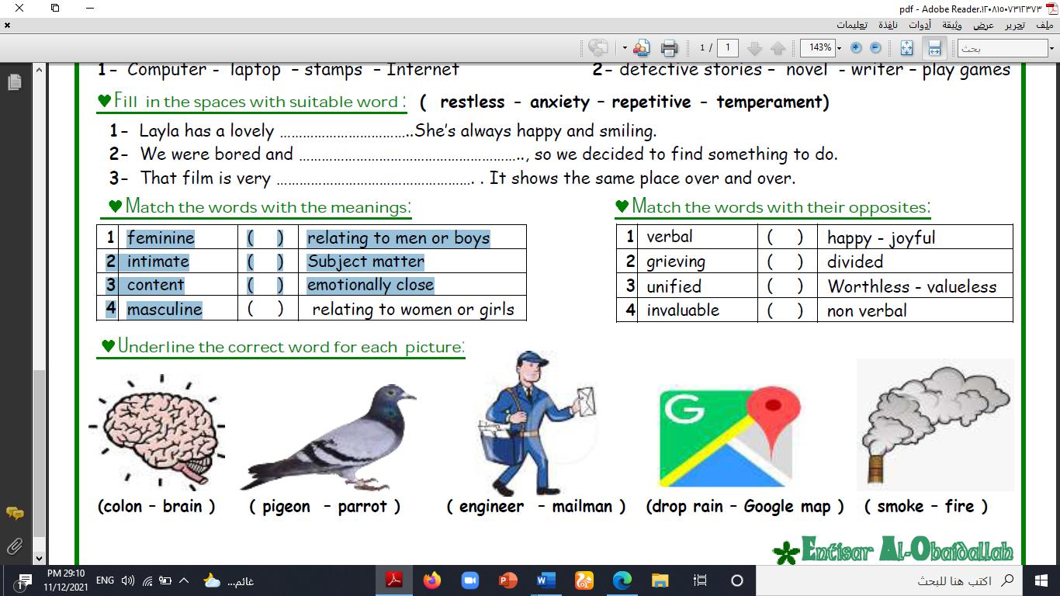

**aviation clothing traffic detective shampoo pigeon**

**A) Match to form new words or expressions:**

**1. No sweet --b-- a. fall asleep**

**2. cash --e-- b. No problem**

**3. doze off --a-- c. expensive**

**4. pioneer --f-- d. position in an ordered group**

**5. steep --c-- e. money**

**6. rank --d-- f. a person who first made something**

**End of Questions**

**Best of Luck**