REPORTED QUESTIONS

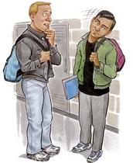
Where is the bank => He asked me where the bank was.
When are you going to visit me? => He asked me when I was going to visit him.
Do you speak English? => He asked me if I spoke English.
Have you seen Mary? => He asked me if I had seen Mary.
REMEMBER:
Word order in reported questions is the same as in affirmative sentences.

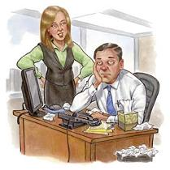
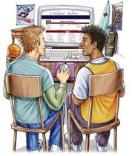
Can you help me with Maths? Is there a problem?
Have you
ever thought of
becoming a
computer
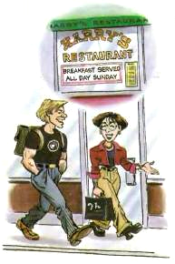
programmer?

❶ ❷ ❸
Do you like your new haircut? Who’s the man in this photo?
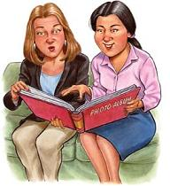
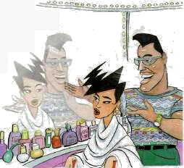
What time
do you get up
on Sundays?

- ❺ ❻

When will the next plane arrive?
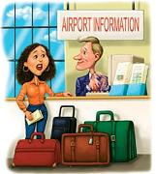
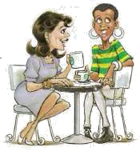
Are you still living with your parents?
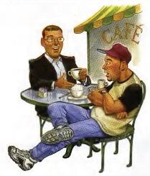
When did you go out with Sam?

❼
Report these questions. Don’t forget to follow the rules for changes.
- ❾

- My friend asked me ……………………………………………………………………………………………………………………………………….
- My secretary ………………………………………………………………………………………………………………………………………………….
- My best friend ……………………………………………………………………………………………………………………………………………….
- Tim …………………………………………………………………………………………………………………………………………………………………….
- My hair stylist ……………………………………………………………………………………………………………………………………………….
- My cousin Beth ……………………………………………………………………………………………………………………………………………….
- A tourist ………………………………………………………………………………………………………………………………………………………….
- Terry ………………………………………………………………………………………………………………………………………………………………….
- Sue …………………………………………………………………………………………………………………………………………………………………….

It was show and tell at school. Some people came to school to talk about their jobs. These are some of the questions that children asked. Match the pictures to the questions.
❶❷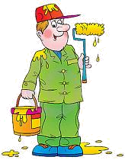❸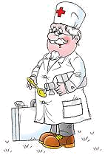❹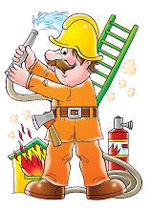❺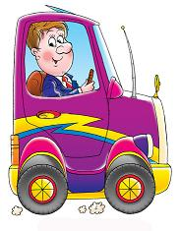
Have you finished medical school?
What was your longest ride?
Do you work in a big restaurant?
Can you paint our classroom pink?
How do you put the fire out?

These people later told their friends what the children asked. Report the questions to see what they said.
- They asked me ……………………………………………………………………………………………………………………………………………….
- …………………………………………………………………………………………………………………………………………………………………………….
- …………………………………………………………………………………………………………………………………………………………………………….
- …………………………………………………………………………………………………………………………………………………………………………….
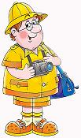
Read what the photographer said to his friends and try to write the question the
children asked.

Q. …………………………………………………………………………………………………?
A. They asked me if I had taken the photo of the Queen.

