**Final Revision & Exams المراجعة النهائية والاختبارات**

**need to be + P.P - The windows need to be ( cleaned – cleans – cleaning)**

**- The car seats need to be ( fix – fixing – fixed).**

**have / get + something شيء + P.P - We have the roof (repaired – repair – repairing)**

**- We had/got the house ( paint – paints – painted)**

**adj = P.P - I repaired the ( break – broken – broke) window.**

**- The tailor sewed the ( torn - tear – tore) sleeve.**

**Past perfect الماضي التام ( had + P.P ) الحدث الأول**

**1. I felt much better after I (** see – saw – had seen **) the results of my test.**

**2. By the time we arrived, the rain (** stop – had stopped – stopping **).**

**must be / can’t be متأكد may / might be غير متأكد**

**1. You haven’t eaten all day. You (** must – can’t – might **) be starving.**

**2. Pat’s joking. She (** must – can’t – might **) be serious.**

**3. Ahmed has been studying all afternoon. He (** must – can’t – might **) be tired by now.**

**4. I’m not sure of the way there. Let’s ask my father. He (**must – can’t – might**) drive us there.**

**should have + P.P X shouldn’t have + P.P**

**- I should have (**say – saying – said**) I was sorry. - I shouldn’t have (**do – done – did**) that.**

**If + Past perfect, would have + P.P**

**1) If you (** helped – helps – had helped**) me, I would have finished early.**

**2) If you had slept early, you (** will – would – would have**) got up early.**

**said + past ماضي - He said he (**has – having – had**) a brother and a sister.**

**- She said that she (**didn’t – don’t – isn’t**) like mangoes.**

**Unit : 3 Complaints , Complaints**

**مراجعة الوحدات**

**Units Revision**

**Choose:**

**1- The windows need to be ( clean – cleaning – cleaned ) .**

**2- The correct form of past participle for "break" (breaking–broken–breaks)**

**3- I'm going to be at home to night . Please call ( him – me - her ) .**

**Arrange the sentences :**

**1- my / to call / need / I / friends**

**2- snacks / to buy / you / Do / need ?**

**3- don't / an invitation / need / we / to send**

***Match :***

|  |  |  |  |
| --- | --- | --- | --- |
| **1** | **Yes, please, if you could** |  | **Lamp** |
| **2** | **It sounds like** |  | **Polite way** |
| **3** | **Electronic products** |  | **It seems to be** |
|  |  |  | **Used to say yes** |

***Choose the correct answer:***

**1- The dress is torn. It (needs- need – needed) to be ( sew – sewn – sewed).**

**2- When the ambulance arrived , the injured man had ( died - die – dead ).**

**3- You (mustn't – couldn't – mightn't) smoke here.**

**4- I ( has - have - had ) finished my homework before my mom returned .**

***Do as shown between brackets:***

**1. The walls are filthy. They need to be repaint. (Correct the verb ).**

**2. The vase was cracked. (Use the past participle verb as adjective ).**

**tornado - water heater - hairdryer – meteorite - tie**

***Match the word with its picture:***

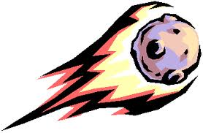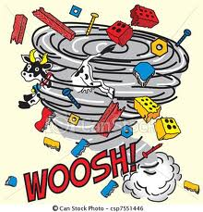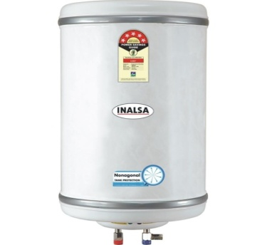

**---------------------- ----------------------- ------------------------------ ------------------------**

***Match the word with the right definition :-***

**1- Filthy ( ) surprise**

**2- Fuzzy ( ) a mistake**

**3- Gee ! ( ) disappoint**

**4- Error ( ) very dirty**

**( ) not clear**

**Choose the correct answer:**

**1. The disk is (** broken – break – broke**). It (**need – needs – needing**) to be fixed.**

**2. My shirt is (** stain – stained – stains**). It (**need – needs – needing**) to be cleaned.**

**Write the sentence differently "Don’t Change the meaning:**

**1. The room is decorated.**

**2. The picture is colored.**

**Choose the correct letter:**

**1. st__in ( a / o / b ) 2. lea__y ( t / k / o)**

**3. t__rn ( a / o / b ) 4. c__acked (t /o / r)**

**Fill in the missing letters :**

**1. ho__e 2. Scratc__ed 3. fau__et 4. scra__ched**

**Put the word in the correct place:**

**1. I will go to the bank to …….. money back ( technician / continually/ refund)**

**2. The kitchen is very ……….. I will clean it. (filthy / continually/ refund)**

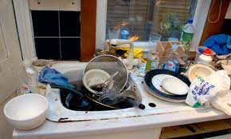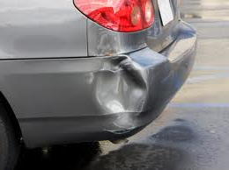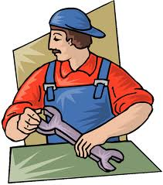 **Put the word under the picture: (filthy / dent / flat tire / technician )**

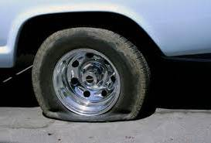

**------------------------------- --------------------- -------------------------- ---------------------------**

**Match the word with its meaning:**

|  |  |  |  |
| --- | --- | --- | --- |
| **No.** | **The Word** |  | **The Meaning** |
| **1** | **flat tire** |  | **someone who makes repairs.** |
| **2** | **dripping faucet** |  | **a tire that has no air in it .** |
| **3** | **technician** | * **­a faucet leaking water** | |

|  |  |  |  |
| --- | --- | --- | --- |
| **No.** | **The Word** |  | **The Meaning** |
| **1** | **dent** |  | **no power in the battery.** |
| **2** | **dead battery** |  | **a tire that has no air in it .** |
| **3** | **filthy** | * **­dirty** | |

**Unit :4 I wonder what Happened**

***Choose the correct answer :***

1. **When we (**arrives – arriving – arrived**) at the airport, our flight had already left.**
2. **They couldn't get in the house because they (**has forget – had forgotten – forget**) the key.**
3. **Had you (** is – are – been **) there before ?**
4. **You have not eaten all day You {** could – must – might **} be starving .**

**Write the missing letter of the following words:**

**1-Thousands of mete__rites enter earth's atmosphere .**

**2- There are also h__zards from space .**

**3- Some sci__ntists speculate that one day there might be "garbage collector"**

**2- There are a lot of pro__ucts come over this industry.**

**Unit: 5 If It Hadn't Happened ?**

**Choose the correct answer :**

**1 – I should have {** say – saying – said **} I was sorry .**

**2 – If I had studied harder, I {**can – would – may**} have passed the exam.**

**3 – If she had left work earlier, she {**might – must – should**} have avoided traffic.**

**Under line the correct answer:**

**1- I should have said I was sorry. A- I didn't say B – I did that**

**2 – If I had not learned English,**

**A – I would understand you. B –I wouldn't understand you*.***

**Match: 1. Oil ( ) guard .**

**2. Electric ( ) bulb .**

**3. Security ( ) well .**

**4. Heavy ( ) load .**

**Unit : 6 What They Said**

**Choose the correct answer:**

**1- I {**have – has – is**} a brother and a sister.**

**2- He said he {**has learned – had learned – have learned**} English in Canada.**

**3- How old {**is – are – am**} you?**

**4- We will have the car (**repair – repairs – repaired**).**

**Do as shown between brackets:**

**1. I learned English in Canada. {Change sentence to reported speech}**

**2. I'm 23 years old. {Make Yes/No Q}**

**3. He will sees them later. {Correct the Verb}**

**Match the words with their meanings :**

**1- Proof ( ) make the effort .**

**2- Candidate ( ) get an image with a computer .**

**3- Scan ( ) person trying to be elected**

**4- Bother ( ) evidence**

**Choose the correct answer:**

**1– I {**have – has – is**} a brother and a sister.**

**2– He said he {**has learned – had learned – have learned**} English in Canada.**

**المراجعة النهائية Final Revision**

**Choose the correct answer:**

**1-The room needs to be ( clean - cleaning - cleaned ).**

**2- Ahmad has been studying all afternoon. He (can't - must) be tired by now.**

**3- I had (take – taked – taken) my breakfast before I (go – went – going) to school.**

**Write the past participle for each verb:**

**drive >>……..……... visit >>……………. see >>……………... do >>……………**

**[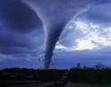](http://www.google.com.sa/imgres?imgurl=http://n4hr.org/up/uploads/n4hr_13249943013.jpg&imgrefurl=http://vb.n4hr.com/187797.html&usg=__pGBHWDRr1rnOUvFgFX1txQF_daM=&h=313&w=400&sz=16&hl=ar&start=4&zoom=1&tbnid=-JQthyEnrWdYUM:&tbnh=97&tbnw=124&ei=M3KET8SsGovktQaFsN22Bg&prev=/search?q=%D8%A7%D8%B9%D8%B5%D8%A7%D8%B1&um=1&hl=ar&safe=active&sa=N&tbm=isch&um=1&itbs=1)[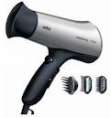](http://www.google.com.sa/imgres?imgurl=http://www.albrens.com/vb/uploaded/34586_1258973696.jpg&imgrefurl=http://www.brooonzyah.net/vb/t130802.html&usg=__Z8lHPcic4usZkJKpeo6SLKrs8E4=&h=472&w=443&sz=21&hl=ar&start=3&zoom=1&tbnid=yVzy8zgXk_SRTM:&tbnh=129&tbnw=121&ei=LnGET8b9FM3rsgbfuvCzBg&prev=/search?q=%D8%A7%D8%B3%D8%AA%D8%B4%D9%88%D8%A7%D8%B1&um=1&hl=ar&safe=active&sa=N&tbm=isch&um=1&itbs=1)[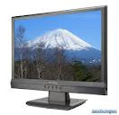](http://www.google.com.sa/imgres?imgurl=http://icbone.webs.com/envision-lcd-monitor.jpg&imgrefurl=http://www.b4bh.com/vb/showthread.php?t=242382&usg=__xSkyJ9cw3-RduYaBNqUAcGTBmTE=&h=515&w=530&sz=84&hl=ar&start=3&zoom=1&tbnid=wLjR1nBwoj3CIM:&tbnh=128&tbnw=132&ei=dXGET_aeE6fP4QSxmuTnBw&prev=/search?q=%D8%B4%D8%A7%D8%B4%D9%87&um=1&hl=ar&safe=active&sa=N&tbm=isch&um=1&itbs=1)Match the word with its picture:**

**tornado - screen - hairdryer - meteorite**

**[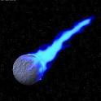](http://www.google.com.sa/imgres?imgurl=http://up.arab-x.com/July09/cbh32004.jpg&imgrefurl=http://www.alhajere.net/vb/t43052.html&usg=__bamE1cNIUprB_ZiOGIKzmQa356w=&h=400&w=400&sz=62&hl=ar&start=2&zoom=1&tbnid=DupZ5LO7fEqZ_M:&tbnh=124&tbnw=124&ei=6nCET7SVMcrSsgbitsSuBg&prev=/search?q=%D8%B5%D9%88%D8%B1%D8%A9+%D9%86%D9%8A%D8%B2%D9%83&um=1&hl=ar&safe=active&sa=N&tbm=isch&um=1&itbs=1)­­**

**Write the missing letter: fro….en hazar… to….ic la…**

**w - x - d - z**

***#Answer the following questions***

**1.What could have caused the extinction of dinosaurs?**

**2.What does Murphy's Law state?**

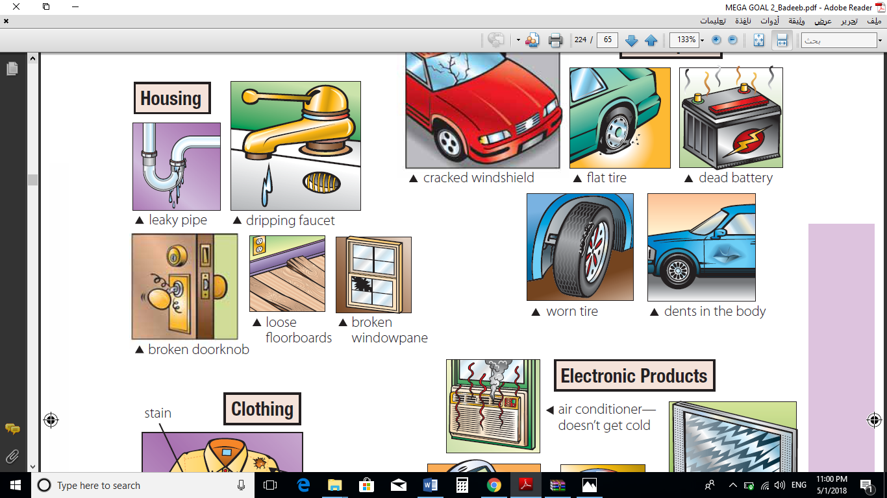**flat tire – scratched DVD – dead battery – broken windowpane – broken doorknob – no signal**

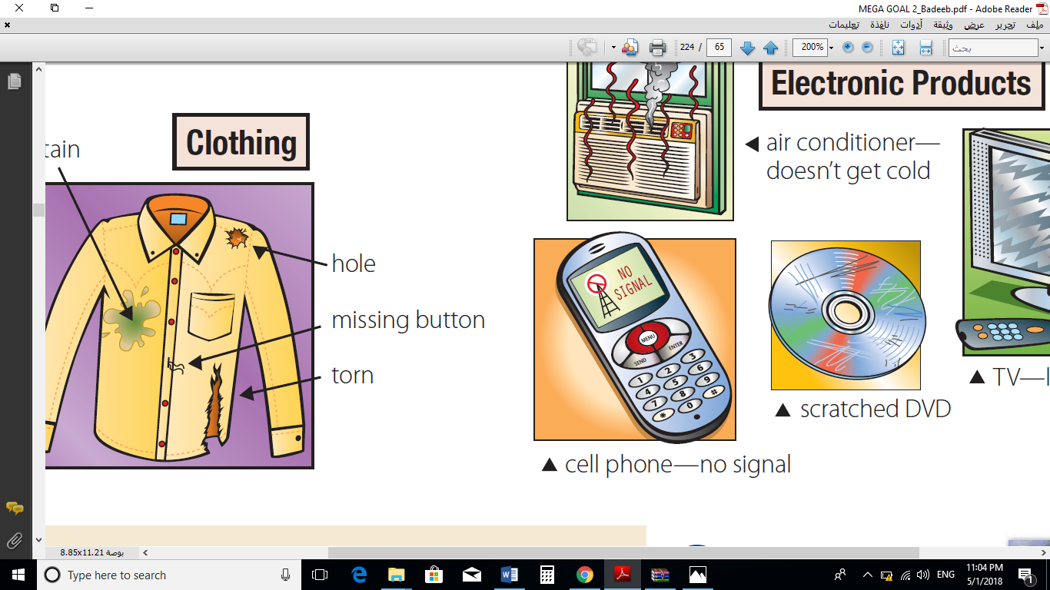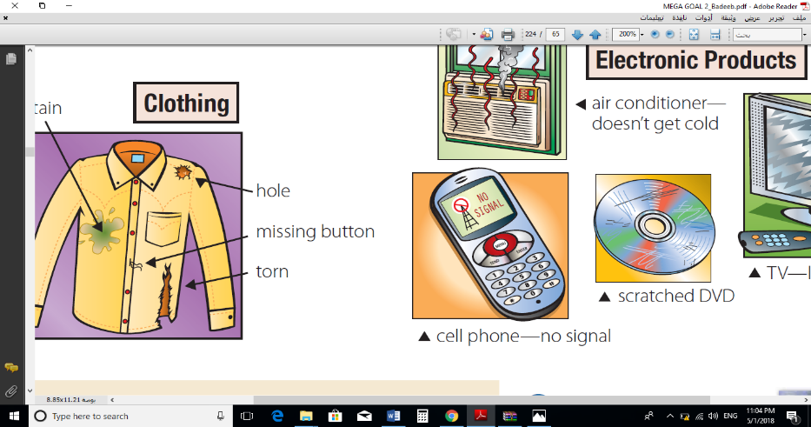

**----------------- ------------ ------------- --------------- -------------- ---------**

**1. oil ___ a. guard**

**2. heavy ___ b. style**

**3. hair ___ c. load**

**4. electric ___ d. bulb**

**5. security ___ e. well**

**1. ____ proof a. make the effort**

**2. ____ candidate b. get image with a computer**

**3. ____ scan c. evidence**

**4. ____ bother d. person trying to be elected**

**1- asset a) relating to the country**

**2- sustainable b) useful or valuable quality**

**3- upgraded c) replaced by newer**

**4- dynamic d) always active**

**5- urban e) business organization**

**6- rural f) lasting**

**7- remote g) made simpler**

**8- streamlined h) far away**

**9- enterprise i) relating to cities**

**Do as shown between brackets:**

**1- I burned my finger on the stove. (Make sentences with should have or shouldn't have)**

**2- I learned English in Canada. (Report the sentence)**

**3- The walls are filthy. They need to be** ……………………. **(repaint).**

**4- I**……………….…**(never, travel) outside my country until I went to Disney world last summer. 5- If they…………. (Stop) to rest, they wouldn't be**……………..(**sleep )right now.**

**6- You (**mustn't / couldn't / mightn't**) smoke here.**

**Write the appropriate words for these pictures**

**(ship - candle-torn – technician - hurricane- wheel)**

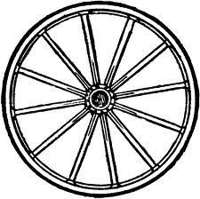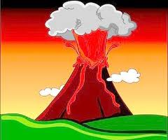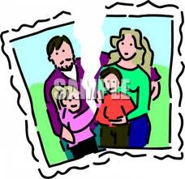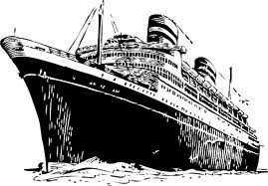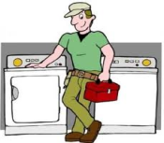

**…………… …………… …….…….. …………**

**Writing: Fill in the missing letters**

**1- anti__iotic 2- s__ash 3- vol__ano 4- cr__ter 5. __ipe**

**6- im__ove 7- den__ 8- an__oyed 9- persua__e 10- can__idate**

**Choose:**

**1- The windows need to be (clean – cleaning – cleaned).**

**2- The correct form of past participle for "break" (breaking – broken – breaks)**

**3-The windows need to be ………… a) cleaning b) clean c) cleaned**

**7- You have not eaten all day. you ………. be starving. a) must b) cannot c) might**

**8- Pat is joking. she …………. be serious. a) must b) cannot c) might**

**9-I will call you when ………… a) I am arriving b) I arrived c) I arrive**

**Match the words with their meanings by putting the correct number in the right space:**

**1. hair …. guard.**

**2. oil …. evidence.**

**3. proof ….well.**

**4. security …. style.**

Do as shown between brackets :

1- She didn't study hard . {Use: should have } ----------------------------------------------------------.

2- I have brother and sister . {Report } -----------------------------------------------------------.

**3- Are they students? {Report} ------------------------------------------------------------------.**

Write the past participle for this verbs :

1- damage …………… 2- eat ……………… 3- clean …………… 4- broke ………

Complete the following sentences: Computers – meteorite – unemployed - penicillin

1- The …………… coming from the sky .

2- Charles had lost his job , he had been ………………… for months .

3- Dr. Alexander Fleming discovered ………….in 1940 s , during the world war .

4- If we did not have …………….. a lots of work would still done with paper and pencil.

**1- I should have [ visited - visit - visiting ] you .**

**2- I have my car [ repaired - repairing - repair ] .**

**3- I am not sure, but Ali [ can't - might - must ] be at the library .**

***Correct the underlined words* :**

**1-Before we arrived the rain stopped . _____________ .**

**2-The windows need to be clean . _______________ .**

**3-If he arrived earlier, he catch his flight . __________ .**

**Choose the correct answer:**

**1- The button on that shirt needs to be _____.**

A. sew B. saw C. sewed D. sews

**2- I’m going to _____ this afternoon.**

A. have it repaired B. have repaired it C. repaired it D. have to repaired it

**3- The plumber fixed the _____ pipe.**

A. breaked B. broked C. broken D. broke

**4- You’ve been working all night! You _____ be tired.**

A. won’t B. must C. can’t D. are

**5- I didn’t have dinner with Carl because I _____ earlier.**

A. eat B. had eaten C. had ate D. eaten

**6- Dan: Do you want to play basketball today?**

A. Dan asked if I wanted to play basketball today. B. Dan asked if I could play basketball today.

C. Dan asked how I wanted to play basketball today. D. Dan asked did I want to play basketball today.

**Write the correct word from the box under the right picture:**

**dead battery / scratched DVD / cracked windshield / dripping faucet / broken doorknob**

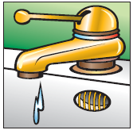

**-------------- -------------- ---------------- ---------------**

***Write the past participle for each verb :***

**1- tear ………………………… 2- paint ……………………….**

***Match column (A) with column (B) :***

**1-security { } evidence**

**2-proof { } guard**

**3-split { } the prize**

**4- bother { } make the effort**

**Do as shown between brackets:**

**1- She didn't study hard . { use " should have" }**

**2- I have a brother and a sister . { report }**

**4-The windows need to be ………… a) cleaning b) clean c) cleaned**

**5- You have not eaten all day. you ……… be starving. a) must b) can't c) might**

**6- Pat`s joking. she …………. be serious. a) must b) can't c) might**

***Complete the sentences below*:** Penicillin - crater - meteorite - advantages - unemployed

**1-A….………………. had made a …………….….. thousands of years ago.**

**2-He had been ………………….. for months .**

**3-Fleming had even discovered …………………. yet .**

**4-Oil would bring great ……………………… to their lives .**

**1- Her face and hands need to be ( washed – washing – washes ) .**

**2- Why are you ( get – getting – got ) the side walk fixed .**

**3- The living room needs to be ( decorate - decorating – decorated ) .**

**4- When the ambulance arrived , the injured man had ( died - die – dead ).**

***B-Do as shown between brackets:***

**1- The old kitchen / redecorate. (Use "need to be" + the past participle of the verb)**

**2- If / my friends / ask / me, / I / go / to the library. (Use " would have " + past participle)**

**3- Ali's mom said," You will not play football." (Report what Ali's mom said)**

***B-Mark the odd word:***

|  |  |  |  |
| --- | --- | --- | --- |
| **today** | **electricity** | **Congratulations** | **a tornado** |
| **yesterday** | **smoke** | **Car repairs** | **volcano** |
| **tomorrow** | **penicillin** | **Housing** | **sunglass** |
| **poet** | **computers** | **Clothing** | **Meteorite** |

***C- Write the suitable word beside each picture:***

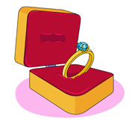**[](http://www.google.com.sa/imgres?imgurl=http://icbone.webs.com/envision-lcd-monitor.jpg&imgrefurl=http://www.b4bh.com/vb/showthread.php?t=242382&usg=__xSkyJ9cw3-RduYaBNqUAcGTBmTE=&h=515&w=530&sz=84&hl=ar&start=3&zoom=1&tbnid=wLjR1nBwoj3CIM:&tbnh=128&tbnw=132&ei=dXGET_aeE6fP4QSxmuTnBw&prev=/search?q=%D8%B4%D8%A7%D8%B4%D9%87&um=1&hl=ar&safe=active&sa=N&tbm=isch&um=1&itbs=1)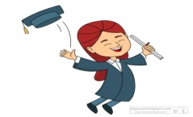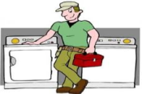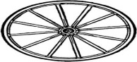 [telegraph–faucet–battery–technician–wheel–hair dryer - screen–torn–wedding anniversary– graduation]**

**------------- --------------- -------------- -------------- -------------- ----------------**

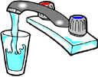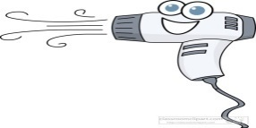**http://images5.clipart.com/thm/thm3/dg_unisym2F/transpr2/airports/seatac/4008633.thm.jpg?pd117tbu**

**------------- ------------------ --------------- ------------**

**1) I have bought a car. It [ need to be repair * needs to repaired * needs to be repaired ]**

**2) You [ shouldn't have drink * should have drunk * shouldn't have drunk ] milk.**

**3) She [ must * can't * might ] be thirsty. She doesn't drink water.**

**4) If he hadn't watched TV, he wouldn't [ have been * had been *had ] late for work.**

**5) Yesterday, I had my hair [ cut * cutting * cuts ].**

**6) The mechanic fixed the [ damage * damaged * damaging ] truck.**

***B) Do as shown between brackets:***

**1) " Do you like school "? Mona asked me. [ *report*] …………………………………….**

**a) They are having the lesson *explain. ……………………***

**d) Abdulrahman said that the school *is* large. ………………………**

***Match the words with the meanings:***

|  |  |  |  |
| --- | --- | --- | --- |
| **The meanings** |  | **The words** |  |
| **Have no air** |  | **Repaint** | **1** |
| **An opening in something** |  | **Flat** | **2** |
| **Evidence** |  | **Doorknob** | **3** |
| **A person trying to be elected** |  | **Hole** | **4** |
| **To color something again** |  | **Candidate** | **5** |
| **The handle by** [**which**](http://dictionary.reference.com/browse/which)**a** [**door**](http://dictionary.reference.com/browse/door) **is opened or closed.** |  | **Proof** | **6** |

**Match to form new words and expression:**

|  |  |  |  |  |
| --- | --- | --- | --- | --- |
| **heavy** | **Oil** | **electric** | **security** | **hair** |
| **load** | **style** | **well** | **bulb** | **guard** |

***Choose the correct word :***

**1) My new dress had a *[ hole * stain * torn]*. I should clean it.**

**2) If Dr. Fleming hadn't discovered *[ wheel * airplane* penicillin].***

**3) According to *(recent * result * feasible]* studies, orange juice is healthy and has vitamin.**

**4) When *[ tornado * volcano * meteorite]* erupted in 1980, it destroyed the city.**

**5) We need to *[ communicate * avoid * dreaming]* with people all around the world.**

**6) Sara is a good student. She is given a beautiful [*game show * prize * cash].***

***Complete with the suitable word :***

**1)………………..is a valuable stone often used in jewelry . *[ diamond * demand ]***

**3) A…………………..is a person who can't see . *[ blind *deaf ]***

**4)………………….the money that is returned to the customer. *[ refund * warranty]***

**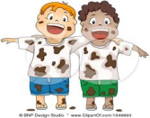 *Write another word has the same meaning:***

**a) The boys are *filthy.***

**Write the correct word under each picture:**

***Candle * bull * penguin * train * tire *pumpkin *pomegranate***

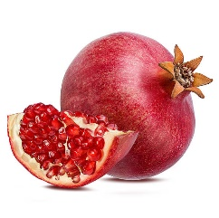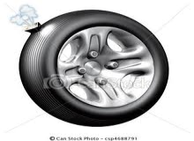

***Choose the correct letter:***

**1) de_ris *[ p * b]*  2) batt_ry *[ i * e ]***

**3) hoa_ *[ s * x ]* 4) impro_e *[ f * v }***

**1. The windows need to be (clean – cleaned – cleans)**

**2. We are having the room (decorate – decorates – decorated)**

**3. The windows were (break – broke – broken).**

**4. The car was (damaged – damage – damages)**

**5. The pipes were (break – broke – broken)**

**6. When we arrived at the airport, our flight had already (leaving – leaves – left)**

**7. If I had gotten the summer job, I (can – could have – could) saved money.**

**8. He said that he (has – had – will) two brothers.**

**9. The rooms need to be decorated. (Rewrite using: have)**

**10. We have the roof repaired. (Rewrite using: need to be)**

**Match the word with its meaning by writing the letter :**

|  |  |  |
| --- | --- | --- |
| **( )** | **1-devastated** | **a- evidence.** |
| **( )** | **2-debris** | **b- well.** |
| **( )** | **3-remote** | **c- get an image with a computer.** |
| **( )** | **4-scan** | **d-distant.** |
| **( )** | **5-oil** | **e- junk.** |
| **( )** | **6-proof** | **f- destroyed.** |

**Form a new word or expression from column A and B. Write the letter:**

|  |  |  |
| --- | --- | --- |
|  | **A** | **B** |
| **( )** | **1- oil** | **a- grinder** |
| **( )** | **2- electric** | **b- well** |
| **( )** | **3-security** | **c- bulb**  12 |
| **( )** | **4-hair** | **d- guard** |
| **( )** | **5-meat** | **e- style** |

**1- The shirt was (tear – tore – torn).**

**2- The tailor sewed the (tear – tore – torn) shirt.**

**3- The car needs to be (repair – repairs – repaired).**

**4- The shirt needed to be (sew – sewed – sewn)**

**5- The wall needs to be (broken – break – breaking)**

**6- That car needs to be (repairs – repaired – repairing)**

**7- I felt better after I (take – took – had taken) the medicine.**

**8- Before she appeared, she (had – has – had been) there.**

**9- When he arrived, the police (had arrested – arrested – arrests) the thief.**

**10. The air conditioner isn’t working. It needs to be (repaired – repair – repairing)**

**11. The pants are torn. They need to be (sew – saw – sewn).**

**12. The knife doesn’t cut. It needs to be (sharpen – sharpened – sharpens).**

**13. The tire on the car is worn. It needs to be (replaced – replacing – replaces).**

**\* Complete using the verbs in parentheses. Use the simple past and the past perfect forms.**

**1. I ____________ (feel) much better after I ____________ (see) the results of my test.**

**2. It had been raining, but by the time we _________ (arrive), the rain _________ (stop).**

**3. Dinosaurs_____ (be) extinct for millions of years before the first humans____ (appear).**

**4. I ____ (never, travel) outside my country until I ____ (go) to Disney World last summer.**

**5. When we ____________ (arrive), the police____________ (already, take) it away.**

**6. I ________ (never see) that man before the night he ______ (break) into my apartment.**

**\* Complete the sentences using *can’t*, *must*, or *might*.**

**1. You haven’t eaten all day. You ____________ be starving.**

**2. Pat’s joking. She ____________ be serious.**

**3. Ahmed has been studying all afternoon. He ____________ be tired by now.**

**4. I’m not sure of the way there. Let’s ask my father. He ____________ drive us there.**

**5. I can’t find my keys anywhere. I ____________ have lost them.**

**6. Who’s at the door? It ____________ be Mariam. She is abroad with her parents.**

**2- The past participle of the verb { tear } is ( tear –tore – torn ) .**

**3- Last month I ( go – gone – went ) to the different art museums in the city .**

**4- Lee didn't eat breakfast or lunch . He ( must - can't – might ) be hungry now .**

**5- If I had cash right now , I ( will – must – would ) buy a cell phone .**

**6- Her face and hands need to be ( washed – washing – washes ) .**

**7- Why are you ( get – getting – got ) the side walk fixed .**

**8- The living room needs to be ( decorate - decorating – decorated ) .**

**10- When the ambulance arrived , the injured man had ( died - die – dead ).**

**\* Choose the correct answer:**

**1. The air conditioner isn’t working. It needs to be (repaired – repair – repairing)**

**2. The pants are torn. They need to be (sew – saw – sewn).**

**3. The knife doesn’t cut. It needs to be (sharpen – sharpened – sharpens).**

**4. The tire on the car is worn. It needs to be (replaced – replacing – replaces).**

***Choose the correct answer* :**

**3- I should have [ visited - visit - visiting ] you .**

**5- I have my car [ repaired - repairing - repair ] .**

**6- I am not sure, but Ali [ can't - might - must ] be at the library .**

**Answer the following Reported:**

**“I have a brother and a sister.” “I don’t like mangoes.”**

**“I’m talking to Mary.” “I learned English in Canada.”**

**“I haven’t seen the film yet.” “I’ll see you later.”**

**“I can’t come to the meeting.” “I have to/must go to the doctor.”**

**“We may be late.” "I went to school."**

**How old are you? Where were you last night?**

**Are you a student? Did you enjoy the dinner party?**

Write the past participle for these verbs:

1- damage …… 2- eat ……… 3- clean ……… 4- broke ……

Complete the following sentences using these words:

**Computers – meteorite – unemployed – penicillin**

1- The ………………………. coming from the sky.

2- Charles had lost his job, he had been ………………………. for months.

3- Dr. Alexander Fleming discovered ……….in 1940 s, during the world war.

4- If we did not have …. a lot of work would still done with paper and pencil.

* Complete the missing letters:

1- m _ssing but _ on

2- c _ ll phon _

**Comprehension:**

***Dialogue***

**Composition**

Comprehension

**Read the passage then answer the questions:**

**The Blue Whale is the largest animal in the world. It grows up to thirty- three meters in length and may weigh as much as 130,000kilograms. It is even bigger than the huge animals that lived on earth long ago. Some people think that the Blue Whale is a fish because it lives in the sea and has a tail like the tail of a fish. However, it is not a fish. Fish breathe water but Blue Whales breathe air. They can stay under water for about an hour but then they have to come to the surface to breathe. The Blue Whale has a thick coat of fat under its skin. This acts as a blanket to keep it warm. The number of Whales in the sea is becoming less every year. This is because men hunt them and kill them, for almost every part of a Whale's body can be used to make something useful.**

**1. Why do some people think that a Whale is a fish?**

**2. Is the whale the largest animal in the world?**

**3. Choose the correct answer:**

**1. Whale may grow to be ……**

a. 33 meters long. b. 30 feet c. 7 or 8 meters d. 100 meters

**2. The layer of fat under the whale's skin …..**

a. helps it to float. b. keeps its blood warm. c. helps it to breathe. d. keeps its blood cool.

**Read the passage, then answer the question below it:**

**MURPHY’S LAW**

**You invite your friends over to watch an NBA basketball playoff game on TV. There are plenty of sodas in the refrigerator, the popcorn is popping, and you are all set to watch the big game. You turn on the TV set, and all you get are fuzzy images on the screen. Is this plain bad luck or is it Murphy’s Law at work? Murphy’s Law states: If anything can go wrong, it might go wrong! Similar situations occur all the time. When you’re in a hurry to open the door and you try several keys on the key ring, the last remaining key is usually the one that works. When you get in a line at the supermarket, you find you’ve chosen the slowest one, and it just doesn’t move. Is this bad luck or coincidence? According to British physicist Robert Matthews, it’s neither one nor the other. He explains that our selective memories tend to remember the bad episodes more readily than the things that usually work out. Also, the law of probability is more against us than in our favor in many situations. For example, in the supermarket with five cashiers, the chances of getting the fastest lane are 20 percent, and 80 percent for a slower lane. Matthews became a popular scientist when he proved that a piece of toast doesn’t necessarily fall on the floor on the buttered side. BBC Television gathered 300 people to throw pieces of buttered toast up in the air and observe on which side they fell. Half fell on the buttered side, and half didn’t.**

**1-What does the examples of the NBA game illustrate?**

**2- Find the meaning of the words from the passage:**

**Law: ………………. Plenty =………………….**

**3- Put (T) or (F):**

**a- There are not plenty of sodas in the refrigerator. ( )**

**b- Murphy’s Law states: If anything can go wrong, it might go wrong! ( )**

**Read the passage then choose the best answer :**

**The living room does not look good. It looks bad without a carpet. Mary and Dan want to buy a carpet for their living room. They go to the store. They look at the carpets. There are many colors and sizes. Some have patterns. Some are lines. Mary likes a pink and purple carpet. It has dots. It has pink and purple dots. Dan says no! He does not like the colors , the pattern and the size. The pink and purple carpet is too big. Dan likes a green and red carpet. It has lines. It has green and redlines. Mary says no! She does not like the colors, the pattern and the size also. The green and red carpet is too small. Mary and Dan see a yellow carpet. It does not have dots. It does not have lines . Dan and Mary like the yellow carpet. They both like the color. They both like the size. They both say yes! Mary and Dan buy the yellow carpet. They put the carpet in the living room. The living room looks wonderful with the new carpet.**

**1) According to the passage, Mary and Dan want to put the new carpet in their ….**

A. bedroom B. dining room C. living room

**2) According to the passage, the pink and purple carpet …..**

A. has lines B. has dots C. is too small

**3) According to the passage, the green and red carpet …..**

A. is too small B. is plain C. is too big

**Mary likes a pink and purple carpet. It has dots. It has pink and purple dots. Dan says no! He does not like the colors, the pattern and the size. The pink and purple carpet is too big. Dan likes a green and red carpet. It has lines. It has green and redlines. Mary says no! She does not like the colors, the pattern and the size also. The green and red carpet is too small. Mary and Dan see a yellow carpet. It does not have dots. It does not have lines. Dan and Mary like the yellow carpet. They both like the color. They both like the size. They both say yes! Mary and Dan buy the yellow carpet. They put the carpet in the living room. The living room looks wonderful with the new carpet.**

**1) According to the passage, the pink and purple carpet …..**

**A. has dots B. has lines C. is too small**

**2) According to the passage, Dan says no for the …..**

**A yellow carpet. B. pink and purple carpet C. blue carpet**

**3) Mary and Dan buy the …. carpet.**

**A. black B. pink C. yellow**

**Read the paragraph then answer the questions:**

**In ancient times, a chain of fires on mountaintops was used to relate the news of the fall of Troy to people in Greece. In the past, native people of Americas used smoke from fires to transmit messages. They developed a code of smoke. Almost anything makes a noise has been used for signaling. Cyrus established lines of signal towers to convey a message. A kind of drum talk is still used in Central Africa to simulate speech of humans. In modern times, people have communicated by letters, telegraph and telephone. But the most widespread one today is email. By the end of the 20th century, there were 263 million email boxes. In the 21st century, that figure has grown to over 2 billion. And text messaging on cell phones is also increasing, so people can be in constant touch with people who are long distances away.**

1. **What did native people of Americas use to transmit messages?**
2. **How many email boxes were there in the 21st century?**
3. **What is used in the Central Africa?**
4. **Write (T) for true and (F) for false statements:**

**a. In ancient times, a chain of fires was used to relate the news of the fall of Paris. ( )**

**b. Cyrus established lines of signal towers to convey a message. ( )**

**Read the following passage then answer the questions :**

**People learn English for many different reasons . They learn English for their Studies and for their work. They learn English for tourism and for entertainment .They also learn English to be part of the world of computers and the internet . Dr. Ahmad Zuwail is a world famous Egyptian scientist in the field of chemistry and medicine , so he won the '' Noble Prize " . When he was young , Dr. Zuwail received his primary education in Dessouk , a big town in Kafr Alsheik . He was fond of learning English and that enabled him to study and discover . If you want to make yourself a big name like Dr.Zuwail , you must learn English first to help yourself and others . Second to make the whole world move .**

**A) Answer the following questions in complete sentences:**

**- Where did Dr. Zuwail receive his primary education ?**

**B) Choose the right answer :**

**- People learn English to be part of the world of :**

**Cinemas theatres technology**

**- Dr. Zuwail was fond of learning another :**

**language hobby subject**

**C) Put ( T ) for the true statement and ( F ) for the false one :**

**- Dr. Zuwail is a world famous Arab scientist . ( )**

**- English is used only in the field of education . ( )**

**Read the passage then choose the best answer:**

**There are many kinds of boats. One kind of boat is called a sailboat. A sailboat uses the wind to move. Wind makes a sailboat move in the water. The wind pushes the sailboat. Wind fills the sails. The sailboat moves when the wind blows. One kind of boat is called a motorboat. A motorboat uses a motor to move. The motor gives power to the boat. The motorboat moves when the motor is running. The motorboat makes a loud noise. One kind of boat is called a rowboat. A rowboat needs people to move it. People make a rowboat move in the water. People use oars to move a rowboat. Oars are long and flat. Oars go into the water. A rowboat moves when people use the oars.**

**1) Which boat uses the wind to move? (sailboat – rowboat – motorboat)**

**2) Which boat makes a loud noise? (sailboat – rowboat – motorboat)**

**3) What is used to move a rowboat? (wind – a motor – oars)**

**4) According to the passage, oars are (short and fat – long and flat – big and heavy)**

**5) This passage is mainly about**

**(different kinds of boats – where to use a rowboat – how to make a boat)**

**6) What would be the best title for this passage?**

**(Boats that Make Noise – The Sailboat and the Motorboat – Three Kinds of Boats)**

**Read the passage then answer the questions:**

**The Muslim world is famous for its rugs. Our rugs are made of wool or silk. They contain many colors, but the most common color is red. The most famous rugs come from Iran. Some have flowers on them and some have geometrical shapes. Many of them have a shape of a Mihrab in the center. This is because the first Muslim rugs were only used for praying. All the rugs are made by hand. It sometimes takes a man a year to make one rug.**

**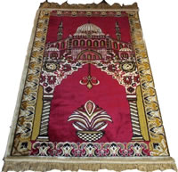*A. Answer the following questions:***

**1. Where do the most famous rugs come from?**

**2. Are the rugs made by hands?**

***B. Choose:***

**1. Some rugs have { flowers – doors - writing}.**

**2. The common color of rugs is: { green – yellow – red}.**

***C. Put ( 🗸 ) or ( 🞩 ):***

**1. The first rugs were only used for decorating rooms. ( )**

**2. One rug takes about one year to finish. ( )**

***Read the following passage, then answer the questions below:***

**There is always a lot of crowd in the city center because big companies, banks, offices and malls are there. There are car parks but they are not enough for all cars. Last week, Hamad and his family went shopping in Salmiya. As usual their poor father drove them there although he doesn't like going to these crowded places. He left them at the nearest place to their favorite mall and went to look for a parking place. While he was driving his car, a truck hit his car at the back. He got down to see what happened and he was very surprised to find that his back lights were broken. He was very angry and wanted to call the police but the driver of the truck told him that he didn't mean it. There was an old woman who fell in front of his truck so he hit his father's car instead of her. Hamad's family went home very sad without buying their needs that day.**

***Answer the following question:***

***1. Why is the city center always crowded?***

***2. Where did Hamad’s father leave his family?***

***3.Did Hamed's father call the police?***

***Put true (T) or false (F)***

***1- There are enough parks for all cars in the city center . ( )***

***2- Hamad's father doesn't like driving in crowded places . ( )***

***3- Hamad bought a nice shirt that day . ( )***

***4- A bus driver hit Hamad's car . ( )***

***Choose the correct answer:***

***1-An old woman fell………the truck.* a) in front of b) behind c) over**

***2-The ………. of the car were broken.* a) back doors b) front lights c) back lights**

**Read the following passage and answer the questions below:**

**James wants a dog. He walks to the pet store. James sees the animals at the pet store. He sees the cats. He sees the rabbits. He sees the birds. He sees the mice. He sees the dogs. “How much does the dog cost?” James says. “Twenty dollars,” the man says. James gives the man twenty dollars. James buys the dog. The dog walks home with James. Now James has a pet.**

**1) What kind of pet does James want?**

**2- Put (T) for true and (F) for false:**

**a-James gives the man Ten dollars. ( ) b- James wants a dog. ( )**

***Read the passage then answer the following* questions:**

**Nearly, three quarters of the world is covered by water. There are two kinds of water: fresh and salt water. Fresh water is found in rivers, lakes and wells. Salt water is found in seas and oceans. We can’t drink water because it is too salty. About 90% of all fresh water in the world is in Antarctica. It is not used because it is remote. Water is very important in our lives. It has many different uses. Water is used for drinking, cooking, making electricity and irrigating crops.**

1- How much of world covered by water ?

2- How many kinds of water ?

3- Is water important I our live ?

* Put (T) or (F) for the following statements :

1- About 90% of all fresh water in the world is in Antarctica . ( ….)

2- Water isn't important (…..) 3- There are three kinds of water (…..)

3- Linda ……. Tired , she stayed up all night . { can't – must }

**Read the paragraph then answer the questions:**

**Thousands of meteorites enter Earth’s atmosphere and fall harmlessly to the ground each year. One widely accepted theory is that the impact of an asteroid 6 miles (10 kilometers) in diameter could have been responsible for the extinction of many life forms. In order to protect against such events (or at least reduce their effects), NASA has developed ways to monitor Near-Earth Objects (NEOs). Scientists believe that Eros might strike Earth in 1.5 to 5 million years. The probability of one of these Near-Earth Objects hitting Earth over the next hundred years is virtually negligible. However, scientists are concerned, because at present, there are about 900 asteroids circulating our solar system. If an asteroid the size of Eros fell on Earth in the middle of the Atlantic, it would have catastrophic effects. Thousands of nuts, bolts, and other debris from space missions form an orbiting garbage dump. Some of these bits and pieces fall back into Earth’s atmosphere and behave just like any other meteor. According to NASA, there must be over 100,000 objects with a diameter of one to ten centimeters floating around space. The U.S. Space Command is aware of the threat of an orbital impact during space missions and monitors this junk constantly. The agency estimates that there might be more than 3,000 satellites orbiting Earth. Some scientists speculate that one day there might be orbiting “garbage collector” machines to pick up the debris. Since the space surveillance mission began, almost 17,000 objects that were tracked re-entered Earth’s atmosphere. Most objects that re-enter the atmosphere either burn up or re-enter over water. As a result, the risk of someone getting hit on the head by one of these objects is very remote. Nearly three-quarters of the planet is covered by water, and large areas of Earth’s land are uninhabited.**

1. **What does (NEOs) mean?**
2. **How many meteorites enter Earth's atmosphere each year?**
3. **What happens to most objects that re-inter the atmosphere?**
4. **What would happen if an asteroid the size of Eros fell on Earth in the middle of Atlantic?**
5. **Write (T) for true and (F) for false statements:**
6. **NASA has developed ways to monitor Near-Earth Asteroid Rendezvous (NEAR). ( )**
7. **Near-Earth Objects may hit Earth over the next hundred years is virtually negligible. ( )**
8. **The agency estimates that there might be more than 3,000,000 satellites orbiting Earth. ( )**
9. **The risk of someone getting hit on the head by one of these objects is very remote. ( )**

***Read the story then answer the questions* :**

**Patricia Polacco can certainly tell a very exciting story. I loved a book she wrote called *Meteor.* So when I saw that she was coming to our local library, I decided to meet her. At the library, she told us something about her life and then read us part of her book. Patricia was born in Lansing, Michigan, and grew up in Oakland, California. When she was a little girl, she often stayed with her grandparents who lived in Union City, Michigan. One summer day, a meteorite fell from the sky, right into her grandparents' backyard. Her grandparents had lived a very quiet life on their farm. Now things were different. They had so much to do. People came to see the meteorite. The university came to study it and analyze it. Her grandparents had never talked to so many people in their lives, everything changed.**

**1-What was the name of patricia's book ? ………………………………………………… .**

**2-Where was she born ? ………………………………………………………….………… .**

**3- Put (T) or (F) .**

**a-When she was a little girl, she often stayed with her parents ( ) .**

**b-The university came to study it and analyze it ( ) .**

**Amir EL-Momeneen Omar Ibn Alkattab ,may Allah bless him , was the second Caliph. He was a kind man and a good Muslim. He often gave food to the poor . Omar sometimes walks through the streets at night he walked alone , he had no soldiers with him . He had ordinary clothes on ,and nobody knew that he was the Caliph . He listened to people talking about their problems . One night, Omar was having a walk in a poor part of the city . He could smell food cooking . Many people were having dinner. Then he came to a small house . He heard children crying . He went in . He saw a woman stirring something in a pot she was very poor. She had a torn dress on . He saw three children sitting on the floor . They were crying . “ Why are your children crying ? “Omar asked. “ Because they are hungry , “ she said . “ But they are going to have dinner “ . “ Let me show you what we have got for dinner.” Said the woman . She led him to the pot . He looked inside and saw some stones lying in the boiling water, “ I have not got any food .” said the woman . “ But I do not want the children to know .” “ Where is your husband ? “ asked Omar . “ I have not got a husband . He was dead .” Omar left the house. He went home and fetched a huge bag of food . Then he put more wood on the woman’s fire, and knelt down to blow the flames. He began to cook a meal for the family by himself .**

***A- Answer the following questions :***

**1-Who was Omar Ibn Alkttab ?**

**2-Where was Omar having a walk that night ?**

**3-What did he fetch from his house ?**

**4- What did he hear when he came to the small house ?**

***B- Put ( ✓ ) or ( 🗴 ) :***

**1- Omar Ibn Alkattab , may Allah bless him , was the fourth Caliph. [ ]**

**2- He didn't listen to people talking about their problems. [ ]**

**3-The woman had 3 children. [ ]**

**4-Omar cooked the food himself. [ ]**

***C- Choose:***

**1- Omar used to walk through the streets: a- with soldiers b- alone**

**2-Nobody knew that he was the Caliph because:**

**a- he had ordinary clothes. b- he listened to the people’s problems.**

**3-The woman was wearing : a- ordinary clothes. b- a torn dress.**

**4-The children were crying because : a- their father was dead. b- they were hungry**

***D- What does each word refer to :***

**1-The underlined word He refers to:………**

**2-The underlined word They refers to : …………….**

***E- Choose the right meaning :***

**1- The word "poor" in line 2 means (have food and money – have no food and no money).**

**2- The word "huge" in line 14 means (very big – very small).**

**\*Read the following passage and answer the questions**

**Maha wanted to buy a new dress. However, she was not able to buy it because she did not have enough money. So, her mother brought her sewing-machine. She said to Maha "If you buy some material, I’ll sew a beautiful dress for you." Maha felt happy and interesting. Immediately, she went to the market and bought some material for her lovely dress.**

**1- Why was Maha not able to buy a new dress? …………………………………….**

**2- Who will sew a new dress for Maha?.....................................................................**

**3- How did Maha feel?.......................................................**

***Choose the correct answer:***

**1) Maha wanted to buy a new . . . . . . . . . . . . * shirt * dress * trousers**

**2) She . . . . . . . . happy. * tasted * smelled * felt**

**3) She went to the . . . . . . . . . . . * market * shop * grocer’s**

**4) Underline the correct meaning: Line 1 : it = . . . * money * the case * the dress**

***Put (√ ) or (× )***

**1) Maha’s mother brought her luggage. [ ] 2) Maha was able to buy a dress. [ ]**

**Comprehension:**

***Read the passage then answer the questions below:***

**David Copperfield is a beautiful story. It is about a boy whose father died before he was born. The boy lived his early years happily with his mother, Carla. Few years his mother got married to Edward Murdstone who was very cruel. David's stepfather used to beat him then he sent David to boarding school. David 's mother died and the boy was sent to work in London. After finishing school, he trained to become a lawyer while he married to beautiful woman, Dora, but few years she died. David left to Switzerland to find comfort on Alps. While living there he worked on his book that his friend published it. Later, he became a famous novelist.**

***A) Answer the following questions:*  
1. What is this story about?-------------------------------------------------------------.**

**2. Did David's mother get married after her husband's death? --------------------------.**

**3. Where did David go after his mother's death? ------------------------------------------.**

**4. Did David publish his book? ----------------------------------------------------------------.**

***B) Put ( √ ) or ( X ):*  
5. While David was in London he worked on his book. ( )  
6. David became a famous novelist.( )**

**7. David's friend helped him to publish his book. ( )**

**8. David never got married. ( )  
*C) Complete:*  
9. David's mother name was --------------------------------.  
10. David's wife name was -----------------------------------.**

***D) Choose the correct answer:***

**11. Line 9: the underlined word (there) refers to: (a. London b. Home c. Switzerland)**

**12. Line 10: the underlined word (he) refers to: (a. stepfather b. David c. friend)**

**Read the following paragraph then answer the questions:**

**When Ray and Judy Fausset arrived home on the afternoon, they discovered to their amazement that a meteorite had crashed through their two-story house. Neighbors said that they heard a terrific noise. The meteorite had penetrated the Faussets' roof and it had ended up in the crawl space the house, leaving debris and fragments along its path. A total mass of 42.5 pounds (19.3 kilograms) the meteorite was recovered from the Fausset house. The three largest fragments weighed 6.5 pounds (2.9 kilograms), 2.9 pounds (1.3 kilograms) and 2.2 pounds (1 kilogram).**

1. **What did Faussets discover?**

**2-How much did the three fragments weigh?**

**3-What did their neighbors say?**

**4- What did the meteorite leave?**

1. **Answer (True) or (False):**
2. **The meteorite had crashed Faaussets' two-floor house. ( )**
3. **The meteorite had penetrated the Faussets' court. ( )**
4. **One fragment weighed 1.3 kilograms. ( )**
5. **1 kilogram equals 2.2 pounds. ( )**

**Read the passage then choose the best answer :**

**There are many kinds of boats. One kind of boat is called a sailboat. A sailboat uses the wind to move. Wind makes a sailboat move in the water. The wind pushes the sailboat. Wind fills the sails. The sailboat moves when the wind blows. One kind of boat is called a motorboat. A motorboat uses a motor to move. The motor gives power to the boat. The motorboat moves when the motor is running. The motorboat makes a loud noise. One kind of boat is called a rowboat. A rowboat needs people to move it. People make a rowboat move in the water. People use oars to move a rowboat. Oars are long and flat. Oars go into the water. A rowboat moves when people use the oars.**

**1) Which boat uses the wind to move?**

**A. a sailboat B. a rowboat C. a motorboat**

**2) Which boat makes a loud noise?**

**A. a sailboat B. a motorboat C. a rowboat**

**3) What is used to move a rowboat?**

**A. wind B. a motor C. oars**

**4) According to the passage, oars are**

**A. short and fat B. long and flat C. big and heavy**

**5) This passage is mainly about**

**A. different kinds of boats B. where to use a rowboat C. how to make a boat**

**6) What would be the best title for this passage?**

**A. Boats that Make Noise B. The Sailboat and the Motorboat C. Three Kinds of Boats**

***Read the passage then answer the following* questions:**

**Nearly, three quarters of the world is covered by water. There are two kinds of water: fresh and salt water. Fresh water is found in rivers, lakes and wells. Salt water is found in seas and oceans. We can’t drink water because it is too salty. About 90% of all fresh water in the world is in Antarctica. It is not used because it is remote. Water is very important in our lives. It has many different uses. Water is used for drinking, cooking, making electricity and irrigating crops.**

Answer these questions:

1- How much of world covered by water?

2- How many kinds of water?

3- Is water important I our live?

* Put (T) or (F) for the following statements:

1- About 90% of all fresh water in the world is in Antarctica. ( )

2- Water isn't important. ( ) 3- There are three kinds of water ( )

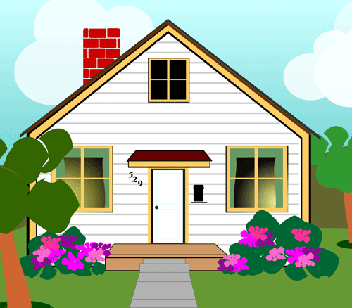**Complete the following dialogue between Nada and Rawan:**

**Nada: Hi, How are you Rawan?**

**Rawan: ………………………………………………………………………………………**

**Nada: Did you buy a new house?**

**Rawan: ……………………………, I did.**

**Nada: ………………………………………………………………………………………**

**Rawan: Thank you. I hope so too.**

**Nada: Please come and visit me soon. Goodbye.**

**Rawan: ………………………………………………………………………………………**

**Dialogue**

***Style - return - trend - loose-fitting, material - fabric torn - flimsy, falling - faded - creation - knees.***

***Complete the conversation:***

**Salesperson: Hello ma'am. Can I help you?**

***Customer: Yes please, if you could. I'd like to ……………… a pair of jeans.***

**Salesperson: What's the problem with them?**

***Customer: They're wide-cut with ……………… colors.***

**Salesperson: This is Milo's …………… He designs ………………. Clothing, and faded clothes are in ……………. this season.**

***Customer: But it's ……………… really ………………..***

**Salesman: Well, lightweight fabrics are the latest ……………………….**

***Customers: Look! They're ……………… at the …………… in several other places and the ………… is …………… apart. I noticed it when I was washing them.***

**Put in the right words to complete the conversation:**

**In the end / hoax / really / or anything like that / totally**

Adam: I …………………………………… think that telemarketing shouldn’t be allowed.

**Sammy: Yes, I ……………………… agree with you. Telemarketers are a real nuisance.**

Adam: Yesterday a man called me up. He said he was from the Dollar Bank, and he asked if he could talk to me for a minute.

**Sammy: What did he want?**

Adam: He tried to persuade me to open an account with them. So I told him I already had an account elsewhere and that I wasn’t interested. But he insisted and was very pushy. ……………………………… , I lost my patience and hung up.

**Sammy: Well, I got a call from a man who said he was from a travel agency. This man said I had won a free trip to the Bahamas and that he was calling me to give me the good news.**

Adam: Had you entered a contest ……………………………………………………… ?

**Sammy: No. It turned out that everything was for free, but I’d first have to pay a huge amount of money to become a member of the Jet Set Club. Big ………………………… !**

Adam: I hate that!

**Complete the following conversation between Ali and Mohammed:**

**Ali: Hello Mohammed, Good Morning.**

**Mohammed: ……………………… .**

**Ali: How are you ?**

**Mohammed: ………………..……………………..**

**Ali: Ok, bye.**

**Mohammad:………………………**

**Complete the following dialogue: (excuse me – sky – satellite – wonder – over – might)**

**Ali : …………….. what is going on ?**

**Omar: When I got to the park, a crowd had gathered around the weird thing ……there.**

**Ali : Gee , I …………… what it is .**

**Omar : it must have fallen from ………………..**

**Ali : do you have any idea what it …….. be ?**

**Omar : what ever it is man-made it look like part of ………….to me .**

**Complete the missing word in the following dialogue:**

**Ali: ………me Nasser, What is going one . Nasser: ……… I got to the park; a crowd had gathered around that weird thing over there.**

**Ali……….! I wonder what it is . Nasser: …………..! it must have fallen from sky . Do you have any idea what it might be ? Ali :…………………..it is man- made .it looks like part of a satellite to me . Nasser: …… it might be the remains of a weather balloon .**

**Ali: ……., it cannot be. I have seen weather balloons before, and that is not the type of equipment**

**Omar : Hi, Ahmad .**

**Ahmad : …………………………………..**

**Omar: I want to apologize for not coming to your graduation ceremony.**

**Ahmad : ...................................................................................What's wrong ?**

**Omar : ……………………………………………………………………. .**

**Ahmad: Do you regret that?**

**Omar: …………………………………………. .**

**Ahmad: It's O.K.**

**Omar: Any way, congratulations, I wish you that's of luck.**

**Ahmad: ………………………………………….**

**Complete the following dialogue use this words :**

**( Excuse me – sky – satellite – wonder – overnight )**

**Ali : ………………………. what is going on ?**

**Omar: When I got to the park, a crowd had gathered around the weird thing ……….… there**

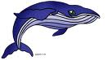**Ali : Gee , I ………………………. what it is .**

**Omar : it must have fallen from ……………………….**

**Ali : do you have any idea what it ………………………. be ?**

**Omar : Whatever it is man-made it look like part of , ………………. to me .**

**Write a paragraph about HOW I COMMUNICATE no more 8 lines you can use these words:**

**(cell phone – communication – class mate – text message – talkative – emails)**

**Friendship is More Important**

**Friendship is very important in our life. I have many friends but my best friend is Saleh. Last week, we went out for lunch at one of the famous restaurants. When we finished, I discovered that I had forgotten my wallet so, I asked Saleh to pay the cheque but he said he didn’t have any money. I decided to let it go and keep my friend. I called my brother to bring my wallet to pay for the lunch.**

**My Cell Phone**

**Last week, I bought a new cell phone from a big store in the city Centre. When I went home I took it out to try it but I discovered that it didn’t work. I went back to the store but they told me that they wanted the package intact. I got angry and told them I tore it to try the cell phone and asked to see the manager who apologized and replaced the cell phone with a new one.**