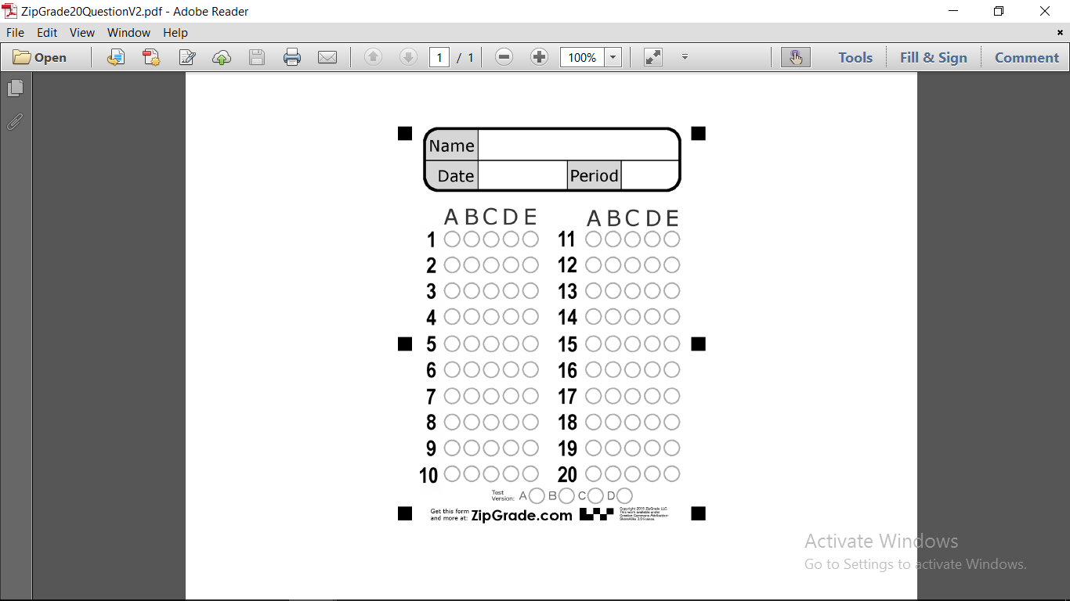

Unit 10 Quiz

**Class**

**Grammar**

**Choose the correct answer:**

**1- …………….. time do you sleep?**

|  |  |  |
| --- | --- | --- |
| (C) Where | (B) What | (A) How |

**2- Does he work? - No, he ……...**

|  |  |  |
| --- | --- | --- |
| (C) doesn't | (B) does | (A) do |

**3- She ………….. long brown hair.**

|  |  |  |
| --- | --- | --- |
| (C) is | (B) have | (A) has |

**Vocabulary**

 **4- It is ………….. and gray, there's no sun.**

|  |  |  |
| --- | --- | --- |
| (C) snowy | (B) cloudy | (A) sunny |

 **5- Snakes can ……….. but they can't fly.**

|  |  |  |
| --- | --- | --- |
| (C) bite | (B) jump | (A) run |



|  |  |  |  |
| --- | --- | --- | --- |
| (D) | (C) | (B) | (A) |

**choose the correct pic.**

|  |  |  |
| --- | --- | --- |
| **8- astronaut** (…..…) | **7- cook** (………) | **6- doctor** (………) |

**Dictation**

|  |  |  |  |
| --- | --- | --- | --- |
| (D) **G** | (C) **S** | (B) **R** | (A) **T** |

**9- I have sho…t hair.**

|  |  |  |  |
| --- | --- | --- | --- |
| (D) **T** | (C) **M** | (B) **S** | (A) **K** |

 **10- I ge… up at 6:00.**

Teacher : Dalal Al-Juaid