

The 5th Grade
 | الأسم ثلاثي: |  | الفصل | 5 / | الدرجة
Unit 3 Exam

- Match: General Questions
3


- Welcome to our house? S-U-N
- Can you find your book? Thanks!
- How do you spell sun? I found it.
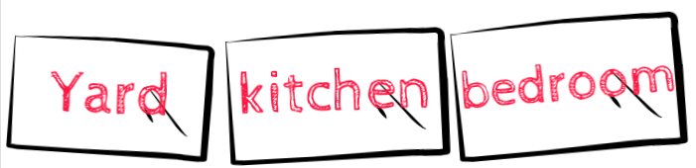
- Complete: Writing
3

- You can find a bed in the__________________.
- You can find a fridge in the ________________.
- You can find big trees and flowers in the_______________.
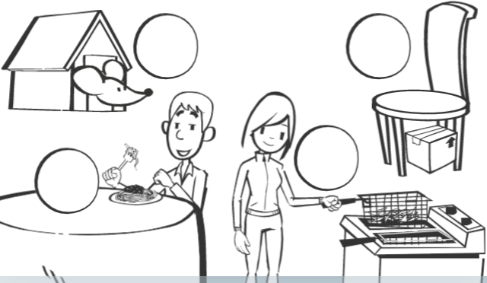
- Match: Reading

- He's in the dining room.
4
- My friend is cooking fries.
- The mouse is in the house.
- The box is under the chair.
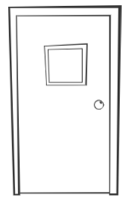
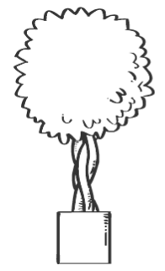
- Match: Vocabulary
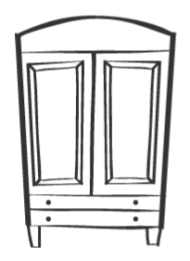
door
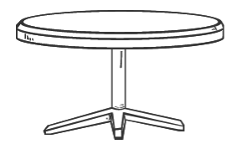
table
4
tree
cupboard

- Choose: Grammar

- When's – Where's the bathroom?
3

- My brother is hungry. He's - She's eating.

- Sarah is my friend. He's – She's 9 years old.


- Complete: Spelling
3


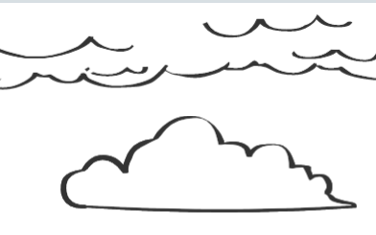
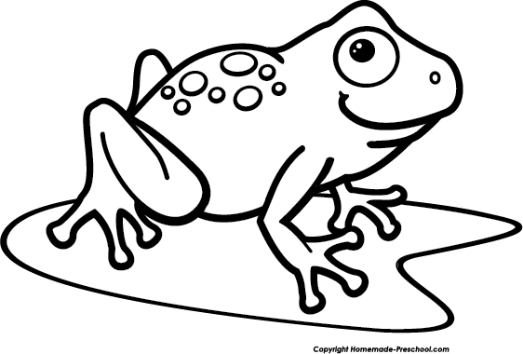

__ __ og __ __ esent cl __ __ d

معلم المادة / خالد الراجح

