

**اختبار الفترة الثانية.**

**الفصل: الدراسي الثالث 1443ه.**

**الصف الرابع الابتدائي.**

**المادة : انجليزي.**

**We Can2**

**المملكة العربية السعودية.**

**وزارة التعليم.**

**إدارة التعليم**

**مكتب تعليم**

**المدرسة**

**الاسم / .**....................................................................................الفصل: ..../.....

**General questions: (4m)**

1 – Answer the following questions :

|  |
| --- |
| **1 - What's the matter?**  **I'm ………… ( happy - sad )** |
| **2 – What day do you like?**  **I like** ………. **(Friday - pizza** ) |
| **3 – What's the weather like?**  **It is …………… ( rainy - sunny )** |
| **4 - How many horses are there?**  **- They are ………………. ( 15 - 11 )** |

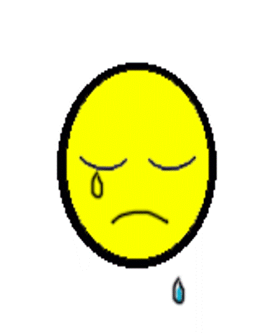

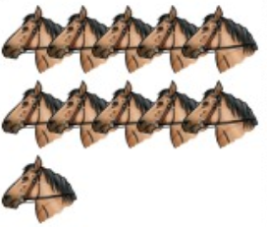

**Reading short sentences: (3m)**

2 – Read and put **🗸 or 🗴**  :

|  |  |  |
| --- | --- | --- |
| **1. I'm happy** | 🗸 | 🗴 |
| **2. It is a cat.** | 🗸 | 🗴 |
| **3. He is hungry.** | 🗸 | 🗴 |

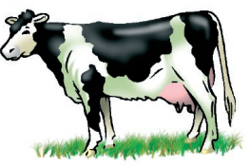

A – Complete:

**Controlled writing : (4m)**

|  |  |  |  |  |  |  |  |  |  |
| --- | --- | --- | --- | --- | --- | --- | --- | --- | --- |
| 100 | …… | 80 | ….… | 60 | …... | 40 | 30 | …... | 10 |

B– Rearrange:

angry / He / is ……………………………………………….

.

**Grammar: (3m)**

4 – Read and choose the correct answer:

|  |  |  |
| --- | --- | --- |
| ؟ | . | **1 – What is this ….** |
| He | my | **2 – ………… mother is angry** |
| are | is | **3 – You ………………… happy.** |

**Vocabulary: (3 m)**

5 – Write the correct word under each picture:

|  |  |  |
| --- | --- | --- |
|  |  |  |
| ………..……. | ………..……. | ………..……. |

cloudy - laptop - zebra

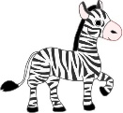

6 – Choose the correct letter:

**Orthography (Spelling): (3m)**

7 – Copy the following:

**……………………………………**

**I have a bicycle.**

|  |  |  |
| --- | --- | --- |
|  |  |  |
| **__ un**  **( s - t )** | **Fo…**  **( y – x )** | **__olf**  **( v - w)** |