|  |  |  |  |
| --- | --- | --- | --- |
| **المملكة العربية السعودية**  **وزارة التعليم**  **الإدارة العامة للتعليم بـن مدرسة مستقبل ن الابتدائية** | **http://tabuk2day.com/wp-content/uploads/IMG_3362.jpgبسم الله الرحمن الرحيم** **اختبار الفصل الدراسي الثالث**  **للعام الدراسي 1443 هـ**  **https://t.me/abokhaledamer** | **المادة** | **لغة انجليزية** |
| **الصف** | **الخامس** |
| **الزمن** | **ساعة ونصف** |
| **الفصل** | **----- /5** |
| **اسم الطالب رباعيا: .............................................................................................................**   |  |  |  |  |  |  |  |  | | --- | --- | --- | --- | --- | --- | --- | --- | | **السؤال** | **1** | **2** | **3** | **4** | **5** | **6** | **المجموع** | | **الدرجة** |  |  |  |  |  |  |  | | **الدرجة** | 4 | 5 | 6 | 6 | 5 | 4 | 30 | | **المصحح** |  |  |  |  |  |  |  | | | | |

**match: General Questions**

**4**

**1. What time do you eat your lunch? --------------------.**

**2. Do you watch TV in the evening? --------------------.**

**3. Can kangaroos fly? --------------------.**

**4. Can I use your pen? --------------------.**

**5**

**match: Controlled Writing**

**1. This is the living _______. a. count**

**2. summer, ------, fall, spring. b. room**

**3. Let's ____ them. 1,2,3,4,5,6,7,8,9,10. c. winter**

**Rearrange:**

**1. are – What - ? – these --------------------------.**

**2. go – Sure – you – here ---------------------------.**

**Choose: Grammar**

**6**

**1. What (**am – are – is**) this?**

**2. They are (**a wallet – wallets - wallet**).**

**3.** (Where're – Where's - Who**) the boy?**

**4. Ali is (**under – in – on**) the bathroom.**

**5. I get up (**in – at – on**) 6:00.**

**6. (**Do – Does – Go**) he work in the office?**

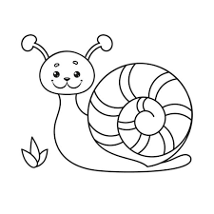**match: Vocabulary**

**6**

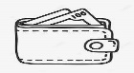**Present**

**Scissors**

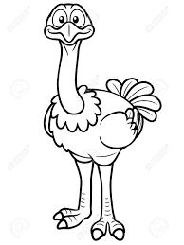**snail**

**astronaut**

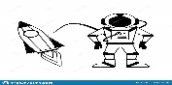**ostrich**

**wallet**

**5**

**match: Reading**

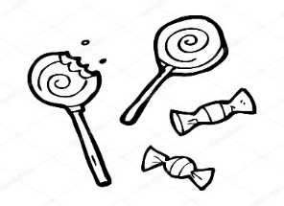 **1. I get up at 7 o'clock.**

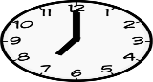 **2. It is rainy and wet.**

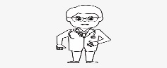 **3. He is a doctor.**

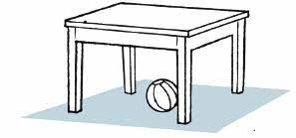 **4. Candy for you.**

**5. The ball is under the table.**

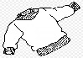**match: Orthography**

**4**

**1. _ _eater sw**

Black and White Cartoon Spider Clip Art - Black and White Cartoon Spider  Image | Spider coloring page, Halloween doodle, Halloween preschool**2. _ _ ider sm**

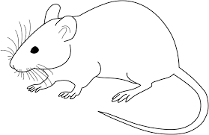**3. m _ _ se sp**

**4. _ _ ile ou**

**End of Questions**