

The 5th Grade
 | الأسم ثلاثي: |  | الفصل | 5 / | الدرجة
Unit 4 Exam

- Match: General Questions
3

- How many are there? Here you go.
- Are you ready? Yes, we are!
- Can I use your glue? Let's count them.

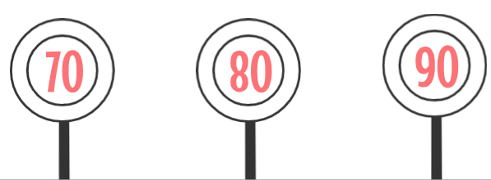
- Complete: Writing
2

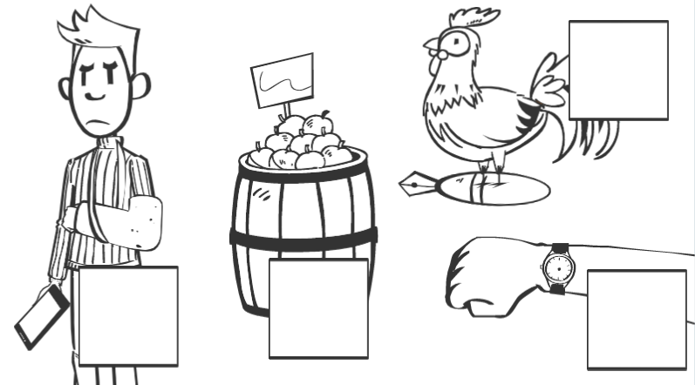
- Match: Reading

1. Can I use your phone?
4
2. What is this? It's my new watch.
3. The pen is under the hen.
4. How many apples are there?
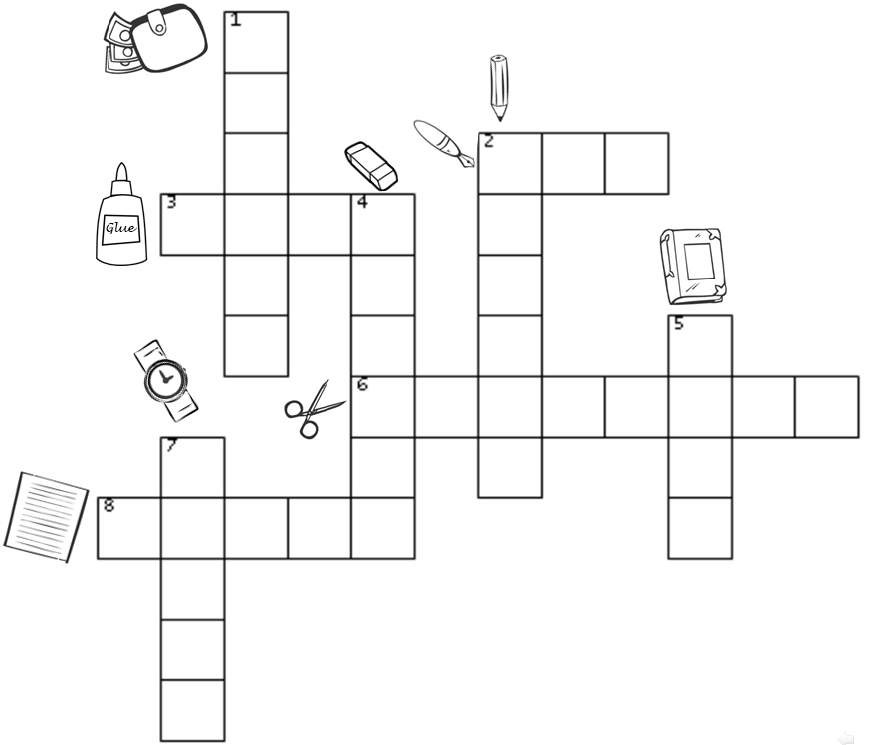
- Match: Vocabulary
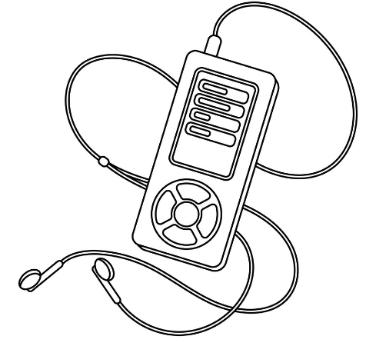
Mp3
4
pencil
scissors
wallet

- Choose: Grammar

3

- What are these? They - It are books.

- What is this ? – these ? It's a candy.

- These are paper – papers .

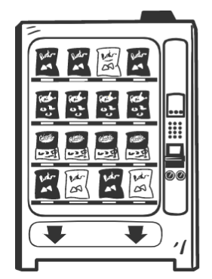

- Complete
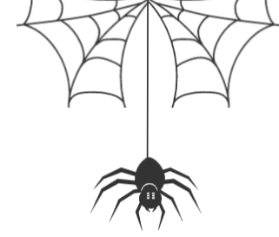


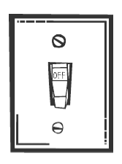

4

__ __ ider __ __ itch __ __ ile __ __ ack

معلم المادة / خالد الراجح

