اللغة االجنليزية | المادة |  |  |  | اململكة العربية السعودية
الخامس | الصف |  |  |  | وزارة التعليم
اختبار الصف الخامس الفترة الثانيه للفصل الثالث
 | رقم اجللوس | خامس / | الفصل |  |  | أسم الطالب:
Vocabulary
A. Write the correct word under each picture: 6
cook - kitchen - behind – bread - scissors

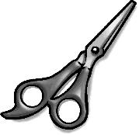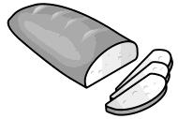
………..……. ………..……. ………..…….

 | B.Choose: |  | Grammar
 |  |  |  |  |  |  |  | 5
 |  | 1 – The mouse is the chair. . |  |  | in |  | on
 |  | 2 – What is ? |  |  | this |  | these
 |  | 3 – These pens . |  |  | is |  | are
 |  | 4- are teeth . |  |  | These |  | Those
 |  |   5- is a astronaut . |  |  | they |  | He
C .Choose the correct letter: Spelling
 |  |  |  |  |  |  |  | 9
 | 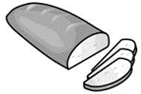 |  | 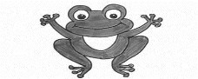 | 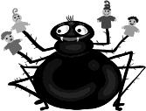 |  | 
 | Br d  ( ea– ee ) |  | rog ( h – f ) | ider  ( sp - sw) |  | clo dy ( o - u )

