لغة انجل زيية –– للصف السادس ابتدا يئ –

س 4111 (الدور األول)

س الثالث للعام الدرا

اختبار نهاية الفصل الدرا

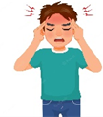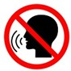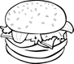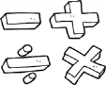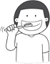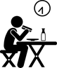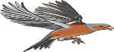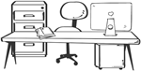



**Q1 : Choose the right answer:**

|  |  |
| --- | --- |
| **1 – What time does your school start ?** | **A**. **It starts at 7:00 a.m. B**. **I'm playing.** |
| **2- Do you like science?** | **A**. **Yes ,I was. B. Yes,I do.** |
| **3- What's the matter?** | **A**. **I have a toothache . B**. **Welcome.** |
| **4– Where're you going?** | **A.Apple juice,please. B** .**I'm going to Dubai.** |
| **5- Does your school has a school bus?** | **A**.**Yes,it has a yellow bus. B** .**About 300** |
| **6- Where's the supermarket?** | **A**. **Don't litter. B. It's near here**. |



**Q2:Do as shown between brackets:**

|  |  |  |  |  |
| --- | --- | --- | --- | --- |
| **1 – skip – shouldn't- You – breakfast. (Rearrange)** | | **......................................................…** | | |
| **2 –I have a** | **(Complete )** | **headache** | **earache** | **toothache** |
| **3-This sign means** | **(Complete)** | **Speak loudly** | **Don't shout** | **No parking** |
| **4- I'd like , please.** | **(choose)** | **Cheese** | **Ice cream** | **burger** |
| **5- History ,science , (Complete )** | | **train** | **Bus station** | **math** |



**Q3: Choose (🗸 ) or ( × ) :**

|  |  |  |
| --- | --- | --- |
| **1. I brush my teeth 3 times a day.** | **🗸** | **🗴** |
| **2.Hassan sleeps early everyday.** | **🗸** | **🗴** |
| **3.She saw a fast beautiful bird.** | **🗸** | **🗴** |
| **4. My Dad is a pilot, he flies planes.** | **🗸** | **🗴** |



**Q4:Choose :**

|  |  |  |  |
| --- | --- | --- | --- |
| **1– You eat healthy food every day.** | **Should** | **Shouldn't** | **is** |
| **2- Did you your breakfast this morning?** | **ate** | **eat** | **eating** |
| **3– What you like to drink ?** | **like** | **have** | **would** |
| **4- Last year, I in the 5th grade.** | **was** | **were** | **am** |
| **5- The past of (*do*) is .** | **does** | **did** | **doing** |
| **6- We are to the library .** | **go** | **goes** | **going** |



**Q5: Choose the right word under the picture :**

|  |  |  |  |  |
| --- | --- | --- | --- | --- |
|  |  |  |  |  |
| 1. **should** 2. **shouldn't** | 1. **T shirt** 2. **belt** | 1. **earache** 2. **headache** | 1. **clothing**   **store**   1. **bakery** | 1. **healthy** 2. **tired** |

 **Q6:Fill in the missing letters :**

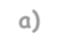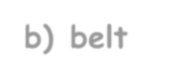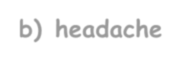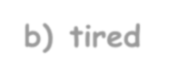

|  |  |  |  |
| --- | --- | --- | --- |
|  |  |  |  |
| **Tiss _ _** | **T _ _ n** | **_ _ ate** | **Sh _ _ t** |
| 1. **ee** 2. **ue** | 1. **ur** 2. **er** | 1. **ss** 2. **sk** | 1. **ir** 2. **rr** |

**Best Wishes. E. T.Afaf Asiri**

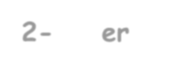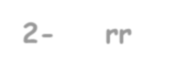

2