اختبار الفترة الأولى–– للصف الخامس ابتدائي – الفصل الدراسي الثالث

الأسم ثلاثي: |  | الفصل | 6 / | الدرجة

General questions match
sure . Here you go . |  | Would you like to come to my house ? | 1
yes, please . |  | Where is your house ? | 2
It's in Riyadh . |  | Can I use your pen ? | 3
Controlled writing match
Welcome |  | This is the living _______. | 1
room |  | ______ to our house . | 2
show |  | Let's ____ them. 1,2,3,4,5,6,7,8,9,10. | 3
count |  | I'll ____ you around. Thanks | 4
Grammar CHOOSE
_______ the boy? | Q2 | He is = ______ | Q1
Where're | A | He's | A
where's | B | She's | B
Hashem is ___ the bathroom. | Q4 | _____ you ready? | Q3
under | A | Is | A
in | B | Are . | B
vocabulary match
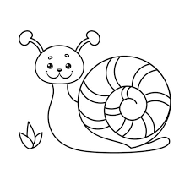 |  | Dining room | 1
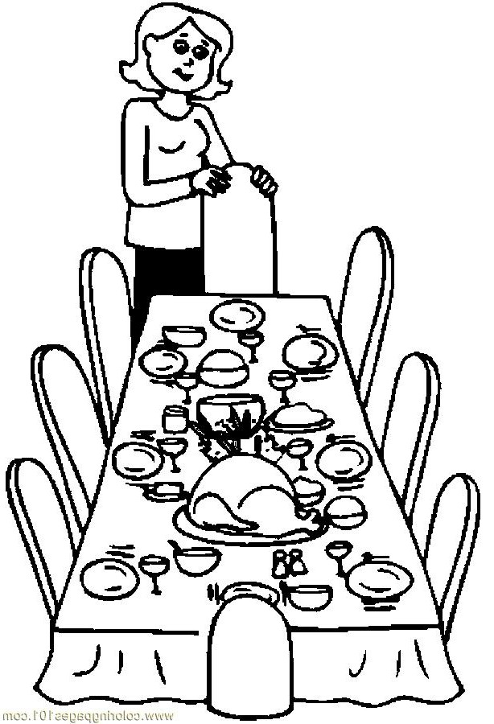 |  | Present | 2
 |  | Scissors | 3
 |  | snail | 4
Orthography match
sm |  |   _x | 1
o |  | 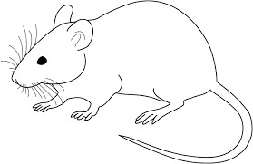  m_ _ se | 2
ou |  |   _ _ ile | 3
Reading match
 |  | The boy is in the yard. | 1
 |  | The ball is under the table. | 2
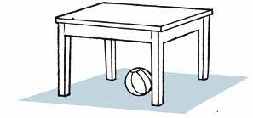 |  | Candy for you. | 3
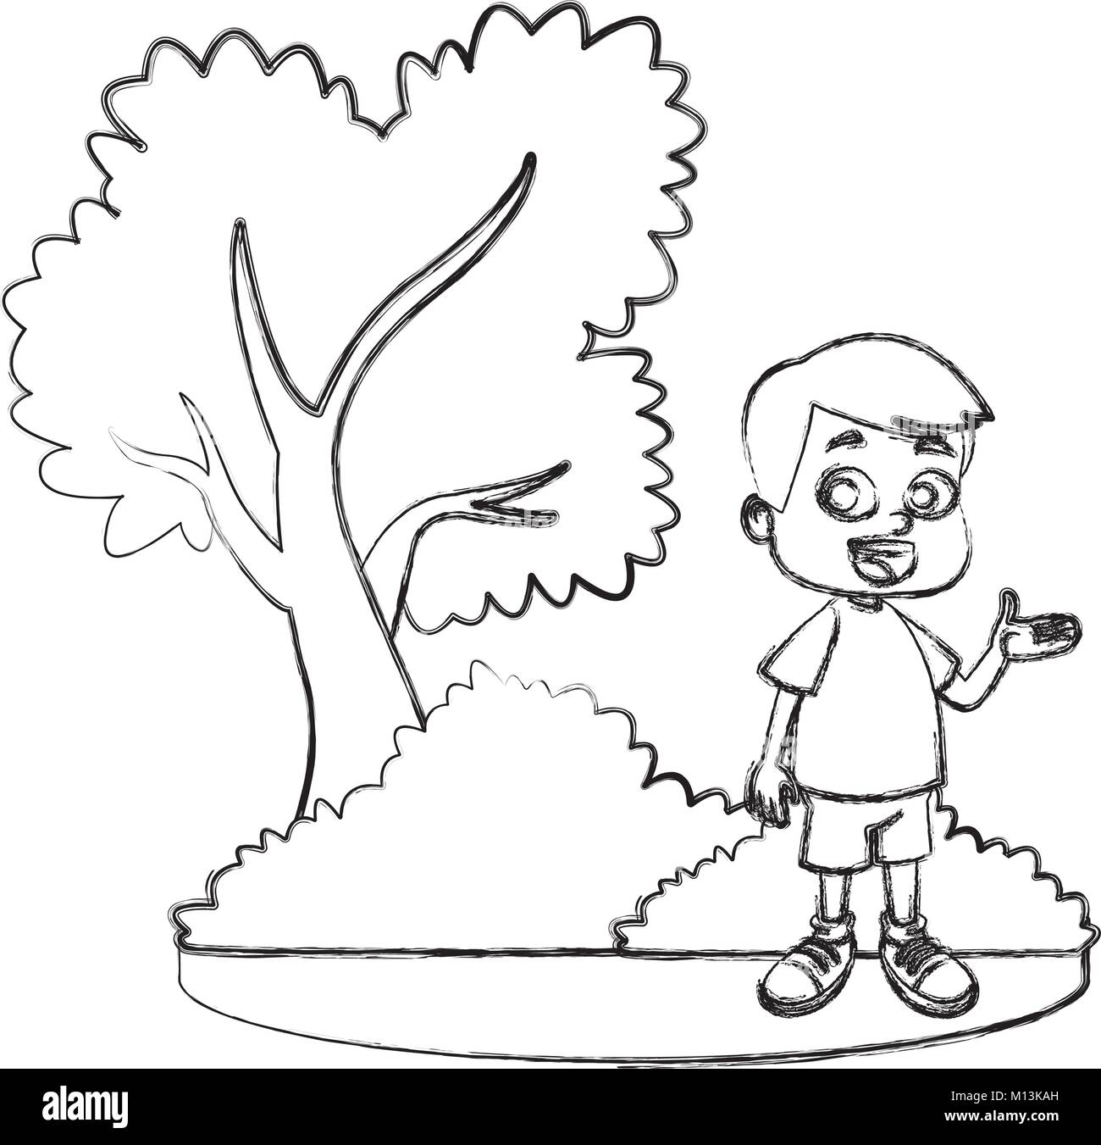 |  | The fridge is in the kitchen . | 4

توزيع الدرجات المقترح

General questions 1mark each

Controlled writing 1mark each

Grammar 1mark each

Vocabulary 1mark each

Orthography 1mark each

Reading 1/2 each

______________________
الاسئلة من الوحدة الثالثة والوحدة الرابعة الى الدرس الثاني حسب توزيع المنهج ( وللمعلم الخيار حسب توزيعة )
وفقكم الله

T. Mohamad Zaid Al Asmari

