1 - General Questions
Mark : /
We can 6مراجعة اللغة الإنجليزية الصف السادس الابتدائي – الفصل الدراسي الثالث – الوحدات 3 – 4 – 5 - 6 صفحة 1 من 7

A: Answer the following questions correctly:
- Do you have school lunch at your school ?
---------------------------------------------------- .
- Does your school have a school bus ?
---------------------------------------------------- .
- Do you have a school uniform ?
---------------------------------------------------- .
- Which grade are you in this year ?
---------------------------------------------------- .
- Which city do you live in ?
---------------------------------------------------- .
B: Choose:
- I go to the ………. Elementary School.
a ) 3rd b ) 5th c ) 8th
- Your school starts in ……. .
a ) 7:15 b ) 8:15 c ) 9:15
3.Don't shout ; …..
a ) think wisely b ) speak clearly c ) drive carefully
- How much is it ?
a ) It's 60 SR . b ) It's blue . c ) It's small .
- I want a stapler and staples . I am going to the …… store.
a ) candy b ) stationary c ) DVD

We can 6مراجعة اللغة الإنجليزية الصف السادس الابتدائي – الفصل الدراسي الثالث – الوحدات 3 – 4 – 5 - 6 صفحة 2 من 7
- You want some candy . You are going to the …… store.
a ) candy b ) stationary c ) DVD
- My brother wants a new DVD. He is going to the …… store.
a ) candy b ) stationary c ) DVD
- Mom wants some bread and cakes . She is going to the …… .
a ) bakery b ) bookstore c ) flower store
- We want some books . We are going to the …… .
a ) bakery b ) bookstore c ) flower store
- They want some flowers and pots .They are going to the …… .
a ) bakery b ) bookstore c ) flower store
- What would you like to drink ? I would like some …… , please.
a ) juice b ) sandwich c ) ice cream
- What would you like to eat ? I would like a …… , please.
a ) cup of coffee b ) sandwich c ) glass of water
- I ate all the soup because I was very …. .
a ) sleepy b ) hungry c ) thirsty
- I drank all the juice because I was very …. .
a ) sleepy b ) hungry c ) thirsty
- I took your toy because it was so …. .
a ) cute b ) sleepy c ) new
- I slept in your bed because I was very …. .
a ) sleepy b ) hungry c ) thirsty
- Sunday , Monday and Tuesday are … .
a ) months b ) days c ) pronouns
We can 6مراجعة اللغة الإنجليزية الصف السادس الابتدائي – الفصل الدراسي الثالث – الوحدات 3 – 4 – 5 - 6 صفحة 3 من 7
- I , he and they are … .
a ) months b ) days c ) pronouns
- January , February and March are … .
a ) months b ) days c ) pronouns

2 - Controlled Writing
Mark : /
A: Choose the correct word from the box:
butcher – listen – healthy – ask – grumpy
1.Early to bed and early to rise , makes you ________ , wealthy and wise.
2. ________ for help when you have a problem .
3.Late to bed and late to rise , makes you sleepy , _________ , and tired.
4. ____________ to the teacher.
5. She wants some meat . She is going to the _________ shop.
B) Rearrange the following :
1. help – I – can – you - ?
.
2. the coffee shop – going to - is – He - .
.
3. takes – 2 – It – about – hours - .
.

3 - Reading Short Sentences
Mark : /
We can 6مراجعة اللغة الإنجليزية الصف السادس الابتدائي – الفصل الدراسي الثالث – الوحدات 3 – 4 – 5 - 6 صفحة 4 من 7

Write the number of the sentence under the picture that matches it:
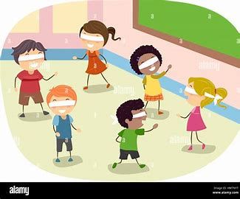 | 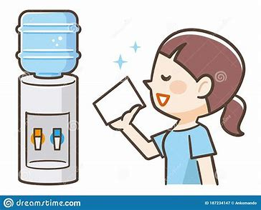 | 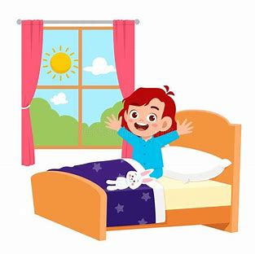 | 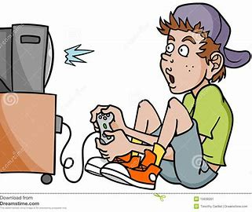 | 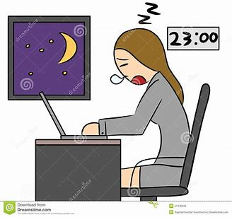 | 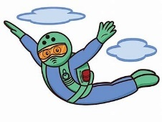
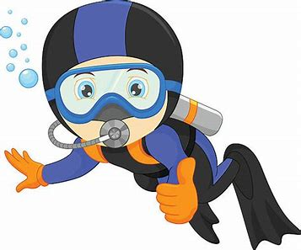 | 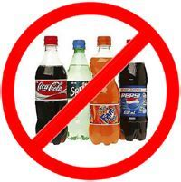 | 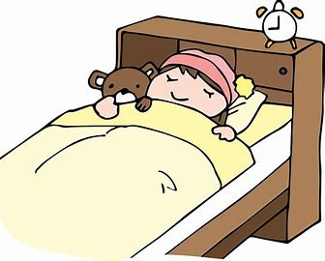 | 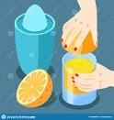 | 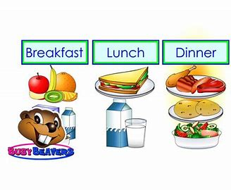 | 
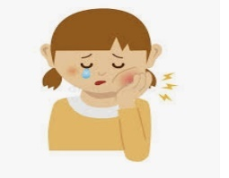 | 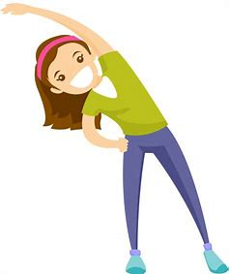 | 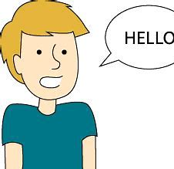 | 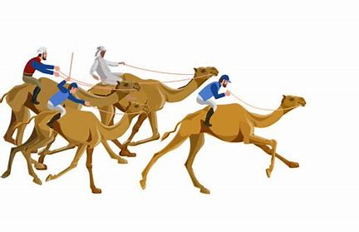 | 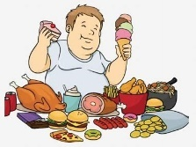 | 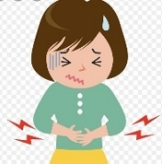
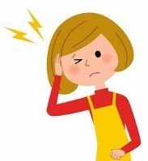 | 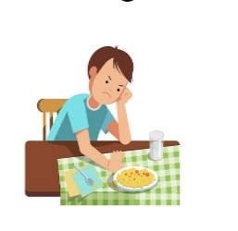 | 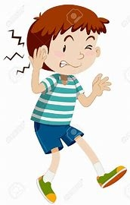 | 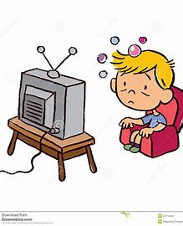

1.Ishould get up early.
2- I should drink a lot of water.
3. Don't make too much noise when you play games.
4. I should eat three meals a day.
5. I should brush my teeth well.
6. Speak English in class.
7.I should do some exercise.
8.I should go to bed early.
9.She is squeezing oranges.
10.I shouldn't eat too much food.
11. I shouldn't drink too much soda.
12. I shouldn't watch too much TV.
13. I shouldn't stay up late.
14. I shouldn't play too many computer games.
15. I shouldn't skip breakfast.
16. I have a headache.
17. I have a toothache.
18. He is sky diving.
19. He is scuba diving.
20. I have a stomachache.
21. I have an earache.
22. You are going to watch camel races in Riyadh .
4 - Grammar
We can 6مراجعة اللغة الإنجليزية الصف السادس الابتدائي – الفصل الدراسي الثالث – الوحدات 3 – 4 – 5 - 6 صفحة 5 من 7
Mark : /
A ) Choose the correct answer:

1- This year I ( like – liked – likes ) math.
2- Last year I ( like – liked – likes ) PE.
3- We ( live – lived – lives ) in Yanbu.
4- Last year We ( go – goes – went ) to Riyadh.
5- Did you ( drink – drinks – drank ) milk this morning ?
6- I ( drink – drinks – drank ) milk this morning .
7. I didn't ( brush – brushes – brushed ) my teeth this morning.
8. I ( am – is – are ) going to school.
9. You ( am – is – are ) going to the mall.
10. He ( am – is – are ) going to the bookstore.
11. She ( am – is – are ) going to the candy store.
12. We ( am – is – are ) going to the stationary store.
13. They ( am – is – are ) going to the DVD store.
14. There ( is – was – were ) an old story about a mouse and a cat .
15. There ( is – was – are ) a moon in the sky .
16. Look , there ( is – are – were ) some books on the desk .
17. There ( was – are – were ) some fine things in the mall yesterday .
18. They are going to ( eat – ate – eats ) at a restaurant .
19. She is going to ( visit – visited – visits ) the city of Abha .
B) Fill in the following table :
Present V ( 1 ) |  | do | does | go
Past V ( 2 ) | got up |  |  |  | drank | played
Present V ( 1 ) | talk |  | watch |  | stay
Past V ( 2 ) |  | brushed |  | ate |  | followed
5 – Vocabulary
Mark : /
We can 6مراجعة اللغة الإنجليزية الصف السادس الابتدائي – الفصل الدراسي الثالث – الوحدات 3 – 4 – 5 - 6 صفحة 6 من 7

Write the number of the word under the picture that matches it:

1 | Train station | 2 | Principal office | 3 | art workshop | 4 | Smart classroom | 5 | No Eating  No Drinking
6 | supermarket | 7 | Convenience store | 8 | social studies | 9 | Elementary school | 10 | Keep Off Grass
11 | Teachers' lounge | 12 | stapler | 13 | lamb | 14 | candy | 15 | No Skateboards
16 | bus stop | 17 | bread | 18 | bottle | 19 | No Parking | 20 | DVD
21 | math | 22 | science | 23 | English | 24 | history | 25 | leader
26 | letter | 27 | library | 28 | language | 29 | art | 30 | classroom
31 | No Cycling | 32 | No Talking | 33 | library | 34 | No Phone | 35 | Post office
36 | No Littering | 37 | No Balls | 38 | globe | 39 | yard | 40 | PE

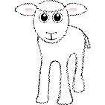 | 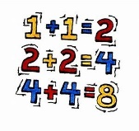 | 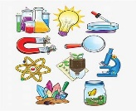 | 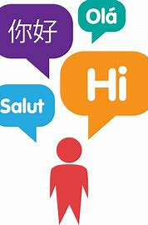 |  | 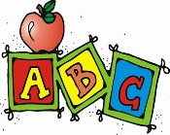
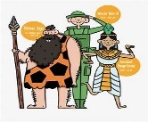 |  | 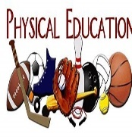 | 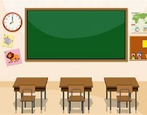 | 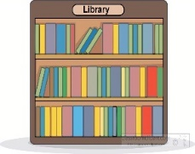 | 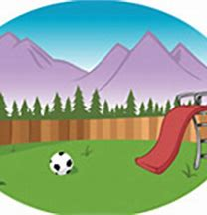
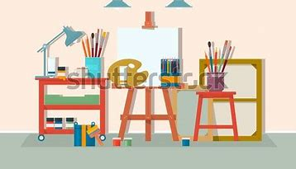 | 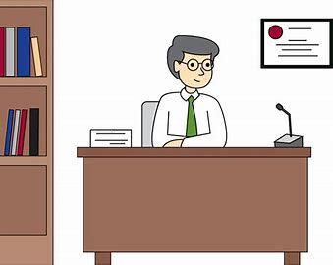 |  | 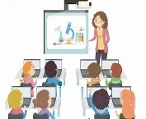 | 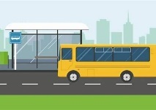 | 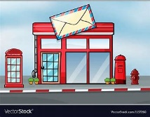
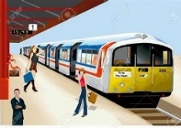 |  | 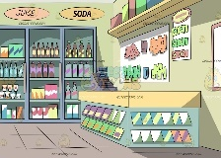 | 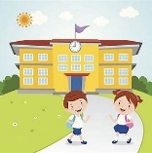 | 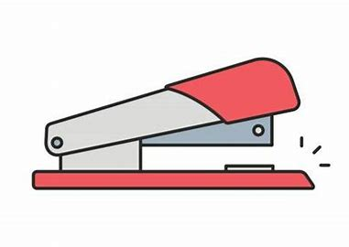 | 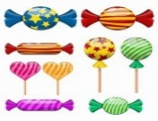
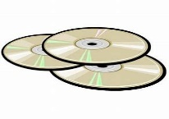 | 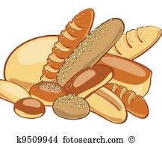 | 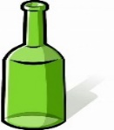 |  | 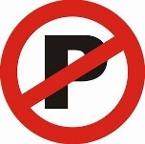 | 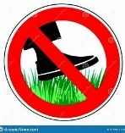
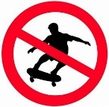 | 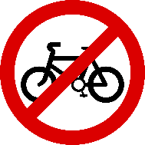 | 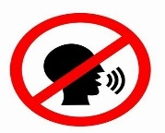 | 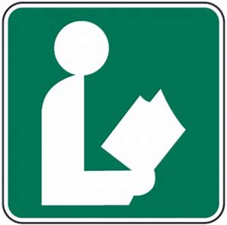 | 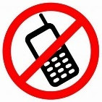 | 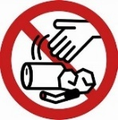
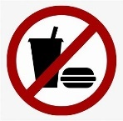 | 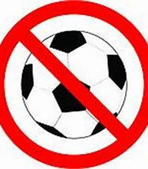 |  | 

6 – Orthography ( Spelling )
We can 6مراجعة اللغة الإنجليزية الصف السادس الابتدائي – الفصل الدراسي الثالث – الوحدات 3 – 4 – 5 - 6 صفحة 7 من 7
Mark : /

- Fill in the missing letters , use letters from the box :
sq - ir - sk – sc - ur – sk - ir - sc - ir – sq – ur – sq – sk – ur - sc

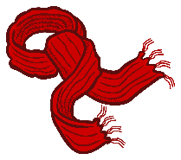 | 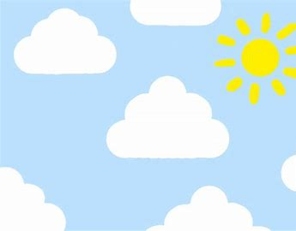 | 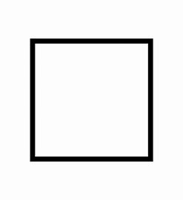 | 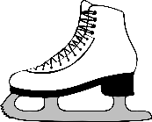 | 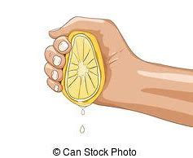
_ _ arf | _ _ y | _ _ uare | _ _ ate | _ _ ueeze
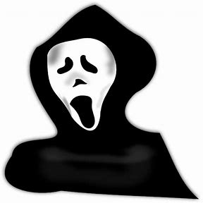 | 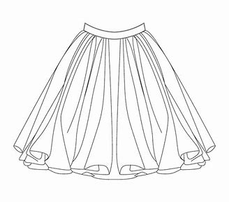 | 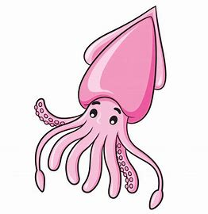 |  | 
_ _ ary | _ _ irt | _ _ uid | _ _ an | P _ _ ple
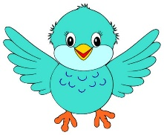 | 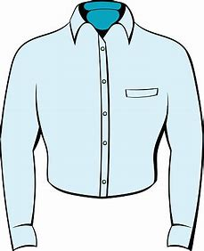 | 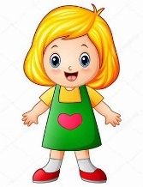 | 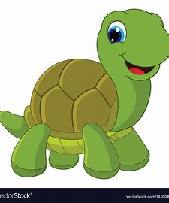 | 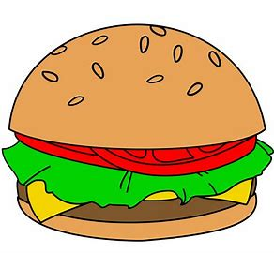
b _ _ d | sh _ _ t | g _ _ l | t _ _ tle | b _ _ ger

B ) put ( √ ) next to the word that has the right spelling :

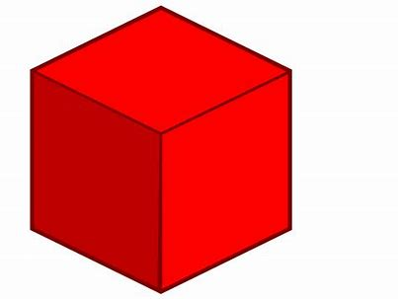 | 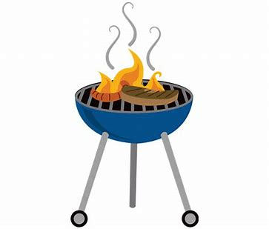 | 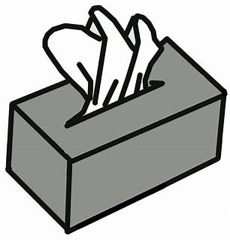 | 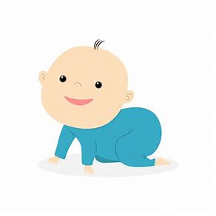
a – cube ( )  b – cape ( ) | a – barbecue ( )  b – barbecai ( ) | a – tissie ( )  b – tissue ( ) | a – cute ( )  b – cite ( )
 | 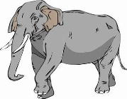 | 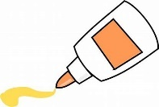 | 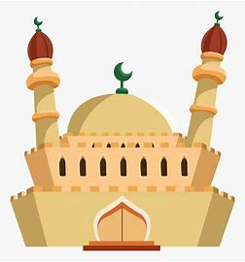
a – blou ( )  b – blue ( ) | a – huge ( )  b – hige ( ) | a – gule ( )  b – glue ( ) | a – mosque ( )  b – mosuqe ( )

انتهت المراجعة مع تمنياتي لكن بالتوفيق معلمة المادة : هاجر محمد آل إبراهيم

