**Unit: 4 (A Healthy life)**

**Question 1: general questions**

1. 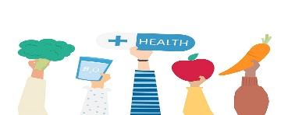**Answer the following questions**



[هذه الصورة](https://freepngimg.com/png/22930-health-clipart) بواسطة كاتب غير معروف مرخصة بالاسم [CC BY-NC](https://creativecommons.org/licenses/by-nc/3.0/)

1. What should you do to be healthy?

…………………………………………………

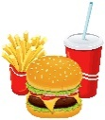

[هذه الصورة](https://medium.com/lifelong-benefits-of-a-plant-based-diet/the-hamburger-coffee-man-550920961b3d) بواسطة كاتب غير معروف مرخصة بالاسم [CC BY](https://creativecommons.org/licenses/by/3.0/)

1. What shouldn’t you do to be healthy?

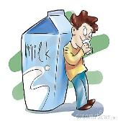…………………………………………………

1. Did you drink milk this morning ?

…………………………………………………..

1. 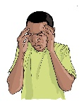What's the matter ?

…………………………………………………….

**Question 2: controlled writing**

1. **Rearrange the sentence:**
2. I / early / should / go to bed /.

………………………………………………………………………………………………..

1. shouldn't / I / breakfast / skip/ .

…………………………………………………………………………………………………..

1. I / can / you / help / ? ………………………………………………………………………………………………..
2. have / I / earache / an / .

…………………………………………………………………………………………………..

1. **Which of the following you should do to live a healthy live :**

1-Get up early

2- Eat too much junk food

3-Brush my teeth

4- Stay up late

**I should ……………………………….. and I should …………………………………**

**Question 3: Reading short sentences**

1. **Read the sentence then choose T (√ ) or F (×)**



1. I have a headache ( )

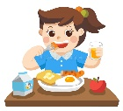

1. I ate breakfast this morning ( )

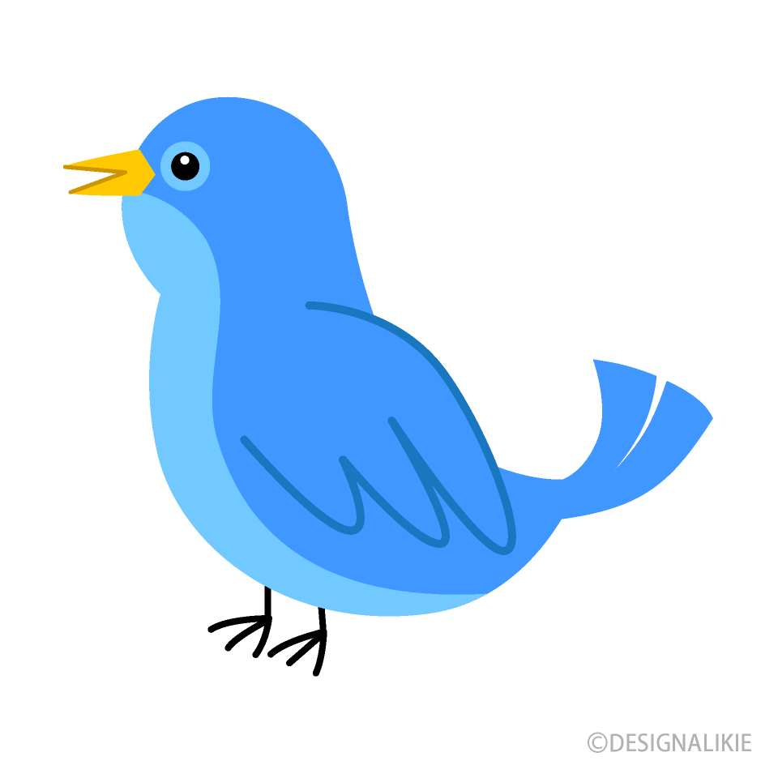

1. I saw a horse in the farm ( )

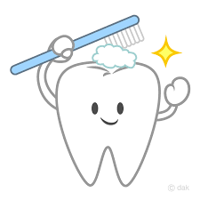

1. I always brush my teeth ( )
2. **Choose the correct answer**
3. I **( should- shouldn’t )** drink a lot of water.
4. I **( should- shouldn’t )** drink too much soda .

**Question 4: spilling**

1. **Choose the missing letters**

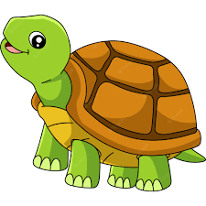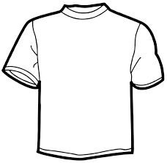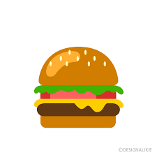

|  |  |  |  |  |  |  |  |
| --- | --- | --- | --- | --- | --- | --- | --- |
| **B………..ger** | | **G…………l** | | **Sh…………..t** | | **T……………tle** | |
| **ir** | **or** | **ir** | **ur** | **ir** | **ur** | **ir** | **ur** |

**Question 5: Vocabulary**

**A - Fill in the blank with the following words :**

**1-Shopping 2- Do exercise 3- Stay up**

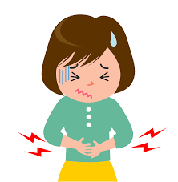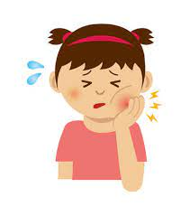**4- Toothache 5-Stomachache**

|  |  |  |  |  |
| --- | --- | --- | --- | --- |
|  |  |  |  |  |

**Question 6: Grammar**

**A-Choose the correct answer :**

1- Did you **(get up – got up )** early this morning ?

2- Did you eat breakfast ? - yes, I **(eat- ate)**breakfast.

3- Did you brush your teeth ? No, I didn’t **(brush – brushed )** my teeth .

**B-Write the past forms of the following :**

1. Play ……………………
2. Get up ……………………
3. Watch …………………...
4. Drink ……………………

إعداد المعلمة: عهود سالم باوزير

مراجعة وتدقيق مشرفة المادة: داليا إبراهيم فرغل