|  |  |  |  |
| --- | --- | --- | --- |
| **المملكة العربية السعودية**  **وزارة التعليم**  **الإدارة العامة للتعليم بـن مدرسة مستقبل ن الابتدائية** | **بسم الله الرحمن الرحيم** **اختبار الفصل الدراسي الثالث**  **للعام الدراسي 1443 هـ**  **https://t.me/abokhaledamer** | **المادة** | **لغة انجليزية** |
| **الصف** | **السادس** |
| **الزمن** | **ساعة ونصف** |
| **الفصل** | **----- /6** |
| **اسم الطالب رباعيا: .............................................................................................................**   |  |  |  |  |  |  |  |  | | --- | --- | --- | --- | --- | --- | --- | --- | | **السؤال** | **1** | **2** | **3** | **4** | **5** | **6** | **المجموع**  **Model Answers نموذج اجابة** | | **الدرجة** |  |  |  |  |  |  |  | | **الدرجة** | 6 | 5 | 4 | 5 | 6 | 4 | 30 | | **المصحح** |  |  |  |  |  |  |  | | | | |

**I- General Questions:**

**6**

**Q1: Answer the following questions correctly:**

**At 7:00**

**1. What time does your school start? -------------------.**

**I should eat healthy food.**

**2. What food should you eat?**  **-------------------------.**

**It's 60 SR**

**3. How much is this sweater? ---------------------- .**

**5**

**II- Controlled Writing:**

**Q2: Do as shown between brackets:**

**1. train - is - the – Where – station? (Rearrange)>**

**Where is the train station?**

**________ ____ _____ ________ ___________?**

**Some water.**

**2. What would you like to drink? (Answer) >. _______________.**

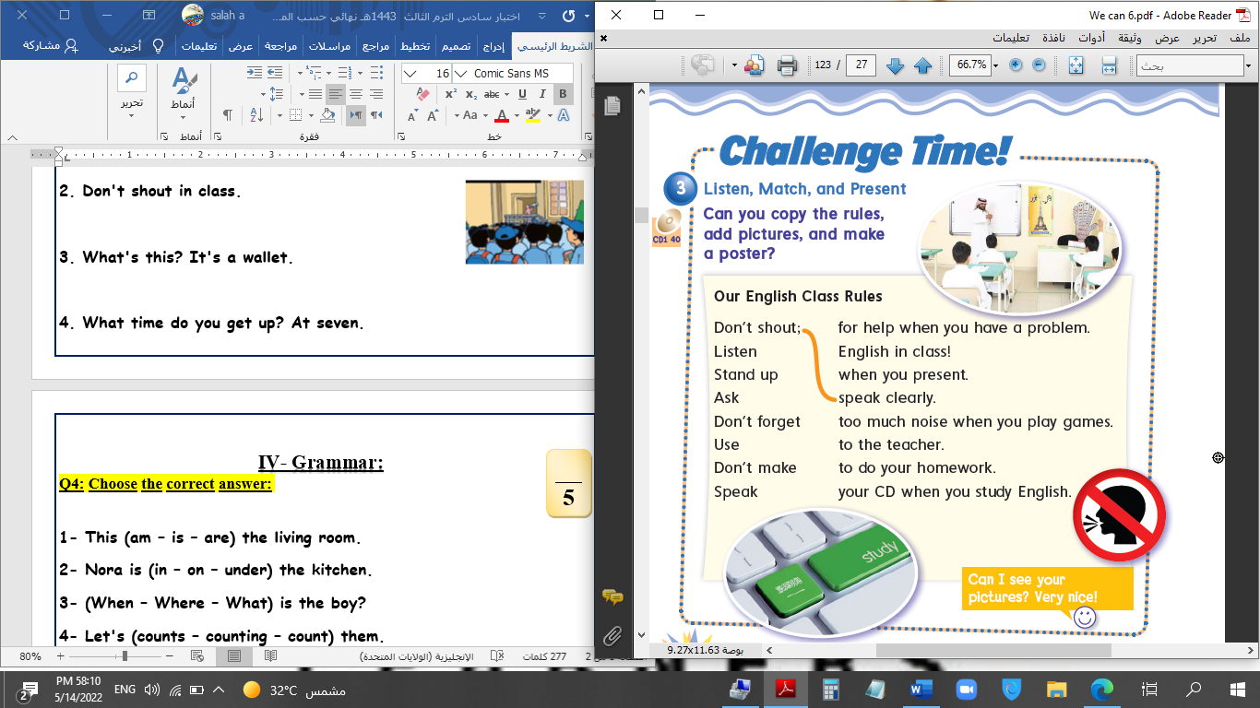**III- Reading Short Sentence:**

**4**

**Q3: Match the sentence with the pictures:**

**1. There are about 300 students.**

**2. Don't shout in class.**

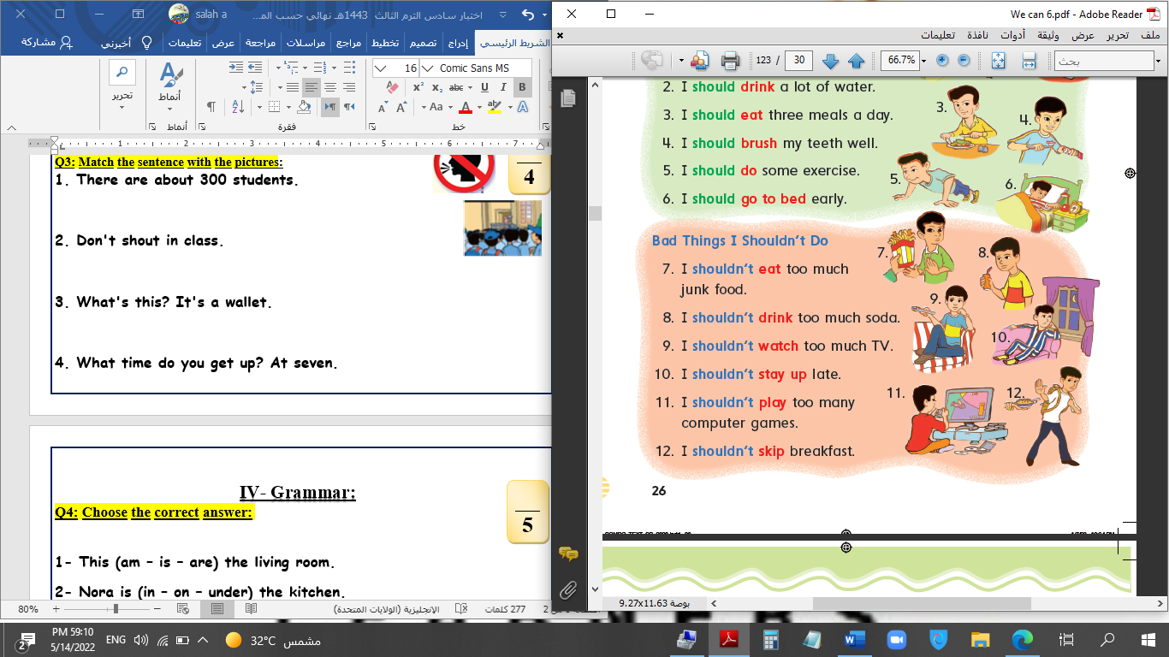**3. You shouldn't eat junk food.**

**4. I have a bad headache.**

**IV- Grammar:**

**5**

**Q4: Choose the correct answer:**

**1- Which city (do – does – did) you live in last year?**

**2- I should (eats – eat – eating) three meals a day.**

**3- He (drink – drinks – drank) three glasses of water yesterday.**

**4- How (long – many – old) does it take to school?**

**5- We (are going – is going – am going) to the bakery.**

**V- Vocabulary:**

**6**

**Q5: Write the number under picture:**

**1.flowers 2.bus stop 3.No bicycles 4.toothache 5.bookstore 6.business**

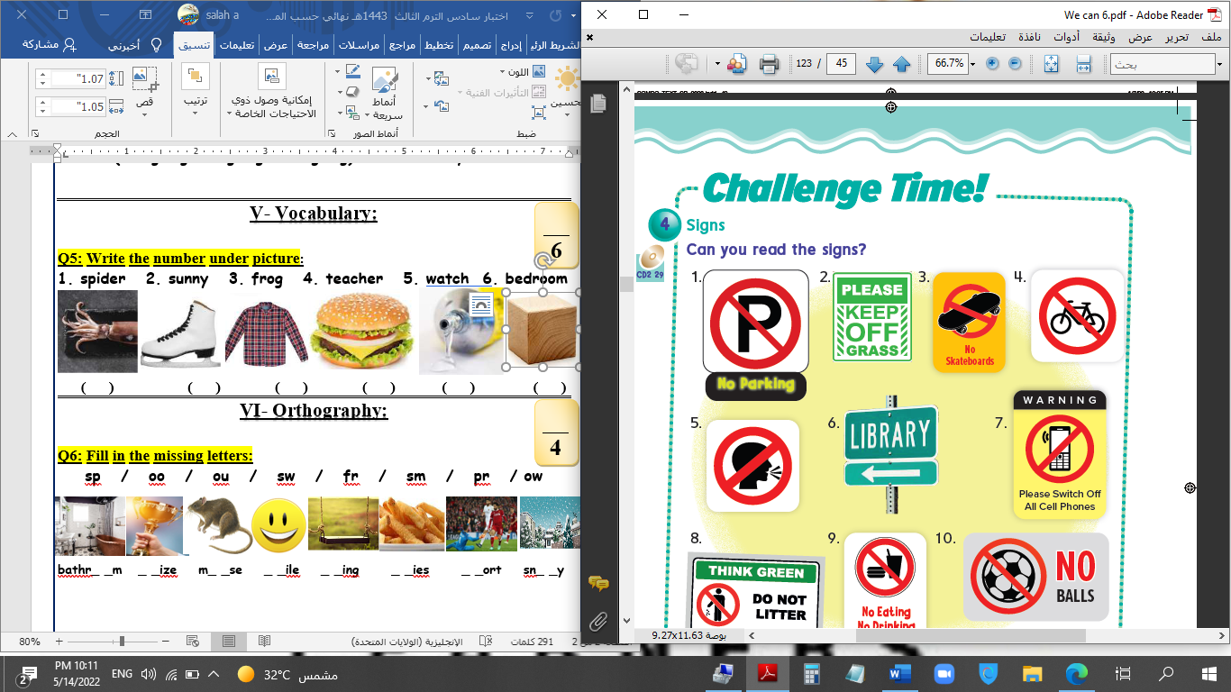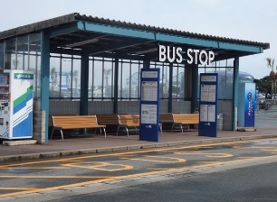****

**( 3 ) ( 6 ) ( 1 ) ( 5 ) ( 2 ) ( 4 )**

**VI- Orthography:**

**4**

**Q6: Fill in the missing letters:**

**ue / u-e / ir / ur / sk / sc / sq / sc**

**sk**

**sc**

**u e**

**ue**

**ur**

**ir**

**sk**

**sq**

**_ _uid _ _ate sh_ _rt b_ _ger gl_ _ c__b_ _ _an _ _y**

**End of Questions**