|  |  |  |
| --- | --- | --- |
| الاسـم :  .................................................................... | السجل المدني:  ..................................................... | رقم الجلوس:  .................................................... |

|  |  |  |  |  |
| --- | --- | --- | --- | --- |
|  |  |  |  |  |
| المصححة |  |  |  |  |
| المدققة |  |  |  |  |

**A: Composition :-** Write a paragraph about [ Things a Roommate should Know About Me **]**

**Guide words :** [ interested – experiment – keep –washing ]

……………….……………………………………………………………………

………………………………………………………………………………………

………………………………………………………………………………………

………………………………………………………………………………………

………………………………………………………………………………………………………………………………………………………………………………

………….…………….…………….……………………………………….…………………………………………………………………………………………………………………………………………………………………………………………………………………………………………………………………………………………………………………………………………………………………………………………………………………………………………………………………………………………………………….………………………………………………………………………………………………………………………………………………………………………………………………………………………………………………………………………………………………………………………………………………................................................................………

[1]

**B] – Multiple Choice**

**- Choose the correct answers :-**

**Grammar:**

**1- we were sitting in the café when a thief………………………….. my bag!**

**a) steal b) stole c) was stealing**

**2- The Computer ……………………….. I bought doesn't work well**

**a) which b) who**

**3- May I speak to the manager? [ agreeing ]**

**a) certainly b) I'm sorry c) that's not possible**

**4-He enjoys ………………………………in the high-tech Computer field .**

**a) work b) working c) to work**

**books that he can hardly carry them . ..................5- He has**

**a) so much b) much c) so many**

**6-Badria Couldn't sleep last night, she………………………….. be tired.**

**a) must b) can't**

**7-If you heat the ice, it……………………………………..**

**a) melt b) melts c) melting**

**8-Sami Would rather.........................coffee than tea .**

**a) drinking b) drank c) drink**

**9-Omar Wishes he ………………………... a car.**

**a) had b) has c) have**

**lo- If they…………………… hard, they would pass the exam .**

**a) study b) studied c) studying**

**11- They decide to……………………………….. hard.**

**a) work b) works c) working**

**12-.................................. TV is a bit boring.**

**a) watch b) watching c) watched**

**13- It's polite to……………………. Please.**

**a) said b) says c) say**

**14- Ahlam had……………………...... to the park.**

**a) go b) went c) gone**

**(2)**

**Vocabulary :**

15- That diamond is not real. It is..............................

a) thief b) fake c) give direction

16- I know you can hear me. Don't.......................you can't !

a) listen b) steal c) pretend

17-You look at Yourself in the…………………………….

a) mirror b) shampoo c) scissors

18- [To cheat] means……………………….

a) to go b) to be dishonest c) sleep

19- [ A ticket ] means…………………………………

a) advantage b) food c) a fine

20-[ homesick ] means………………………………

a) missing home and family b) strange c) failure

**Spelling:**

21-The people who live in the city are always in a hur…..y .

a) c b) r c) k

22- The watches that the man was S.....lling were fakes .

a) e b) h c) n

23- I hate this program. I'm going to turn it of….

a) f b) c c) k

24- Have You taken the garbage o….t yet ?

a) e b) h c) u

25- She leaves the foo……. on the ground.

a) r b) d c) s

26- It rains on the far.........

a) m b) n c) l

27- I am not used to ea…….ing with chopsticks .

a) m b) n c) t

28- we used to wa..….k to school .

a) f b) t c) l

**(3)**

**C- True False :**

**-Reading Comprehension :** Read the passage then answer

Every Thursday, Mr. Saleh goes shopping. He likes to buy things from the supermarket near his house. It is a big supermarket. He buys meat, fruit, milk, and vegetables for the week.

Today, two of his children are going with him, Marram and Basil wants to buy biscuits

For her sister Hanan. Basil wants to buy ice-cream. Basil does not have much money.

He asks his father to give him some money.

**Put true (✓) or False (X) :**

**1- Every Sunday, Mr. Saleh goes shopping. [ ]**

**2- He likes to buy things from the supermarket near his house. [ ]**

**3- It is a small supermarket. [ ]**

**4- Today, two of his children are going with him. [ ]**

**5- Maram wants to buy milk. [ ]**

**6- Basil does not have much money. [ ]**

**D- Matching**

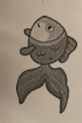**write the correct word under the picture :-**

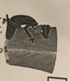 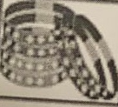

(1)

(4)

(3)

(2)



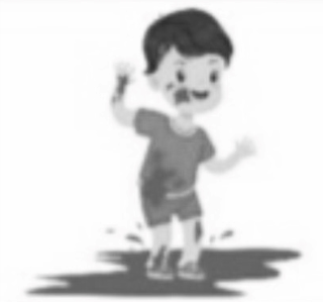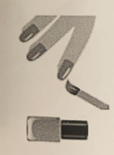.......................................... ...................................... .............................................. ....................................

(7)

(8)

(6)

(5)

…………………………………... …………………………………….. …………………………………… …………………………………..

**A] police officer B] thief C] goldfish D] nail polish**

**E] bracelets F] airshow G] mud H] chopstick**

**(4)**

**Good luck**