

The Final Exam for 3rd Grade
Third Term
First Session
1443 - 1444 AH
Time: Two Hours
Kingdom of Saudi Arabia
Ministry of Education
…………. Educational Directorate
………….. Intermediate School

 | ……………………… | Corrected by
30 | Thirty marks | Total marks

…………………………………………………...…… Seat No.: ……………… : Name

Question No. 1 Composition: Write about "How to prepare a cup of tea" using sequence words:
6
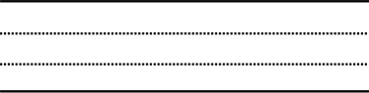
o prepare a cup of tea,
T

- take a cup.
- boil the water.
- wait 3-5 minutes.
- add tea and sugar.
- enjoy it.

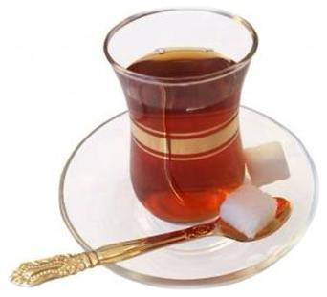

Question No. 2 Reading Comprehension:
6

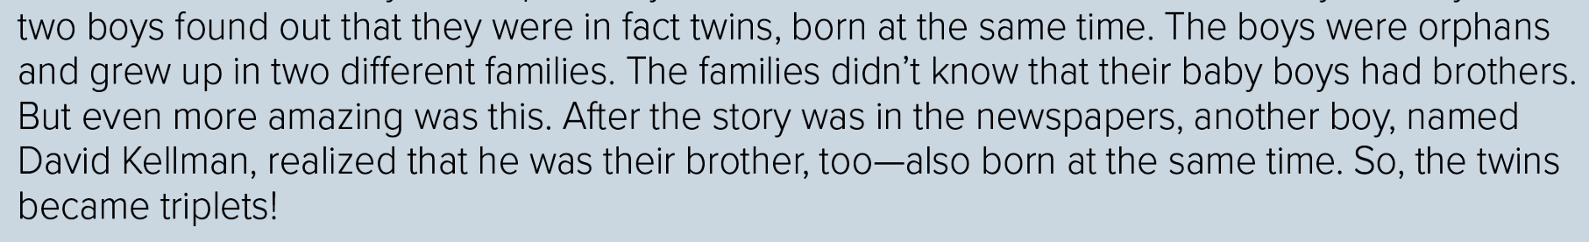

- Put true ( T ) or false ( F ) :

1- The boys were orphans. ( )
2- The story was in books. ( )
3- David Kellman was their father. ( )

Be continued

Question No. 3 (A) Grammar: Do as shown between brackets:
7

1) He has had his car ……………… May. (using for or since)
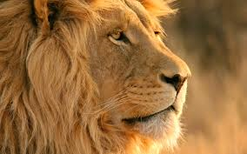
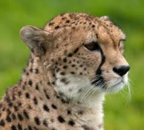

2) Lion/cat/cheetah. (fast)
- Cheetah is ………….. ………………………………… .

3) He isn't student, ………… …………… ? (Question Tags)
4) That …………………… be 90% true. (must or shouldn't)

(B) Vocabulary:
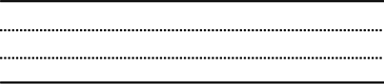


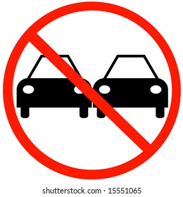
7

invention
GPS
audiences
seat belt
no passing
no parking
danger

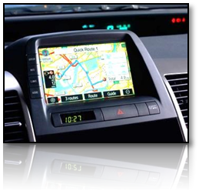





Question No. 4 Orthography (spelling): Write the missing answers:
2
ch - on - at - sh
1- We come to school ……… 7:00 a.m.
2- The students don't study ……….. Friday.
3- ........ina >>>>>>>>
4- refre……. >>>>>>>>

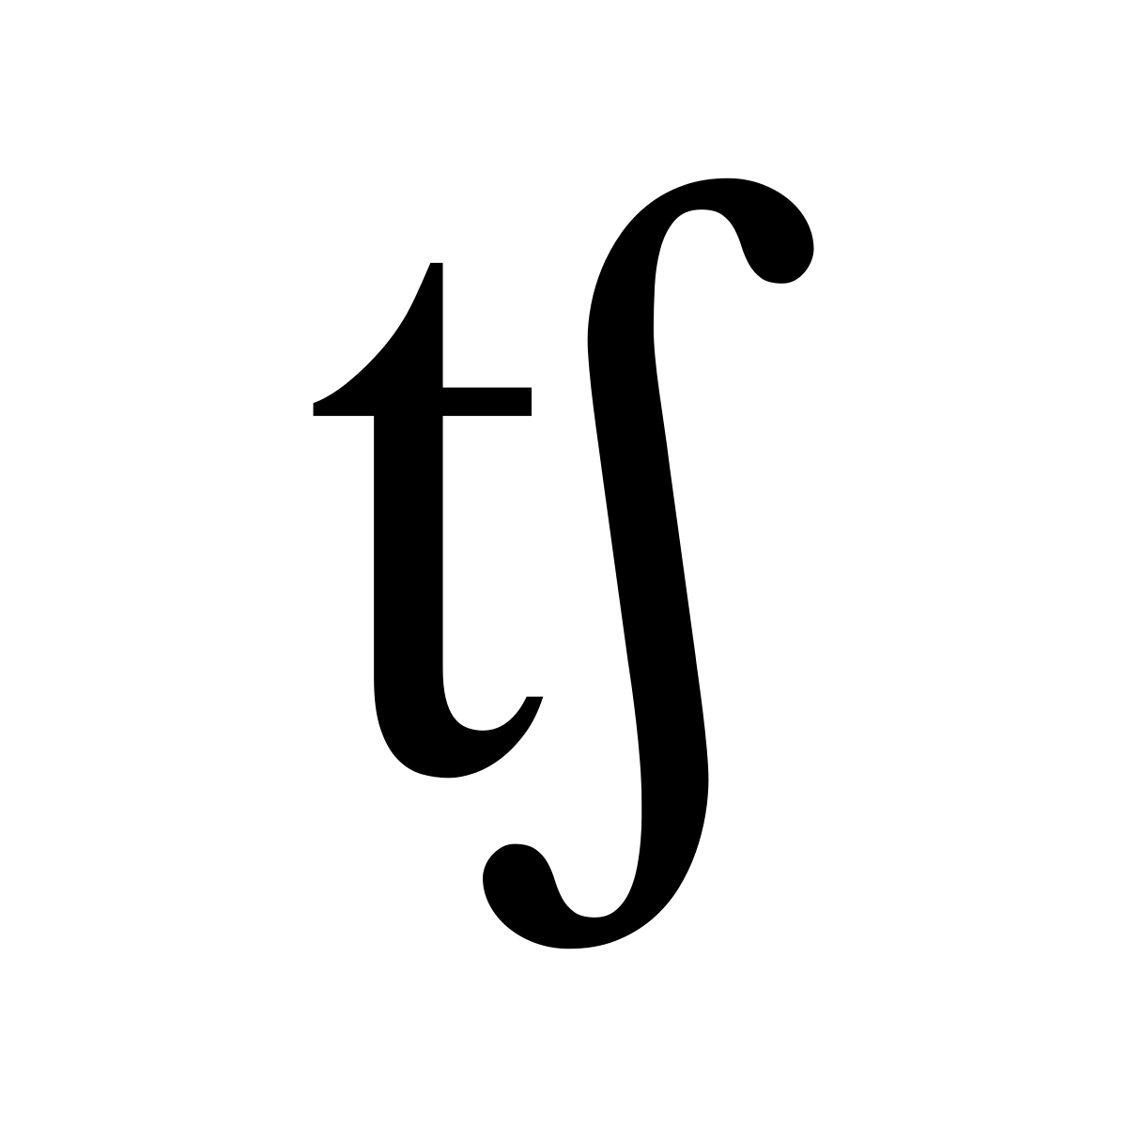

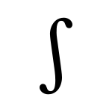

Questions finished

انتهت الاسئلة

