

Vocabulary

- Choose the suitable words:

flyers - realize - prize – hailing a taxi - pocket - tourist

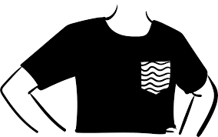

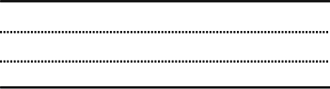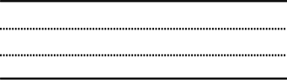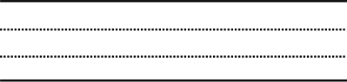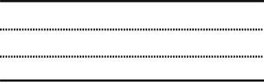





Who said?

1- Yes, thank you. They look delicious.

2- I have to leave early. Thanks for inviting me.

3- Now, smile everyone. Say "cheese".

4- What a beautiful painting! What inspired you?

5- Well, nature has always been an inspiration in my work.

6- Would you like to try one of these?

7- Oh, I'm terribly sorry.

8- As Mayor, it is my pleasure to support the talent of new artists.



Application



**Defining relative clause :**

We use : which with things

who with people

where with places

when with times

* we can use **that** instead of **who** and **which**

**\* Choose the correct answers:**

**a-** The university is a building **( which – who – where – when )** students study there.

**b-** A football is a game **( which – who – where – when )** many people play.

**c-** Biology is a subject **( which – who – where – when )** deals with knowledge of life on earth.

**d-** The journalist is a person **( which – who – where – when )** works in journalism to reports news.

**e-** Ramadan is a month **( which – who – where – when )** Muslims are fasting.

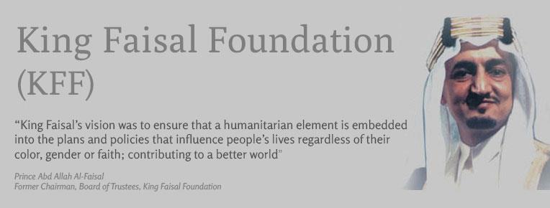

**The king Faisal International Prizes**

The King Faisal Foundation is a huge humanitarian foundation,

which was set up by King Faisal's sons in 1976. It does a lot of

charitable work and one of its aims is to recognize and reward

people who have worked hard to improve humanity and society.

5

These are men and women whose contributions make a positive difference. Prizes have been awarded each year since 1979. They are called The King Faisal International Prizes and go to outstanding people in a number of different areas of life. These Prizes are for good work in the service of Islam, Islamic studies, Arabic Language and Literature, science and medicine . Money is included in the prizes , but they are not just money. The winners also receive a certificate and a gold medal. The certificate is special because it is handwritten in Diwani calligraphy and the gold medals are also unique, as each one is made in a different way. Of course, there is also great prestige in winning these prizes and all of them are presented to winners by the King of Saudi Arabia.

15

10