4
I- Composition:
Write about a choice that you want to make in the future and why you decided to make this choice.
( student / future / study / decided / because / nowadays / improve / hard )
………………………………………………………………………………………………………………………………………………………………………………………………………………………………………………………………………………………………………………………………………………………………………………………………………………………………………………………………………………………………………………………………………………………………………………………………………………………………………………………………………………………………………………………………………………………………………………………………………………………………………………………………………………………………………………………
………………………………………………………………………………………………….

6
II-Comprehension:
Read the following passage then answer the questions :
Khalid Al-Eid is a famous Saudi horseman. He is a member of the Saudi Equestrian Team and travels around the world to compete in showjumping events.
Khalid was born on January 2, 1969. His family has a long tradition of horse riding, and they own stables with Arabian horses near Riyadh. He was ten years old when he first learned to ride with his father. Khalid was a very talented young rider.
A: Answer the following question:
1- When was Khalid born?
……………………………………………….
B: Choose the correct answer:
1- Khalid Al-Eid is a famous Saudi ( businessman / horseman / doctor ).

2- He is a member of the Saudi ( Equestrian / basketball / football ) Team

C: Check the following sentences with ( T ) for true or ( F ) for false :

- His family has a long tradition of horse riding. ( )

- He was five years old when he first learned to ride. ( )
- Khalid was a very talented young rider. ( )
2
9
III-Grammar
A- Choose the right answers.

1- The man ( who / which ) was talking to the tourist was friendly.

2- Have you done the dishes ( yet / already / just ) ?

3- Sara couldn’t sleep last night. She ( can’t / must ) be tired.

4- They wish they ( have / having / had ) more time.

5- She tried ( to sleep / sleeping / sleeps ) on the plane.

6- ( Travel / Travelling ) is a good way to learn about other cultures.

7- I’d rather ( live / lived ) in the country

B- Do as shown between brackets:
“ Rewrite the sentence with a two-word verb in two ways “
1- Turn down the TV.

………………………………………….

2- Can I ask you a question ? “ Agree “

………………………………………………………
***********************************************************
9
VI – Vocabulary:
A- Match:

1- Of course a- phone
2- Call up b- to answer yes in a strong way
3- talkative c- nice
4- friendly d- talk all the time
5- homesick e- return
6- give back f- missing home and family
3

B- Write the correct word under the correct picture :
( toothpaste / lazy / dishwashing liquid / skyscrapers / nail polish / hardworking)

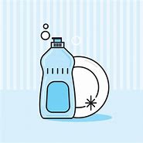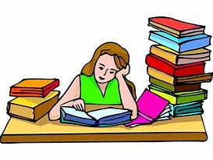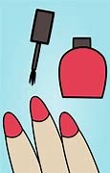

…………………………………………………………………………………………………………………………………………………………………………………………..

2
V- Orthography
Give the missing letters
( m , p , sh , f )

1- …...eople 2- …...ust

3- …..ock 4- …unny
4
Best Wishes
T. Jawaher

