***A)-. Each country has its own culture, use the following phrases to write about some customs***

صورة تحتوي على طعام, طبق, خارجي, صحن

تم إنشاء الوصف تلقائياً***In Saudi Arabia,***

Page 1

Page 1

a-is a famous traditional dish

b-people are generous

c-use incenses in different occasions

صورة تحتوي على ثياب, بدلة

تم إنشاء الوصف تلقائياً

d-wear white thobe and ghotra

e- wear abaya

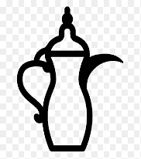

f- Saudi coffee with dates

Each country has its own culture. In Saudi Arabia,(1)………………………. People (2)…………………………. Kabsah is (3)……………………. Men (4)…………………………. Women (5)…………………. People drink(6)……………………………