
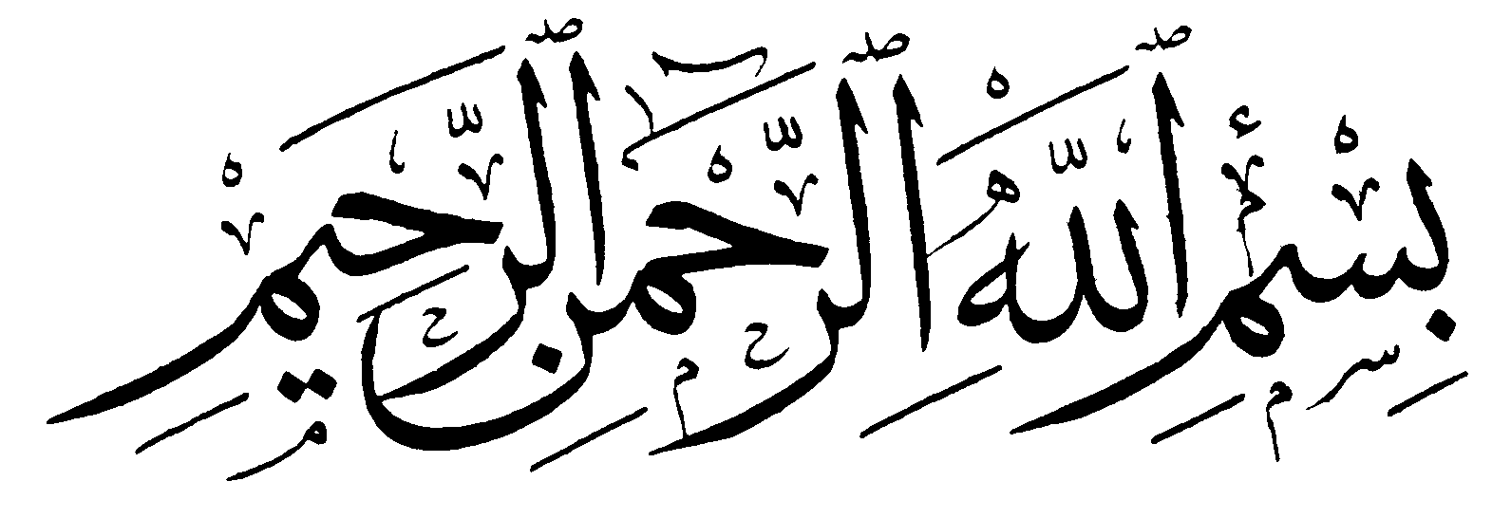

مدرسة ..............................

الفصل الدراسي : الأول | العام الدراسي : 1440/1441هـ

أوراق عمل مادة

للصف الرابع الابتدائي

معلم المادة | المشرف التربوي | قائد المدرسة
............................ | ............................ | ............................


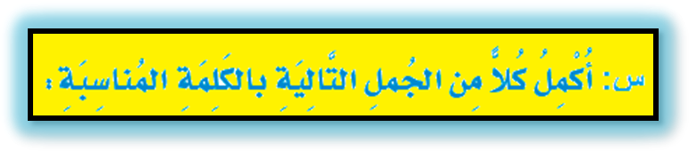
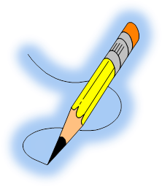

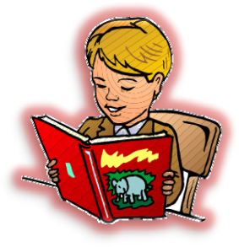
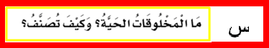
.............................................................................................................................................................................................................................................................................................................................................................................................................................................................................................................................................................
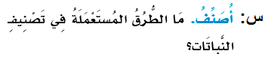

...............................................................................................................................................................................................................................................................................................................................

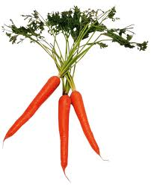

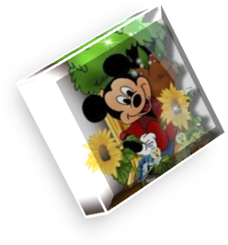


(الْجَهَازِ الْهضميِّ -- هَيْكَلٌ خَارِجيٌّ – الجهاز الهضميال الجهاز العصبي – الزواحف – الفقاريات – اللافقاريات).




