



Super Goal2 Note book

2nd intermediate Grade

Student name:………………………………………………………………

School:…………………………………………………………….………….

Class:……………………………………………………………………………

Teacher's name:……………………………………………………..........

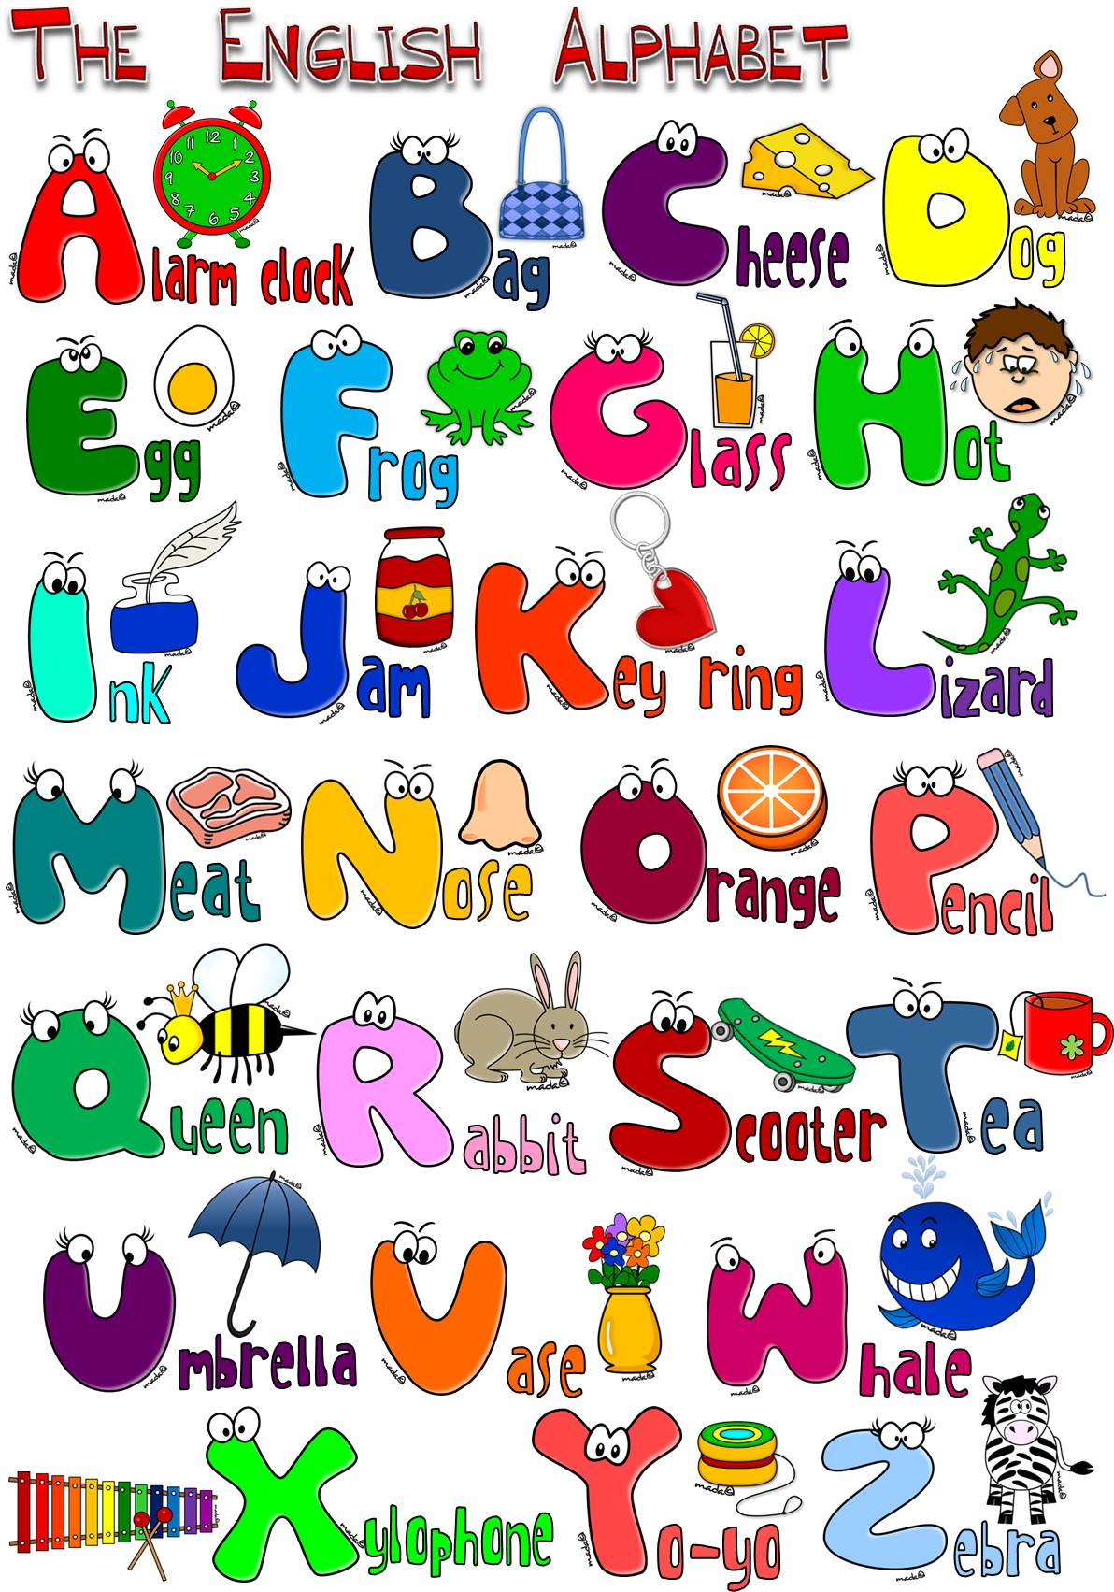

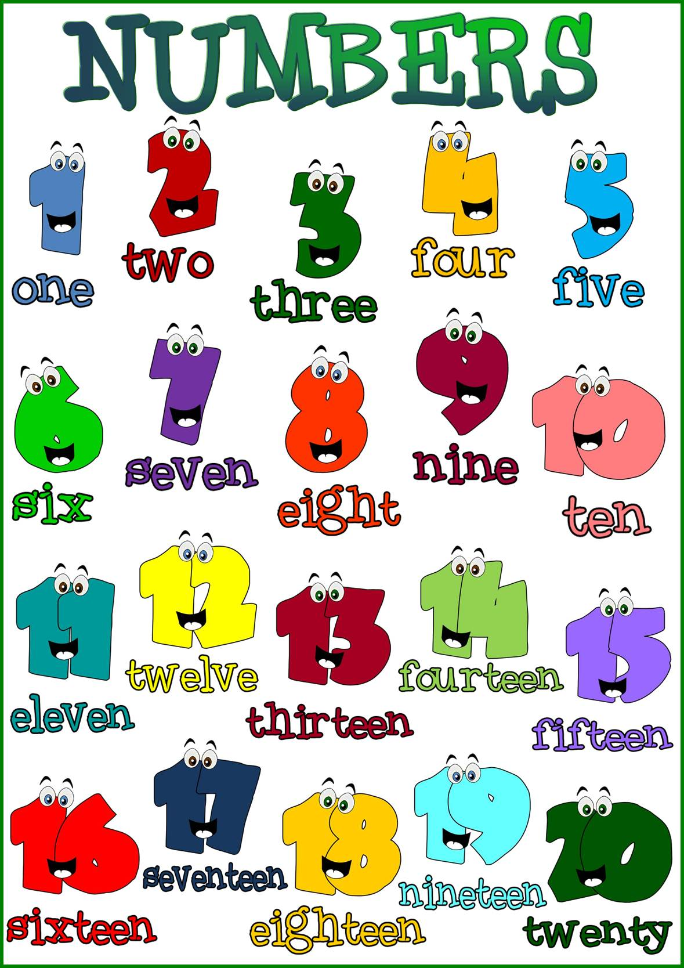

**A1 Listen & Discuss**

Date: \ \14

**New Vocabulary:**

|  |  |  |  |
| --- | --- | --- | --- |
| **Words** | **Kind** | **Meaning** | **Examples** |
|  |  |  |  |
|  |  |  |  |
|  |  |  |  |
|  |  |  |  |
|  |  |  |  |
|  |  |  |  |
|  |  |  |  |
|  |  |  |  |
|  |  |  |  |
|  |  |  |  |
|  |  |  |  |
|  |  |  |  |
|  |  |  |  |
|  |  |  |  |

Greeting and Introduction

*Greeting: *Goodbyes:

Hello,……..\ Hi,……….. Good bye \Bye\See you later

Good morning\ Good afternoon \ Good evening See you soon nice to meet you again

I'm glad\ I'm happy\ I'm pleased to see you

|  |
| --- |
| How are you? - I'm Fine, thanks. And you? |
| How have you been? _Very well. And you? |

|  |
| --- |
| **Study tool box** |
| Expressions to introduce yourself:   * My name is ………………… * I'm …………………….. * Let,s me introduce myself,I'm ………….. * I'd like to introduce myself; I'm ……………. * Nice to meet you. * Pleased to meet you. |

**\*classify the following items under the correct column:**

[ good morning – bye – see you later – good evening – sunshine]

|  |  |
| --- | --- |
| Greeting | Good bye |
|  |  |
|  |  |

**Grammar**

Date: \ \14

C:\Program Files (x86)\Microsoft Office\MEDIA\CAGCAT10\j0299125.wmf

Verb to be:

|  |  |  |
| --- | --- | --- |
| **Short form** | | |
| He's  She's  He's  Is not  Are not | They're  We're  You're  Isn't  Aren't | I'm |

|  |  |  |
| --- | --- | --- |
| **Verb To Be** | | |
| is | are | am |
| He  she  th.jpgHe | they  we  you | I |

The short forms with apostrophes (**‘**) are contractions

Examples:

----------------------------------------------------

*Information questions :

|  |
| --- |
|  |
|  |

**\*Choose the correct answer:**

1-It [ are – is – am ] a cute cat.

2-My father [ am – are – is ] a taxi driver.

3-We [ are – is – am ] good friends.

4-David [ are – am – is ] our family doctor.

5-My grandparents [ is – are – am ] old.

6-Sara and I [ are – am – is ] happy.

7-[ she – they – I ] am hunger.

th (1).jpgAACtivity:

Ask about the underlined words:

1- I am 16 years old.

…………………………………………….?

2- They are students .

……………………………………………..?

*Do as shown between brackets:

1-The chair [ be ] brown. [ write the correct verb to be ]

----------------------------------------------------------

2-The sky ------ full of stars. [Complete with the suitable verb to be]

3-Tomi and Rani [ be ] pupils . [ write the correct verb to be ]

----------------------------------------------------------

4-a\she is -------- b\ I am ------------ [ Give the short form]

Date: \ \14

**about you**

Personal Information Questions

Read the following in column A and match them with the right answer in column B:

|  |
| --- |
| 1-What 's your first name?  2-What's your last name?  3-What's your full name?  4-How old are you?  5-Where are you from?  6-Where do you live?  7-What do you do?  8-what's your nationality?  9-What's your e-mail?  10-What's your phone number? |

|  |
| --- |
| ( )I am from ……………  ( )I am ………. Years old.  ( ) My first name………  ( )My full name is ……………………………  ( ) I live in …………….  ( ) My phone number is ……………..  ( ) My nationality is ………….  ( ) I am a ………………………….  ( ) My e-mail is ………………….  ( ) My last name is ……………….. |

Column A Column B

**complete the following conversation:**

**I am here for ………..**

**What is the purpose of your trip?**

**How long are you staying?**

**I am staying for………**

**I will stay ……………………….….. ……………………** ………………….

**What is your address in this country ?**

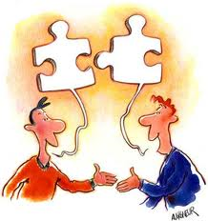

**Conversation**

Date: \ \14

**New Vocabulary:**

|  |  |  |  |
| --- | --- | --- | --- |
| **Words** | **Kind** | **Meaning** | **Examples** |
|  |  |  |  |
|  |  |  |  |
|  |  |  |  |
|  |  |  |  |
|  |  |  |  |
|  |  |  |  |
|  |  |  |  |
|  |  |  |  |

Answer these questions from the conversation:

1. Where are the people in the picture?

................................................................................................

2-Where is Ibrahim last name ?

……………………………………………………………………………………………..

3-What is his room number?

…………………………………………………………………………………………..

******************************************************************************

**Reading**

Date: \ \14

**New Vocabulary:**

|  |  |  |  |
| --- | --- | --- | --- |
| **Words** | **Kind** | **Meaning** | **Examples** |
|  |  |  |  |
|  |  |  |  |
|  |  |  |  |
|  |  |  |  |
|  |  |  |  |
|  |  |  |  |
|  |  |  |  |
|  |  |  |  |
|  |  |  |  |

**Reading Questions:**

1-What does S.A.Y.H.A mean ?

……………………………………………………………………….

2-Is there a youth hostel in your town ?

……………………………………………………………………..

3-How many youth hostels are there around the world?

………………………………………………………………………

{{{{{{{

**9 Writing**

Date: \ \14

Use Can / Could/ May politely ask

a question



Formal Language

* Reservation
* Make requests



Answer the questions in your pupil book page ( 8 ). Make a paragraph from these answers:

…………………………………………………..

……………………………………………………………………………………………………………………………………………………………………………………………………………………………………………………………………………………………………………………………………………………………………………………………………………………………………………………………………………………………………………………………………………………………………………………………………………………………………………………………………………………………………………………………………………………………………………………………………………………………………………………………………………………………………………………………………………………………………………………………………………………………………………………………………………………………………………………………………

**Rules of writing**

*Write the title with capital letters and underlined

*Leave a space of five letter in the beginning of the paragraph.

*End each sentence with a full stop.

*Start the new sentence with a capital letter

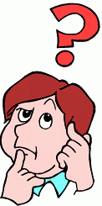

**project**

Date: \ \14

**Make a list of prepositions of place :**

Project ideas Your plane

Resources needed Assessment

( equipment – materials )

**During project End of project**

Reflection Methods ( individual – group – whole class)

Date: \ \14

**11 Form , Meaning and Function**

Match the pictures and the sentences .

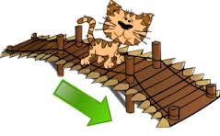

[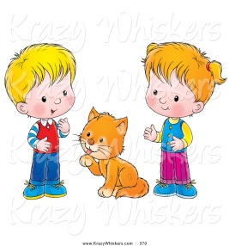](http://www.mycutegraphics.com/graphics/school/supplies/orange-calculator.html)

The bear is near the tree.

The boy is next to the snowman

[](http://www.mycutegraphics.com/graphics/school/supplies/purple-pen.html)

[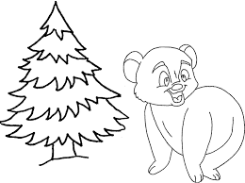](http://www.mycutegraphics.com/graphics/school/supplies/cartoon-ruler.html)

The cat is between the boys .

The cat is across from the bridge .

[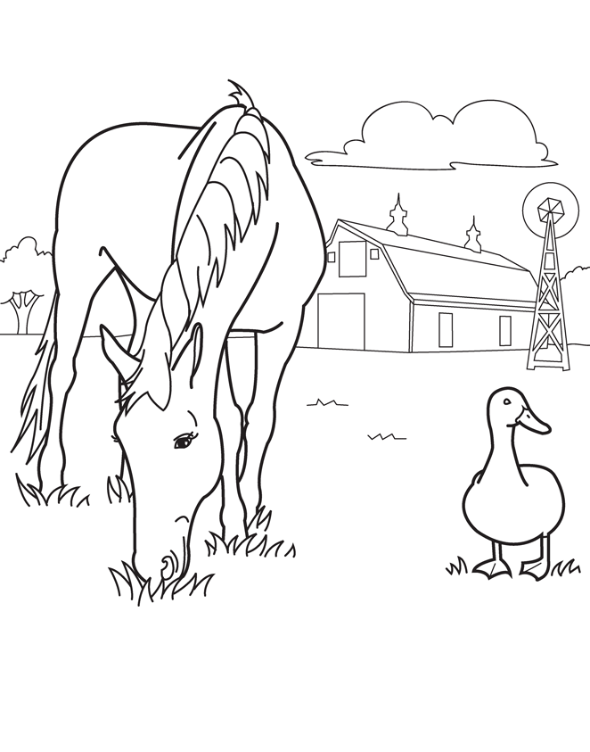](http://www.mycutegraphics.com/graphics/school/pink-pencil-sharpener.html)

[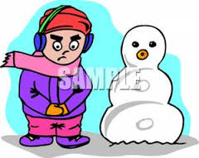](http://www.mycutegraphics.com/graphics/school/supplies/mechanical-pencil.html)

The mouse is on the box .

The house is far from the animals .



**A1 Listen & Discuss**

Date: \ \14

**New Vocabulary**::

|  |  |  |  |
| --- | --- | --- | --- |
| **Words** | **Kind** | **Meaning** | **Examples** |
|  |  |  |  |
|  |  |  |  |
|  |  |  |  |
|  |  |  |  |
|  |  |  |  |
|  |  |  |  |
|  |  |  |  |
|  |  |  |  |

Do you like to watch films ?

………………………………………………………………………….

What is wrong in the picture ?

…………………………………………………………………………

Note:

Date: \ \14

**2 Grammar**

*Present progressive:

|  |
| --- |
|  |

th.jpg

p.s:

Don't add ing to the following verbs :

Like , love , want , see , smell , taste , hear

**Activity .**

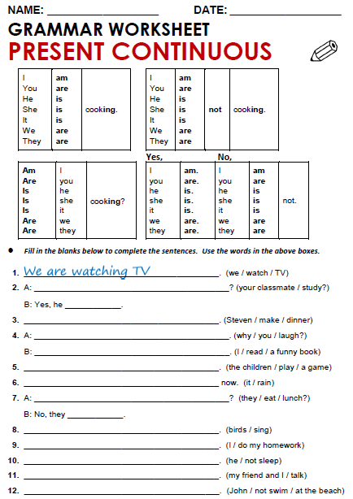

**conversation**

Date: \ \14

**New Vocabulary:**

|  |  |  |  |
| --- | --- | --- | --- |
| **Words** | **Kind** | **Meaning** | **Examples** |
|  |  |  |  |
|  |  |  |  |
|  |  |  |  |
|  |  |  |  |
|  |  |  |  |
|  |  |  |  |
|  |  |  |  |
|  |  |  |  |

1-Match the words with its meaning:

|  |  |  |
| --- | --- | --- |
| A |  | B |
| So |  | With no one else's help |
| All by myself |  | A strong no answer . |
| Not at all |  | A way to start a new topic in a conversation |

2-Write the correct word under each picture:

[ scene - martial arts - location ]

1-……………………… 2-………………………

**Reading**

Date: \ \14

**New Vocabulary:**

|  |  |  |  |
| --- | --- | --- | --- |
| **Words** | **Kind** | **Meaning** | **Examples** |
|  |  |  |  |
|  |  |  |  |
|  |  |  |  |
|  |  |  |  |
|  |  |  |  |
|  |  |  |  |
|  |  |  |  |
|  |  |  |  |
|  |  |  |  |

*1***-Answer the following questions :**

**What do you know about web videos and e- learning ?**

……………………………………………………………………………………………

**writing riting**

Date: \ \14

**Writing corner**

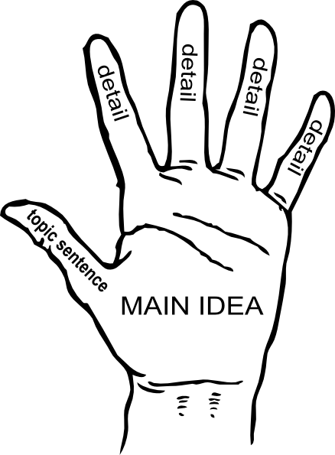

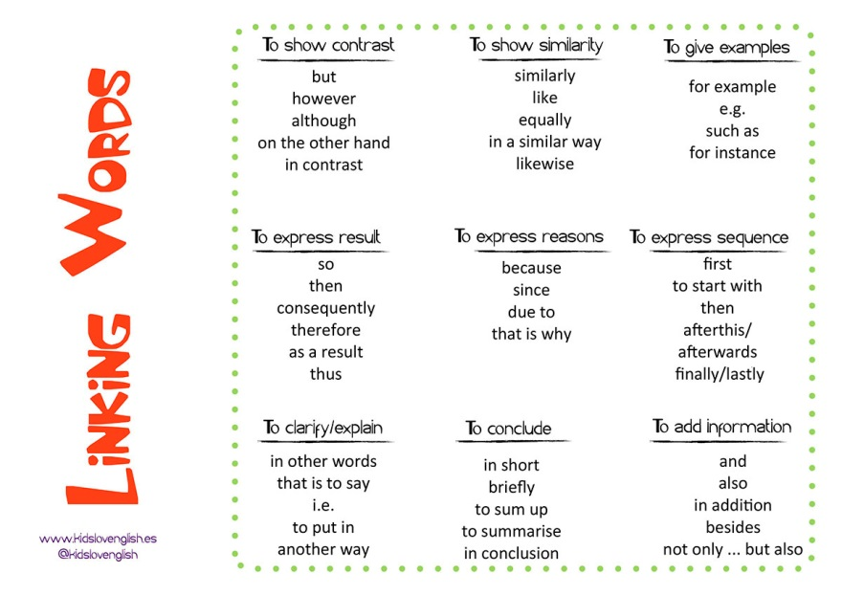.

**write a paragraph about Using internet for learning using the chart on page 16** :

……………………………………………..

…………………………………………………………………………………………………………………………………………………………………………………………………………………………………………………………………………………………………………………………………………………………………………………………………………………………………………………………………………………………………………………………………………………………………………………………………………………………………………………………………………………………………………………………………………………………………………………………………………………………………………………………………………………………………………………………………………………………………………………………………………………………………………………………………………………………………………………………………………………………………………………………………………………………………………………………………………………………………………………………………………………………………………………………………………………………………………………………………………………………..…………………………………………………………………………………………………………………………………………………………………………………………………………………………..

Date: \ \14

**project**

**Write a short comic :**

Date: \ \14

**Form, Meaning and Function**

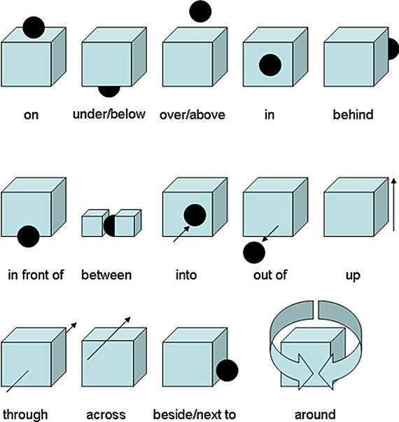

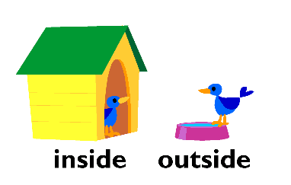

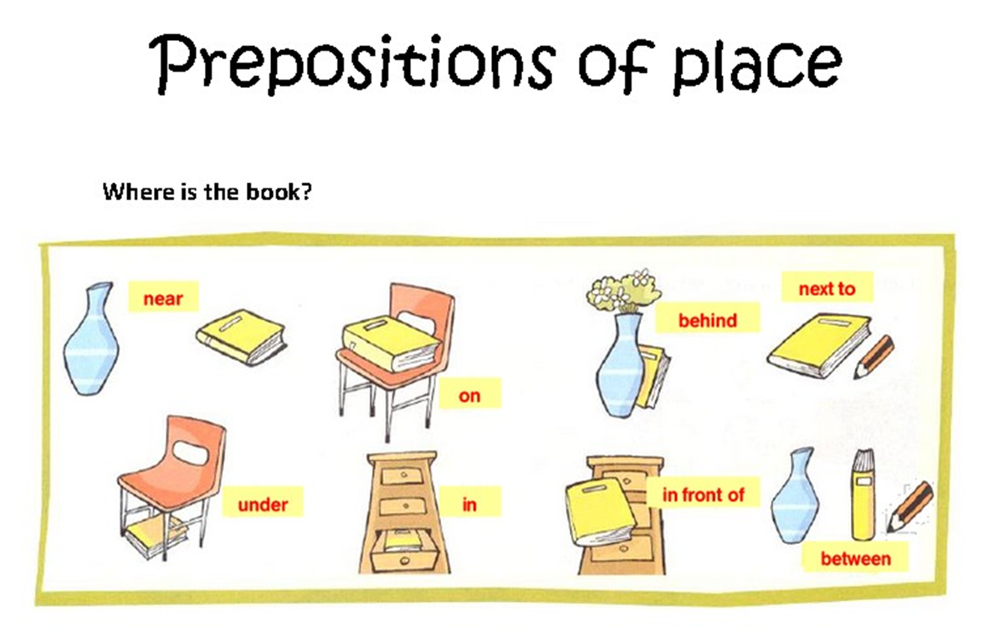

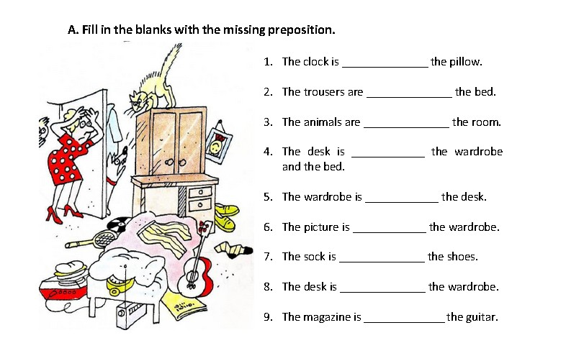

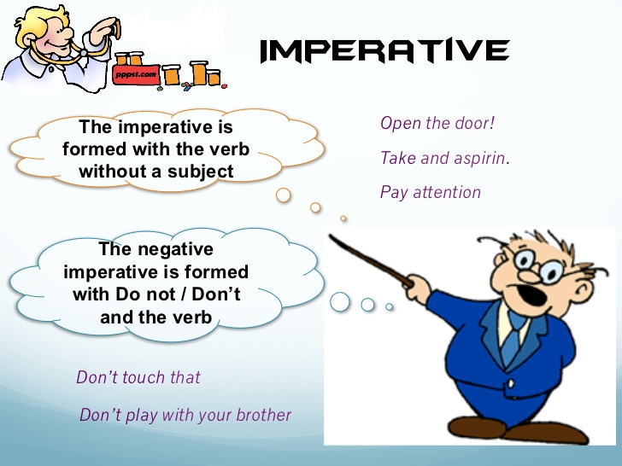

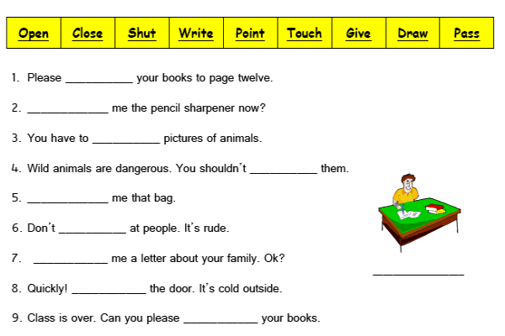

**1 Listen and Discuss**

Date: \ \14

**New Vocabulary:**

|  |  |  |  |
| --- | --- | --- | --- |
| **Words** | **Kind** | **Meaning** | **Examples** |
|  |  |  |  |
|  |  |  |  |
|  |  |  |  |
|  |  |  |  |
|  |  |  |  |
|  |  |  |  |
|  |  |  |  |
|  |  |  |  |
|  |  |  |  |
|  |  |  |  |
|  |  |  |  |
|  |  |  |  |
|  |  |  |  |

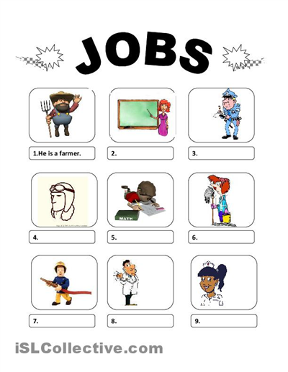

**Grammar**

Date: \ \14

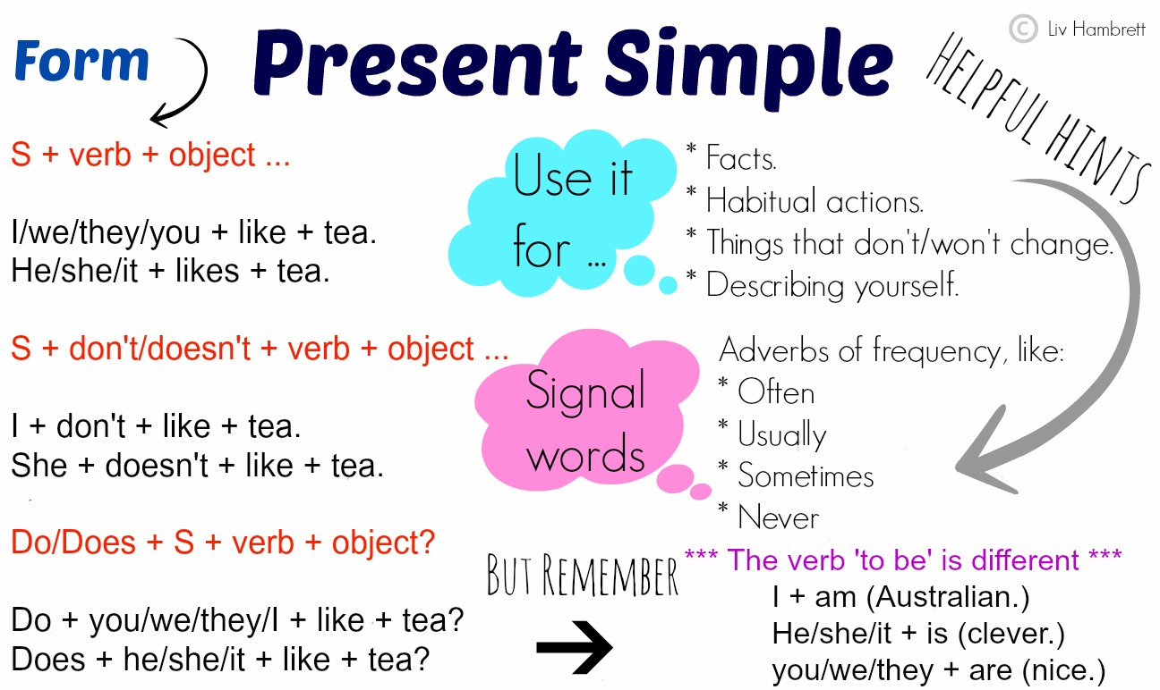

**:**

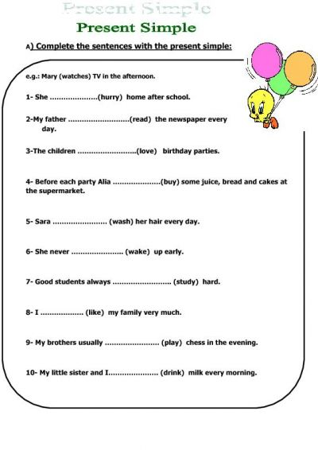

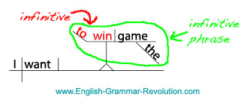

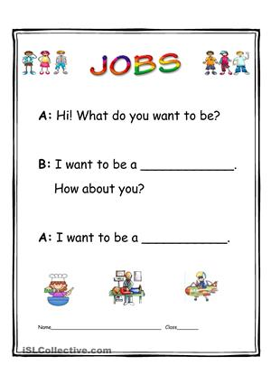

**about you**

Date: \ \14

What do you think are interesting jobs? Bad jobs ?

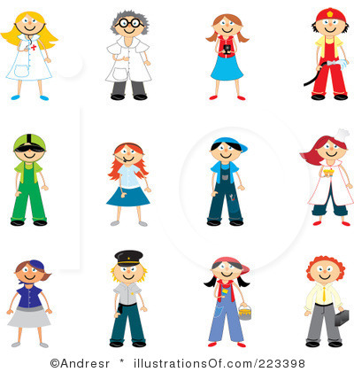

**7 conversation**

Date: \ \14

**New Vocabulary:**

|  |  |  |  |
| --- | --- | --- | --- |
| **Words** | **Kind** | **Meaning** | **Examples** |
|  |  |  |  |
|  |  |  |  |
|  |  |  |  |
|  |  |  |  |
|  |  |  |  |
|  |  |  |  |
|  |  |  |  |
|  |  |  |  |
|  |  |  |  |

**Questions about the conversationn:**

1- What does David's father do ?

………………………………………………………………………………….

2- What does Ross father's do ?

………………………………………………………………………………….

Date: \ \14

**Reading**

**New Vocabulary:**

|  |  |  |  |
| --- | --- | --- | --- |
| **Words** | **Kind** | **Meaning** | **Examples** |
|  |  |  |  |
|  |  |  |  |
|  |  |  |  |
|  |  |  |  |
|  |  |  |  |
|  |  |  |  |

**Write the correct word under each picture:**

**[ Moon -spacecraft – Pinter – heart – submarine ]**

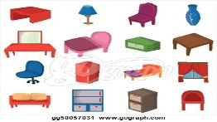

1-……………………………….. 2-………………………………… .. 3-……………………………

Date: \ \14

**Writing**

**Write about your Dream Job . Use your notes from the chart in A and ideas from this unit.**

**Use the connectors : and , but , because .**

………………………………………………………………………………………………………………………………………………………………………………………………………………………………………………………………………………………………………………………………………………………………………………………………………………………………………………………………………………………………………………………………………………………………………………………………………………………………………………………………………………………………………………………………………………………………………………………………………………………………………………………………………………………………………………………………………………………………………………………………………………………………………………………………………………………………………………………………………………………………………………………………………………………………………………………………………………………………………………………………………………………………………………………………………………………………………………………………………………………………………………………………………………………………………………………………………………………………………………………………………………………………………………………………………………………………………………………………………………………………………………………………………………………………………………………………………………………………………………………………………………………………………………………………………………………………………………………

………………………………………………………………………………………………………………………………………………………………………………………………………………………………………………………………………………………………………………………………………………………………………………………………………………………………………………………………………………………………………………………………………………………………………………………………………………………………………………………………………………………………………………………………………………………………………………………………………………………………………………………………………………………………………………………………………………………………………………………………………………………………………………………………………………………………………………………………………………………………………………………………………………………………………………………………………………………………………………………………………………………………………………………………………………………………………………………………………………………………………………………………………………………………………………………………………………………………………………………………………………………………………………………………………………………………………………………………………………………………………………………………………………………………………………………………………………………………………………………………………………………………………………………………………………………………………………………

**Project**

Date: \ \14

**Work and try to collect some pictures about different occupations outside of class and write a short summary about it:**

…………………………

…………………………………………………………………………………………………………………………………………………………………………………………………………………………………………………………………………………………………………………………………………………………………………………………………………………………………………………………………………………..

…………………………

……………………………..

……………………………………………………………………………………………………………………………………………………………………………………………………………………………………………………………………………………………………………………………………………………………………………………………………………………………………………………………….........................................

Picture

Picture

………………………………….

……………………………………………………………………………………………………………………………………………………………………………………………………………………………………………………………………………………………………………………………………………………………………………………………………………………………………………………………………………………………………………………………….

………………………………

…………………………………………………………………………………………………………………………………………………………………………………………………………………………………………………………………………………………………………………………………………………………………………………………………………………………………………………………………………………………………………………………………………………………………………………………..

Picture

Picture

**Form, Meaning & Function**

Date: \ \14

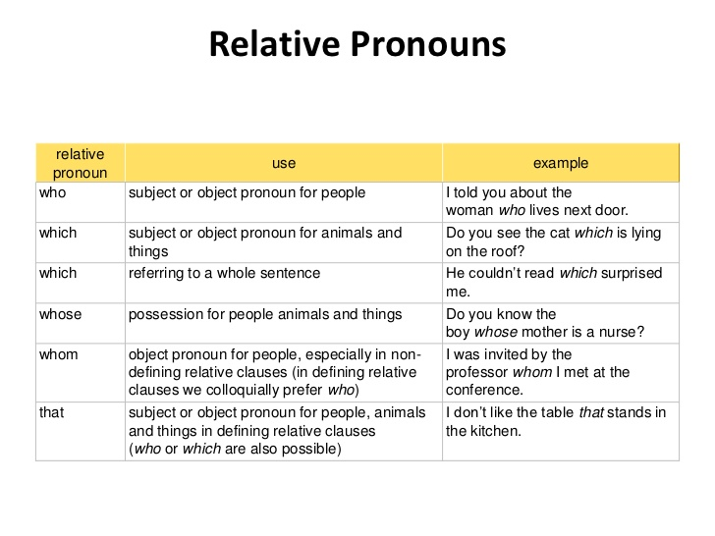

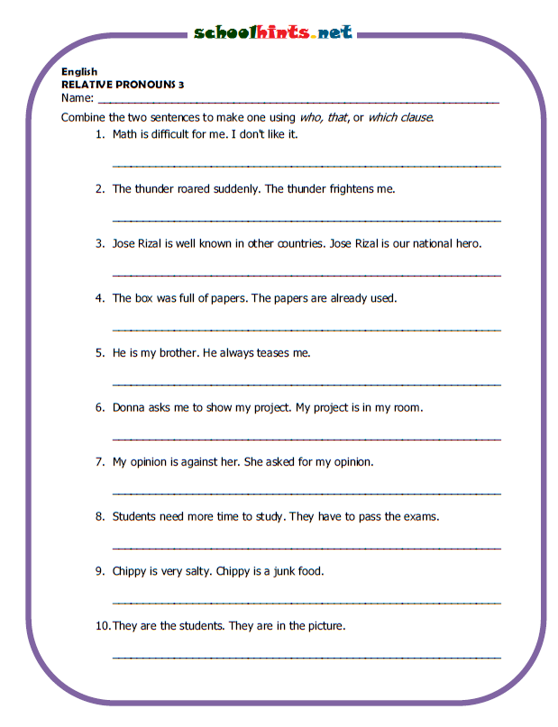



Date: \ \14

**1 listen & discuss**

**" و عن شبابه فيما أفناه "**

**New Vocabulary:**

|  |  |  |  |
| --- | --- | --- | --- |
| **Words** | **Kind** | **Meaning** | **Examples** |
|  |  |  |  |
|  |  |  |  |
|  |  |  |  |
|  |  |  |  |
|  |  |  |  |
|  |  |  |  |
|  |  |  |  |
|  |  |  |  |
|  |  |  |  |
|  |  |  |  |
|  |  |  |  |
|  |  |  |  |
|  |  |  |  |

**Draw and color the activity :**

1.

1-work out 2. Play hockey 3. Reading

**Write the correct word under each picture:**

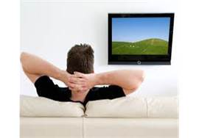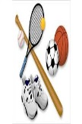[watch TV – ride a horse – rollerblade – workout - surf the internet – ride a bike - reading ]



1-…………………… 2-………………………… 3-…………………………. 4-……………………… 5-……………………… 6-…………………..

Date: \ \14

**Grammar**

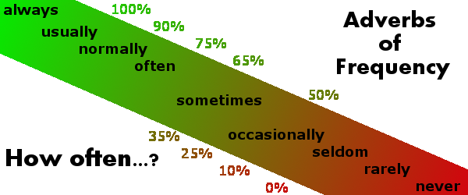

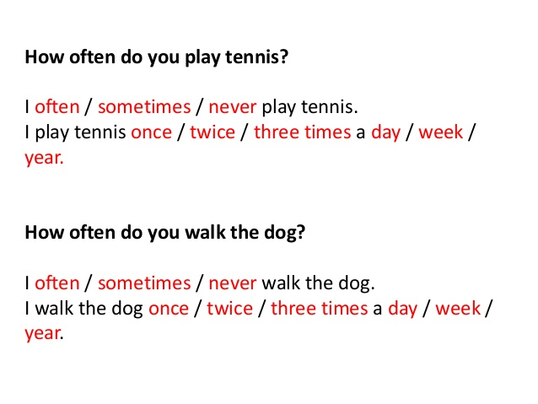

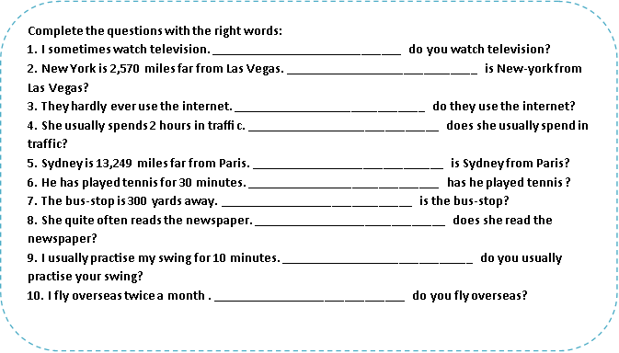

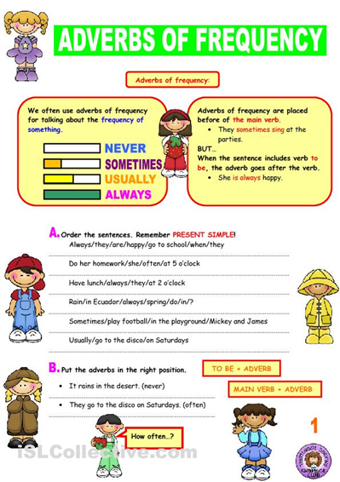

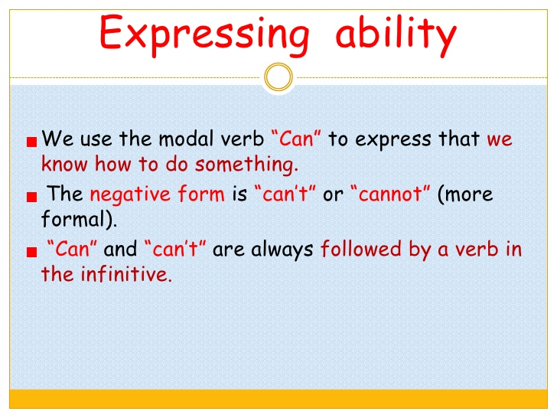

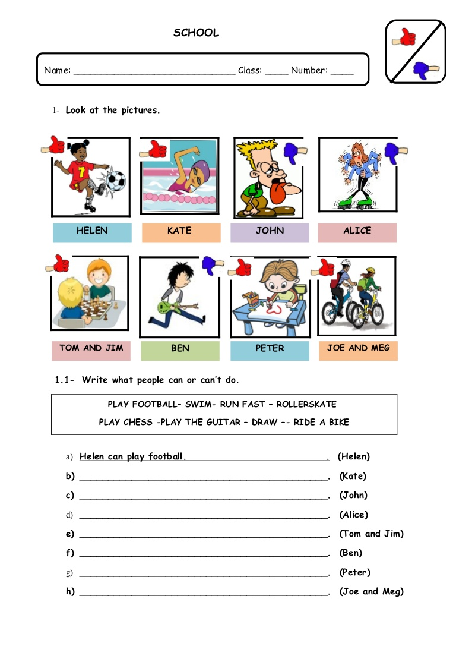

**conversation**

Date: \ \14

**New Vocabulary:**

|  |  |  |  |
| --- | --- | --- | --- |
| **Words** | **Kind** | **Meaning** | **Examples** |
|  |  |  |  |
|  |  |  |  |
|  |  |  |  |
|  |  |  |  |
|  |  |  |  |
|  |  |  |  |
|  |  |  |  |
|  |  |  |  |
|  |  |  |  |

**Match:**

1-I see an expression to confirm you understand correctly .

2-you mean …………. I understand .

a way to make an invitation .

**Reading**

Date: \ \14

**New Vocabulary:**

|  |  |  |  |
| --- | --- | --- | --- |
| **Words** | **Kind** | **Meaning** | **Examples** |
|  |  |  |  |
|  |  |  |  |
|  |  |  |  |
|  |  |  |  |
|  |  |  |  |
|  |  |  |  |
|  |  |  |  |
|  |  |  |  |
|  |  |  |  |

**Questions:**

1-What is aero modeling ?

………………………………………………………………………………

*2-Does this hobby cost money ?*

…………………………………………………………………………………

**Writing**

Date: \ \14

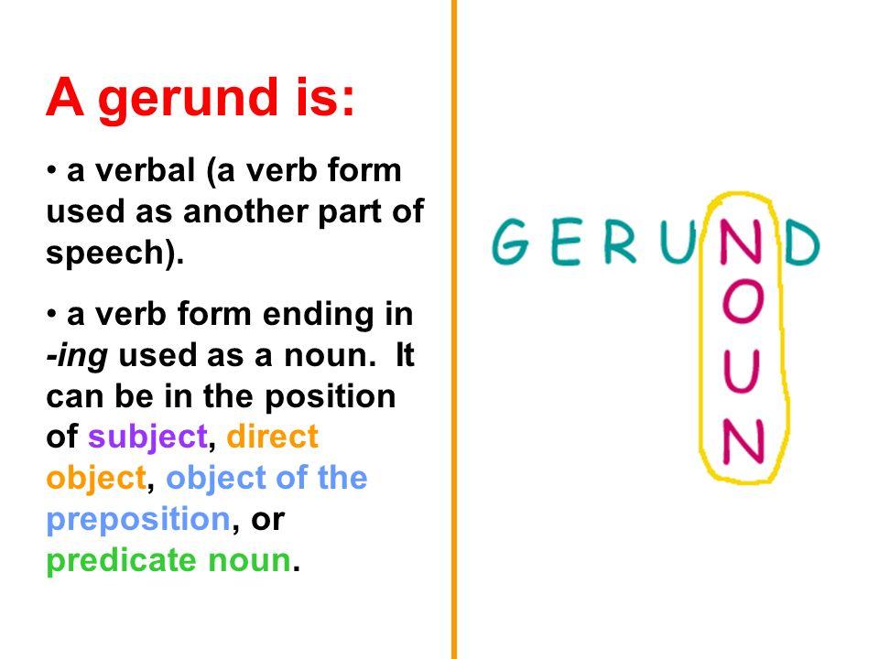

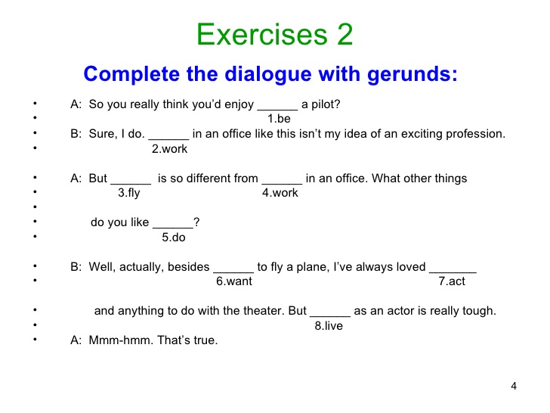

**project**

Date: \ \14

**\*Choose an unusual hobby and make information about it:**

……………………………………………………………………………………………………………………………………………………………………………………………………………………………………………………………………………………………………………………………………………………………………………………………………………………………………………………………………………………………………………………………………………………………………………………………………………………………………………………………………………………………………………………………………………………………………………………………………………………………………………………………………………………………………………………………………………………………………………………………………………………………………………………………………………………………………………………………………………………………………………………………………………………………………………………………………………………………………………………………………………………………………………………………………………………………………………………………………………………………………………………………………………………………………………..

Hobby

………………….

Picture

**From, meaning and Function**

Date: \ \14

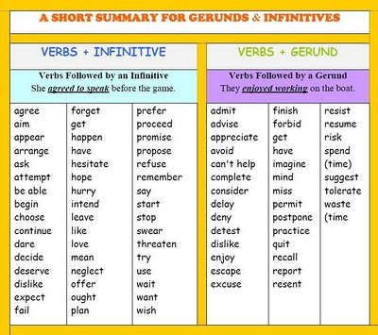

**1-listen & discuss**

Date: \ \14

**قال تعالى:" وكلوا و اشربوا و لاتسرفوا "**

**New Vocabulary:**

|  |  |  |  |
| --- | --- | --- | --- |
| **Words** | **Kind** | **Meaning** | **Examples** |
|  |  |  |  |
|  |  |  |  |
|  |  |  |  |
|  |  |  |  |
|  |  |  |  |
|  |  |  |  |
|  |  |  |  |
|  |  |  |  |
|  |  |  |  |
|  |  |  |  |
|  |  |  |  |
|  |  |  |  |
|  |  |  |  |
|  |  |  |  |

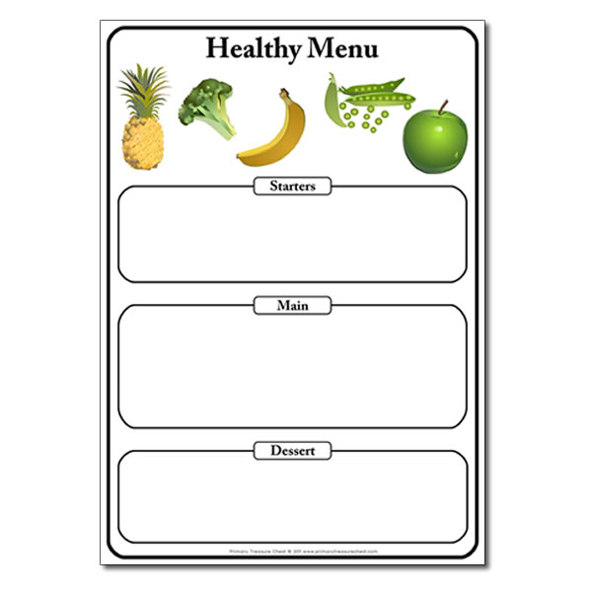

**2Grammar**

Date: \ \14

\\\\\\\

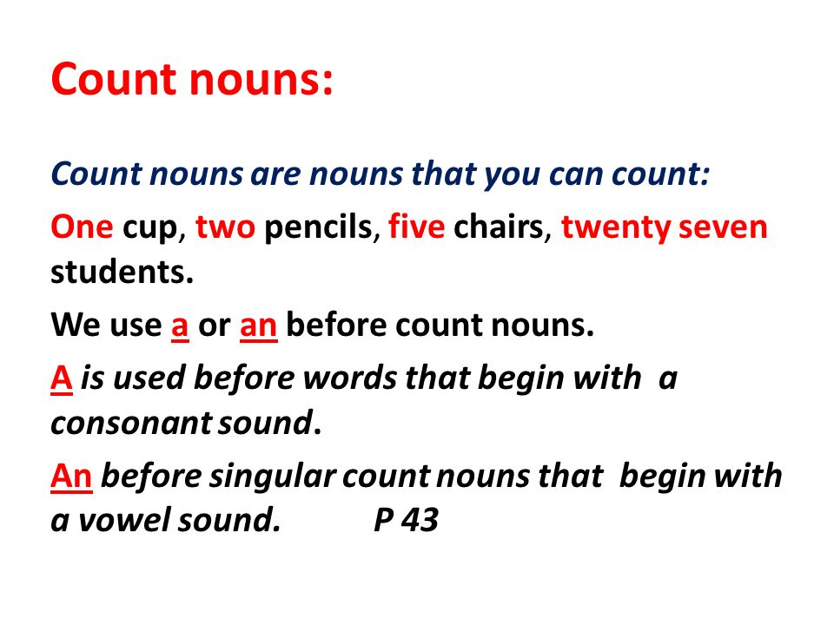

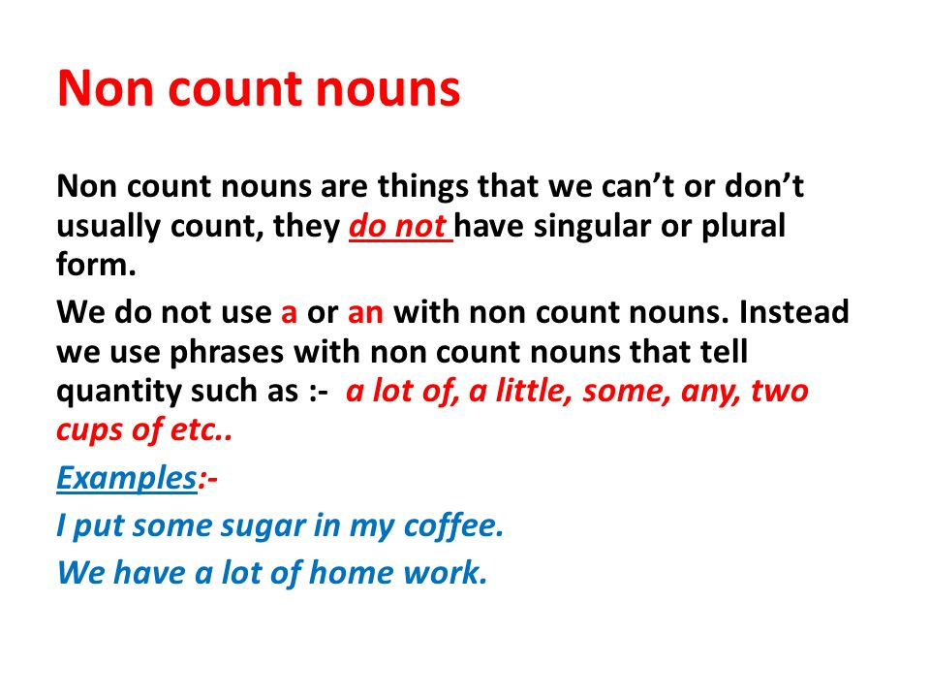

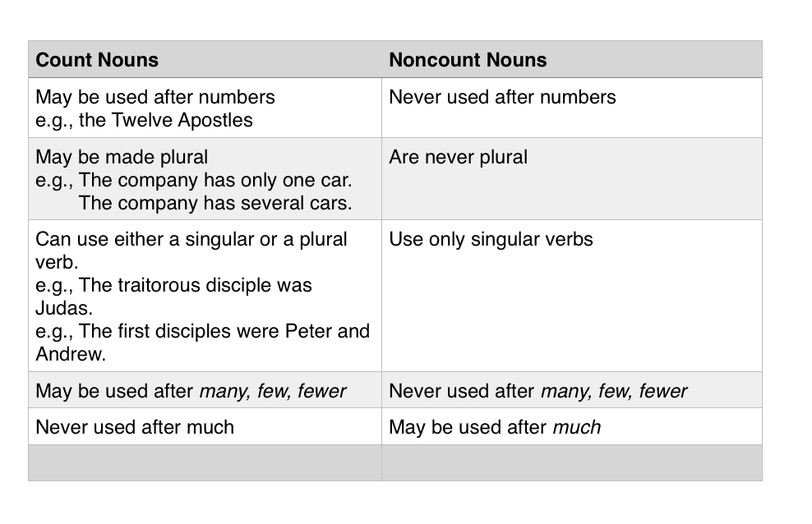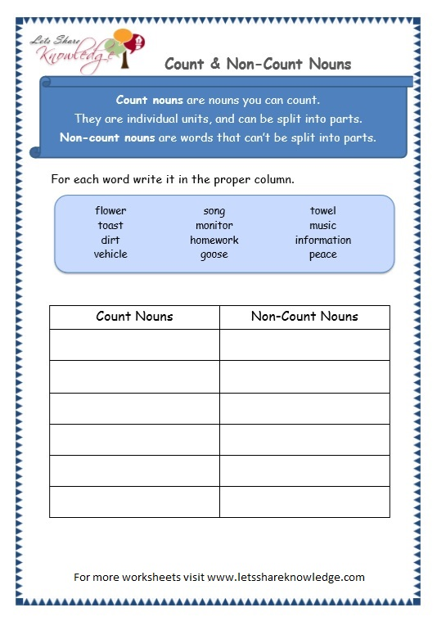

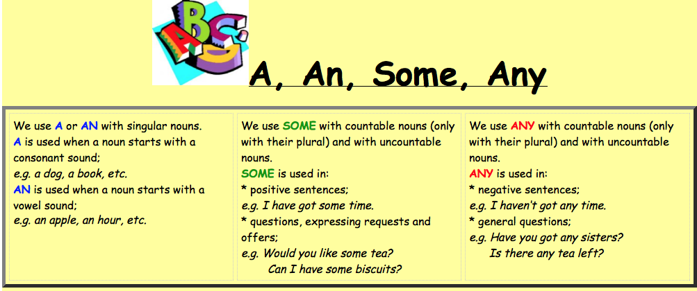

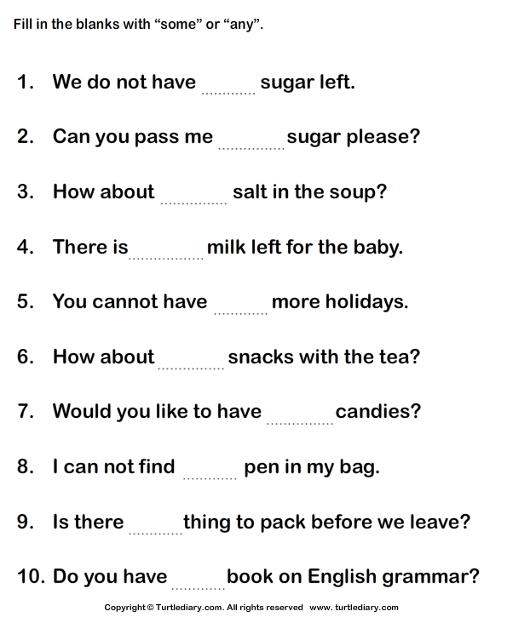

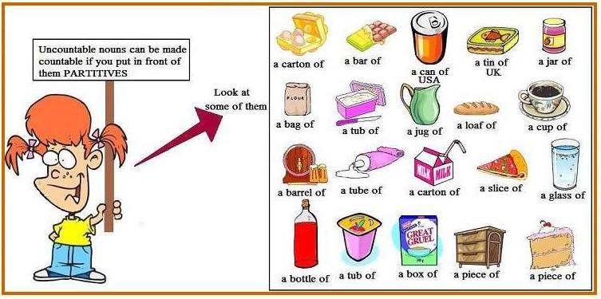

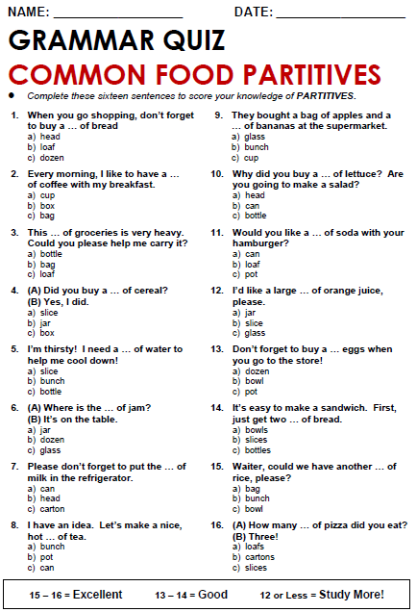

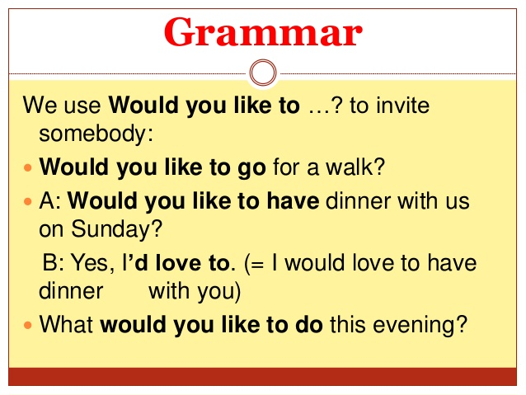

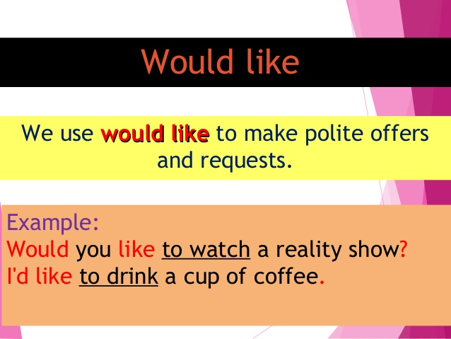

Choose the correct answer in the following:

أعلى النموذج

**1**   
Sara:  some cake?   
Marta: Yes, please. http://speakspeak.com/a/images/quiz/mark_blank.gif

**2**   
Steve: What sort of music  ?  
Andy: Most types, but especially dance music. http://speakspeak.com/a/images/quiz/mark_blank.gif

**3**   
Jana:  a banana?   
Nicola: No, thanks, I'm not hungry. http://speakspeak.com/a/images/quiz/mark_blank.gif

**4**   
Liz:  bananas?   
Paul: Yes, I love them. I have one every morning. http://speakspeak.com/a/images/quiz/mark_blank.gif

**5**   
Tony: Do you play tennis?   
Mike: Yes, I do.   
Tony:  a game now?   
Mike: Yeah, sure. Great idea! http://speakspeak.com/a/images/quiz/mark_blank.gif

**6** I'm hot and thirsty.  a cold drink. http://speakspeak.com/a/images/quiz/mark_blank.gif

**7** I'm tired.  to go to bed now. http://speakspeak.com/a/images/quiz/mark_blank.gif

**8** I'd like  , please. http://speakspeak.com/a/images/quiz/mark_blank.gif

**9** I like  . They're my favourite fruit. http://speakspeak.com/a/images/quiz/mark_blank.gif

**10** I  to go to Italy for a holiday next year

أسفل النموذج

**conversation**

Date: \ \14

**New Vocabulary:**

|  |  |  |  |
| --- | --- | --- | --- |
| **Words** | **Kind** | **Meaning** | **Examples** |
|  |  |  |  |
|  |  |  |  |
|  |  |  |  |
|  |  |  |  |
|  |  |  |  |
|  |  |  |  |
|  |  |  |  |
|  |  |  |  |
|  |  |  |  |

**Match:**

1-I' ll have I have

2-Let me see I want to think .

I want

**Mention three expressions you use in a restaurant while ordering food:**

1-…………………………………………………………………….

2-…………………………………………………………………….

3-…………………………………………………………………….

**Reading**

Date: \ \14

**New Vocabulary:**

|  |  |  |  |
| --- | --- | --- | --- |
| **Words** | **Kind** | **Meaning** | **Examples** |
|  |  |  |  |
|  |  |  |  |
|  |  |  |  |
|  |  |  |  |
|  |  |  |  |
|  |  |  |  |
|  |  |  |  |
|  |  |  |  |
|  |  |  |  |
|  |  |  |  |
|  |  |  |  |
|  |  |  |  |

**Write the correct word under each picture:**

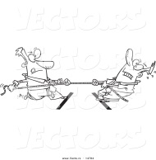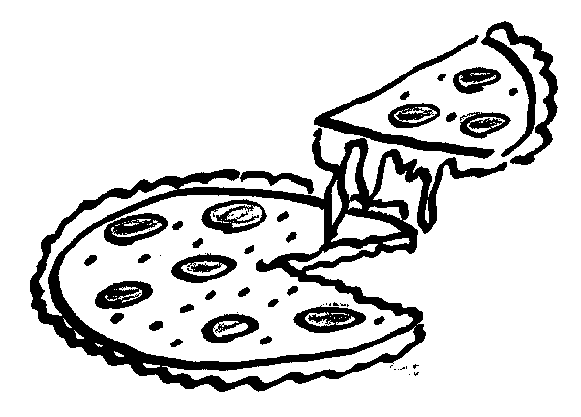[ pizza – compete – globalization ]

1-……………………… 2-……………………….

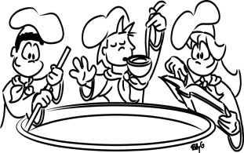

**Writing**

Date: \ \14

**\*Write a recipe for a dish that you know how to make :**

**project**

Date: \ \14

**\* Make a typical menu from your country . Include food for breakfast , lunch and dinner. Add some pictures.**

Date: \ \14

**Form , meaning and Function**

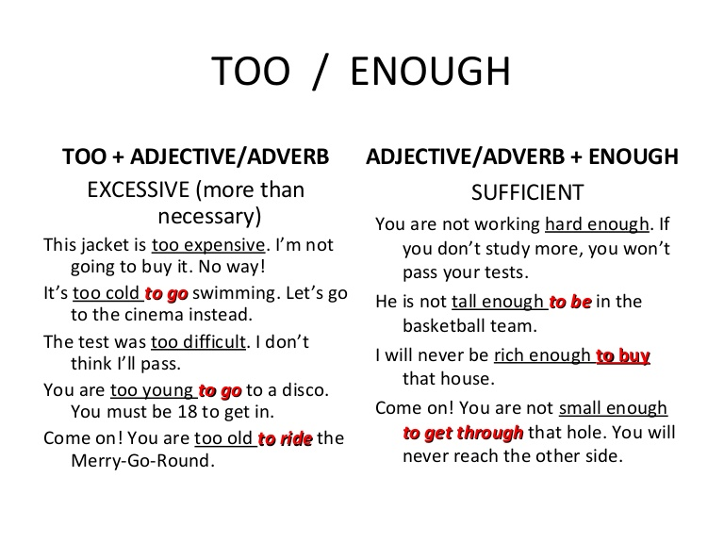

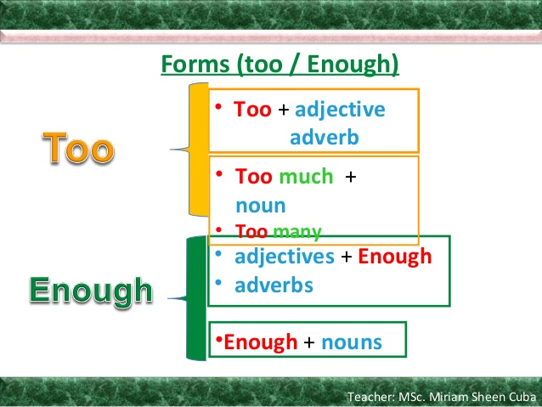

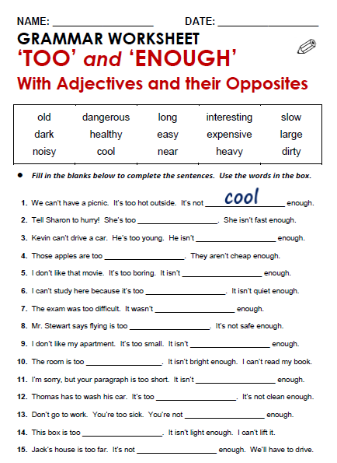

Date: \ \14

**1 Listen & discuss**

**New Vocabulary:**

|  |  |  |  |
| --- | --- | --- | --- |
| **Words** | **Kind** | **Meaning** | **Examples** |
|  |  |  |  |
|  |  |  |  |
|  |  |  |  |
|  |  |  |  |
|  |  |  |  |
|  |  |  |  |
|  |  |  |  |
|  |  |  |  |
|  |  |  |  |
|  |  |  |  |
|  |  |  |  |
|  |  |  |  |
|  |  |  |  |

**General Questions:**

1-Where can you see dinosaurs ?

……………………………………………………………………………………………………………

2-Where did Mike go on the weekend ?

……………………………………………………………………………………………………………

**Grammar**

Date: \ \14

### 

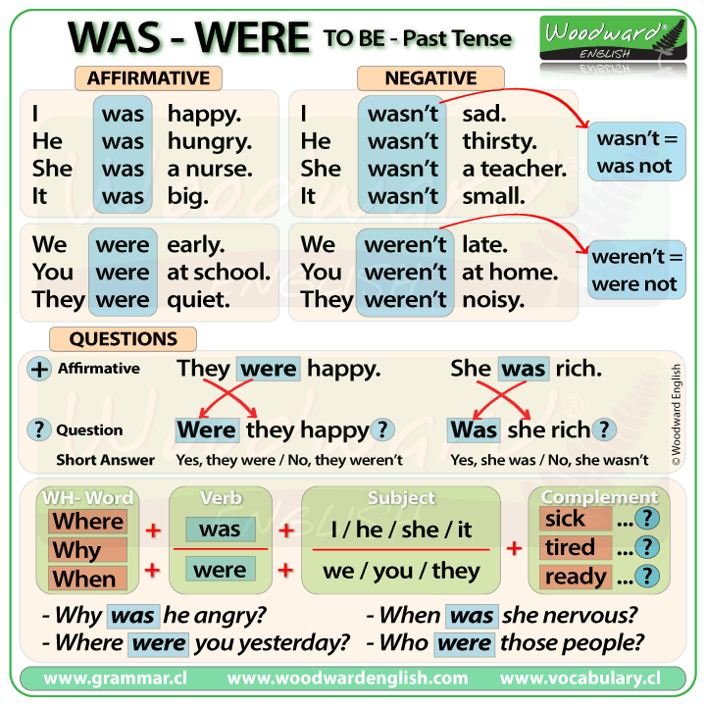

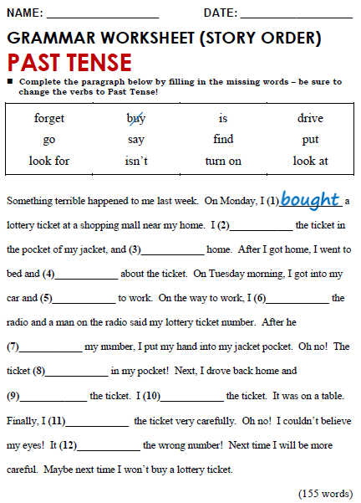

**conversation**

**Conversation**

Date: \ \14

**New Vocabulary:**

|  |  |  |  |
| --- | --- | --- | --- |
| **Words** | **Kind** | **Meaning** | **Examples** |
|  |  |  |  |
|  |  |  |  |
|  |  |  |  |
|  |  |  |  |
|  |  |  |  |
|  |  |  |  |
|  |  |  |  |
|  |  |  |  |
|  |  |  |  |
|  |  |  |  |

**7- about you:**

Did you ever see an interesting film on TV? What was it like? Did you ever eat at a nice restaurant ? what was it like ?

…………………………………………………………………………………………………………………………………………………………………………………………………………………………………………………………………………………………………………………………………………………………………………………………………………………………………………………………………………………………………………………………………………..

…………………………………………………………………………………………………………………………………………………………………………………………………………………………………………………………………………………………………………………………………………………………………………………………………………………………………………………………………………………………………………………………………………..

**Reading**

**Conversation**

Date: \ \14

**New Vocabulary:**

|  |  |  |  |
| --- | --- | --- | --- |
| **Words** | **Kind** | **Meaning** | **Examples** |
|  |  |  |  |
|  |  |  |  |
|  |  |  |  |
|  |  |  |  |
|  |  |  |  |
|  |  |  |  |
|  |  |  |  |
|  |  |  |  |
|  |  |  |  |
|  |  |  |  |

**1- Write the correct word under each picture:**

[script - calligrapher]



1-…………………………….. 2-……………………………

**2-Write the opposite of:**

1-Big# ………………… 2-beautiful # …………………. 3- simple # ………………………….

2-easiely # ………………………. 5- old #....................... 6- large#.........................

**-Writing**

**Conversation**

Date: \ \14

**\*Describe an interesting museum , performance or a sport event you attended . Use your notes from the chart in exercise A page 54 and ideas from this unit to write a paragraph .**

……………………………………………………….

…………………………………………………………………………………………………………………………………………………………………………………………………………………………………………………………………………………………………………………………………………………………………………………………………………………………………………………………………………………………………………………………………………………………………………………………………………………………………………………………………………………………………………………………………………………………………………………………………………………………………………………………………………………………………………………………………………………………………………………………………………………………………………………………………………………………………………………………………………………………………………………………………………………………………………………………………………………………………………………………………………………………………………………………………………………………………………………………………………………………………………………………………………………………………………………………………………………………………………………………………………………………………………………………………………………………………………………………………………………………………………………………………………………………………………………………………………………………………………………………………………………………………………………………………………………………………………………………………………………………………………………………………………………………………………………………………………………………………………………………………………………………………………………………………………………………………………………………………………………………………………………………………………………………………………………………………………………………………………………………………………………………………………………………………………………………………………………………………………………………………………………………………………………………

**Project**

**Conversation**

Date: \ \14

*Check on the events in your town . Choose one , and make a brochure about it .

Date: \ \14

**Form ,Meaning & Function**

**Conversation**

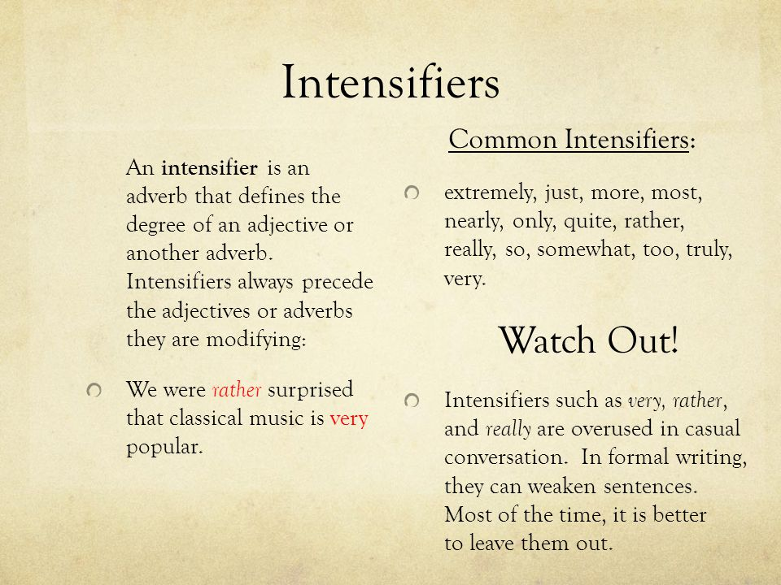 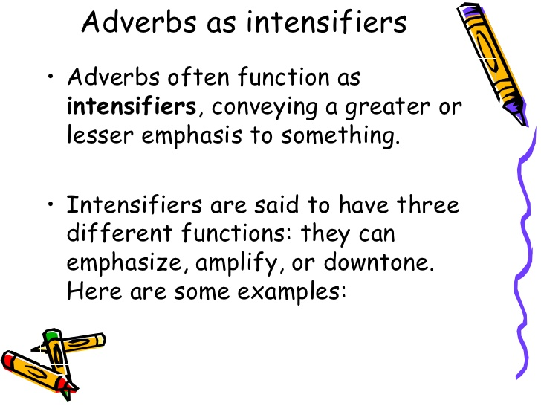

**قال تعالى" قل لن يصيبنا الا ما كتب الله لنا "**

**Conversation**

**1 Listen & Discuss**

**Conversation**

Date: \ \14

**New Vocabulary:**

|  |  |  |  |
| --- | --- | --- | --- |
| **Words** | **Kind** | **Meaning** | **Examples** |
|  |  |  |  |
|  |  |  |  |
|  |  |  |  |
|  |  |  |  |
|  |  |  |  |
|  |  |  |  |
|  |  |  |  |
|  |  |  |  |
|  |  |  |  |
|  |  |  |  |

**Grammar**

**Conversation**

Date: \ \14

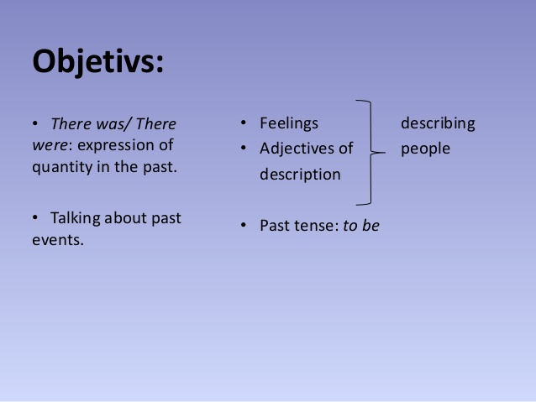

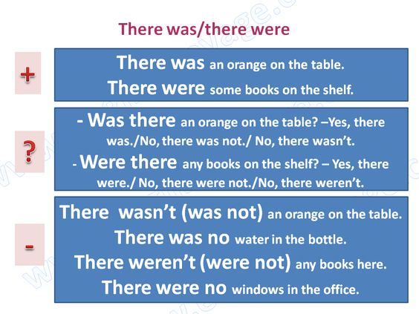

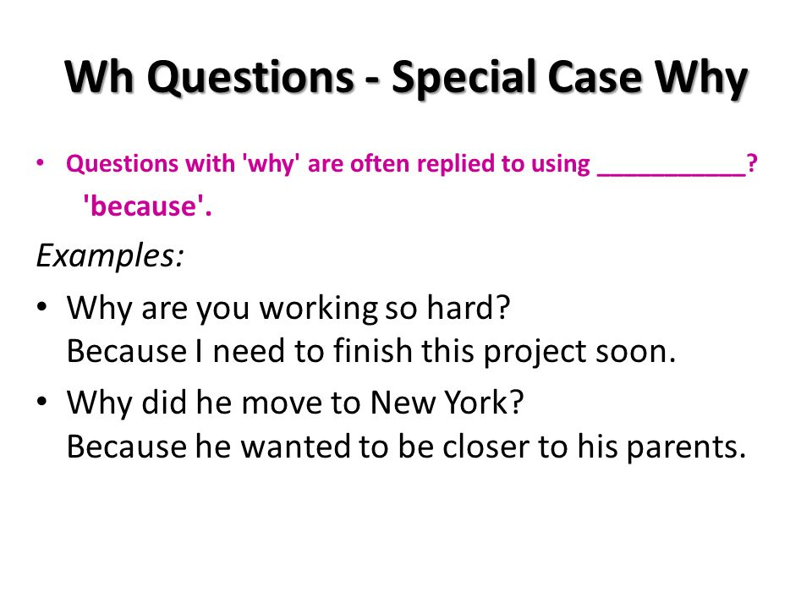

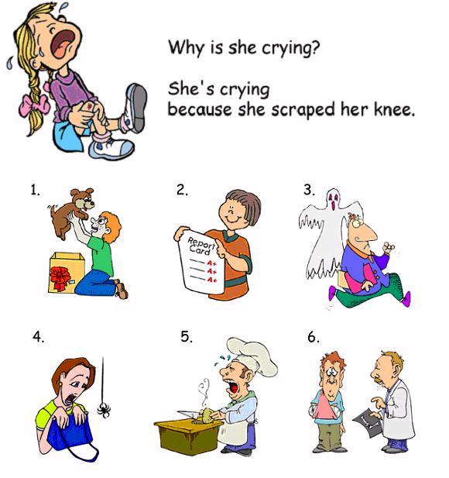

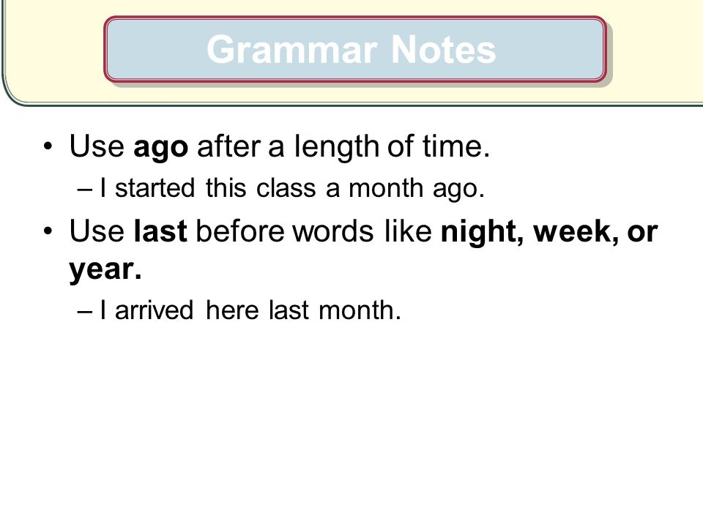

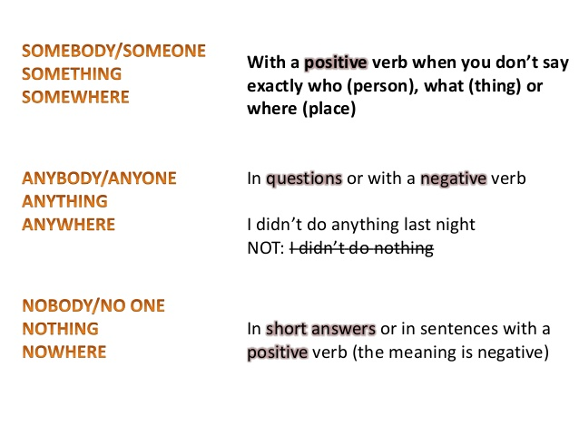

**Conversation**

**Conversation**

Date: \ \14

**New Vocabulary:**

|  |  |  |  |
| --- | --- | --- | --- |
| **Words** | **Kind** | **Meaning** | **Examples** |
|  |  |  |  |
|  |  |  |  |
|  |  |  |  |
|  |  |  |  |
|  |  |  |  |
|  |  |  |  |
|  |  |  |  |
|  |  |  |  |
|  |  |  |  |
|  |  |  |  |

**Match:**

1- Don't lose your cool believe me

2-The thing is The problem is

Don't get angry

**7- about you:**

Were you ever in an accident ? How did you or that person feel about it ?

What happened?

……………………………………………… ………………………………………………………

……………………………………………… ……………………………………………………

Date: \ \14

**Reading**

**Conversation**

**New Vocabulary:**

|  |  |  |  |
| --- | --- | --- | --- |
| **Words** | **Kind** | **Meaning** | **Examples** |
|  |  |  |  |
|  |  |  |  |
|  |  |  |  |
|  |  |  |  |
|  |  |  |  |
|  |  |  |  |
|  |  |  |  |
|  |  |  |  |
|  |  |  |  |
|  |  |  |  |
|  |  |  |  |

**\*Write the correct word under each picture:**

[ well-groomed / cool / topic / silly ]



1-…………………….. 2-………………………….. 3-……………………..

**Writing**

**Conversation**

Date: \ \14

**\*Write your own witness report about an accidentyou saw or heard about. Use your notes from the diagram page 62and ideas from this unit :**

………………………………………………………………………………………………………………………………………………………………………………………………………………………………………………………………………………………..……………….

…………………………………………………………………………………………………………………………..…………………………

………………………………………………………………………………………………………………………………………………….

……………………………………………………………………………………………………. ______________________

……………………………………………………………………………………………………. ______________________

………………………………………………………………………………………………………. ______________________

………………………………………………………………………………………………………. ______________________

……………………………………………………………………………………………………… ______________________

…………………………………………………………………………………………………….

………………………………………………………………………………………………………

……………………………………………………………………………………………………..

**project**

**Conversation**

Date: \ \14

**\*Make a brochure for your classmates . List things that make them happy , sad, scared, etc.**

|  |  |
| --- | --- |
| ……………………………………………...... ……………………………………………….  ………………………………………………….  ………………………………………………….  …………………………………………………  …………………………………………………  …………………………………………………  ………………………………………………….  ………………………………………………….  …………………………………………………..  ………………………………………………….  ………………………………………………….  ………………………………………………….  ………………………………………………….  …………………………………………………..  ………………………………………………….  …………………………………………………  …………………………………………………  ………………………………………………….  …………………………………………………  …………………………………………………  …………………………………………………  …………………………………………………..  ………………………………………………….. | ……………………………………………...... ……………………………………………….  ………………………………………………….  ………………………………………………….  …………………………………………………  …………………………………………………  …………………………………………………  ………………………………………………….  ………………………………………………….  …………………………………………………..  ………………………………………………….  ………………………………………………….  ………………………………………………….  ………………………………………………….  …………………………………………………..  ………………………………………………….  …………………………………………………  …………………………………………………  ………………………………………………….  …………………………………………………  …………………………………………………  …………………………………………………  …………………………………………………..  ………………………………………………….. |

**[ you can add pictures]**

**11 Form, Meaning &Function**

**Conversation**

Date: \ \14

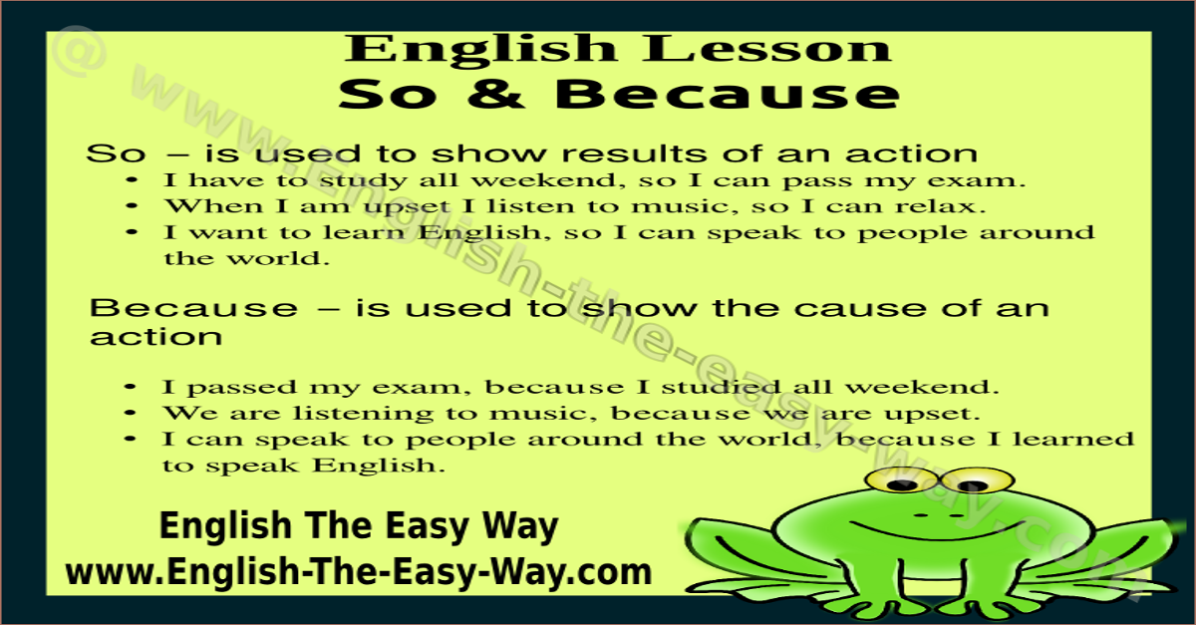

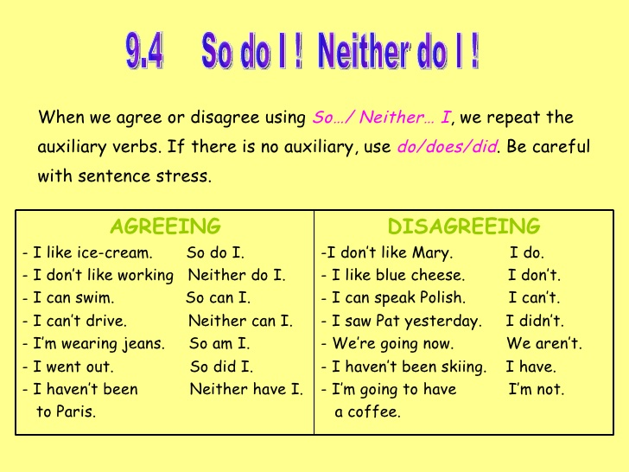

c

Date: \ \14

**Listen & Discuss**

**Conversation**

**قال تعالى" و اذا مرضت فهو يشفين "**

**Conversation**

**New Vocabulary:**

|  |  |  |  |
| --- | --- | --- | --- |
| **Words** | **Kind** | **Meaning** | **Examples** |
|  |  |  |  |
|  |  |  |  |
|  |  |  |  |
|  |  |  |  |
|  |  |  |  |
|  |  |  |  |
|  |  |  |  |
|  |  |  |  |
|  |  |  |  |
|  |  |  |  |
|  |  |  |  |

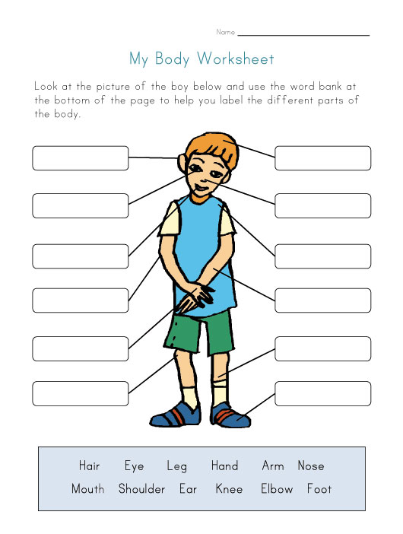

Date: \ \14

**Grammar**

**Conversation**

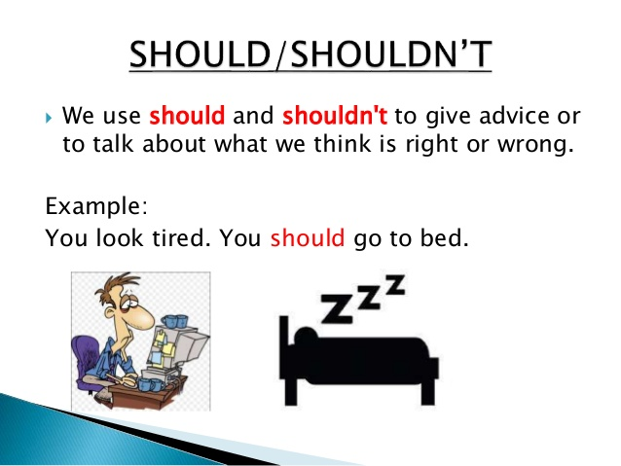

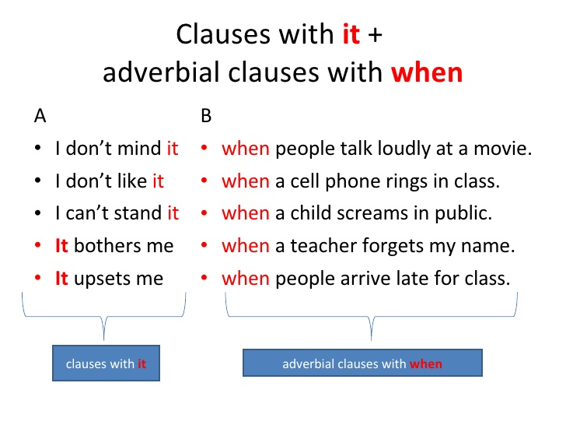

*Conversation*

***Conversation***

Date: \ \14

**New Vocabulary:**

|  |  |  |  |
| --- | --- | --- | --- |
| **Words** | **Kind** | **Meaning** | **Examples** |
|  |  |  |  |
|  |  |  |  |
|  |  |  |  |
|  |  |  |  |
|  |  |  |  |
|  |  |  |  |
|  |  |  |  |
|  |  |  |  |
|  |  |  |  |

**Match:**

1-And things like that Looking for information.

2-nothing much and similar things .

Not a great amount.

7**- About You:**

**Write the correct word under each picture**:

[ healthy / ill / work out ]

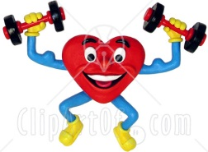

1-…………………… 2-……………………… 3-……………………….

***Reading***

***Conversation***

Date: \ \14

**New Vocabulary:**

|  |  |  |  |
| --- | --- | --- | --- |
| **Words** | **Kind** | **Meaning** | **Examples** |
|  |  |  |  |
|  |  |  |  |
|  |  |  |  |
|  |  |  |  |
|  |  |  |  |
|  |  |  |  |
|  |  |  |  |
|  |  |  |  |
|  |  |  |  |
|  |  |  |  |
|  |  |  |  |
|  |  |  |  |

**Write the opposite of the following:**

1-common # ……………………………………….

2- impossible#................................

3-tradiontal #..................................

4-similar #........................................

***9-Writing***

***Conversation***

Date: \ \14

**\*What should you do when you have flu ? Write about it . Use your notes from the chart and other ideas from this unit .**

……………………………………………………………………

……………………………………………………………………………………………………………………………………………………………………………………………………………………………………………………………………………………………………………………………………………………………………………………………………………………………………………………………………………………………………………………………………………………………………………………………………………………………………………………………………………………………………………………………………………………………………………………………………………………………………………………………………………………………………………………………………………………………………………………………………………………………………………………………………………………………………………………………………………………………………………………………………………………………………………………………………………………………………………………………………………………………………………………………………………………………………………………………………………………………………………………………………………………………………………………………………………………………………………………………………………………………………………………………………………………………………………………………………………………………………………………………………………………………………………………………………………………………………………………………………………………………………………………………………………………………………………………………………………………………………………………………………………………………………………………………………………………………………………………………………………………………………………………………………………………….

***project***

***Conversation***

Date: \ \14

*Research home remedies for common illnesses.

…………………………………………………………………….

………………………………………………………………………………………………………………………………………………………………………………………………………………………………………………………………………………………………………………………………………………………………………………………………………………………………………………………………………………………………………………………………………………………………………………………………………………………………………………………………………………………………………………………………………………………………………………………………………………………………………………………………………………………………………………………………………………………………………………………………………………………………………………………………………………………………………………………………………………………………………………………………………………………………………………………………………………………………………………………………………………………………………………………………………………………………………………………………………………………………………………………………………………………………………………………………………………………………………………………………………………………………………………………………………………………………………………………………………………………………………………………………………………………………………………………………………………………………………………………………………………………………………………………………………………………………………………………………………………………………………………………………………………………………………………………………………………………………………………………………………………

***Form ,Meaning &Function***

***Conversation***

Date: \ \14

Dictation

أسفل النموذج

|  |  |  |  |
| --- | --- | --- | --- |
| **Correction** | **Mark** | **Words** | **DATE** |
|  |  |  |  |
|  |  |  |  |
|  |  |  |  |
|  |  |  |  |
|  |  |  |  |

|  |  |  |  |
| --- | --- | --- | --- |
| **Correction** | **Mark** | **Words** | **DATE** |
|  |  |  |  |
|  |  |  |  |
|  |  |  |  |
|  |  |  |  |
|  |  |  |  |

|  |  |  |  |
| --- | --- | --- | --- |
| **Correction** | **Mark** | **Words** | **DATE** |
|  |  |  |  |
|  |  |  |  |
|  |  |  |  |
|  |  |  |  |
|  |  |  |  |

|  |  |  |  |
| --- | --- | --- | --- |
| **Correction** | **Mark** | **Words** | **DATE** |
|  |  |  |  |
|  |  |  |  |
|  |  |  |  |
|  |  |  |  |
|  |  |  |  |