الاسم ……………………………..

Reading

3 Mark

❖ Read the text and answer the questions.

Saleh lives in a big house . It is in Riyadh.  There is a nice garden behind the house .His wife Amal waters the flowers every morning .The  family have breakfast  in that garden on Thursday . His daughter Laila likes picking up flowers .

Questions :

1- Where does Saleh live .?

    ……………………………………………………………………………………..…………………………

2- Is Amal Saleh's daughter   ?

………………………………………………………………………………..………………………….

Choose :

1- Laila likes [ watering – eating – picking up ] flowers .

2- There is a garden [ near – behind – between ] the house .

Put [     ] or [  X ] ;

1- Saleh 's house is in  Dammam .  [       ]

2- The family have breakfast in garden .  [     ]

5 Mark

**Grammar**

**❖ Choose the best answer to fill in the blank in each question.**

1- Does he depend on his family? Yes, he [ do-does-did]

2- They [ was-were-do] surfing the internet last night.

3- The cell phone was [breaks-broke- broken]

4- She [has-do-have] not created her own website.

 5- [ Am- Is- Are] your cell phone charged?

* **Write the correct word under the picture.**

1 Mark

Asthma—.Inmate – Technology

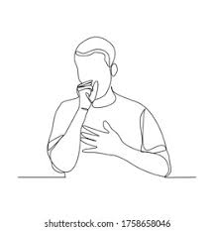

………………………………………………….

………………………………………………….

* **Choose the correct letter.**

1 Mark

* C....ime doesn’t pay . ( o – y – r )
* Connecte…. by technology . ( t – d – r )

Good luck 👍