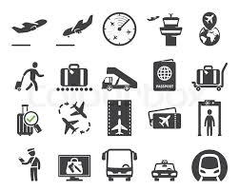Name _____________________________ Class ___

1. Find the replay:

* What are you doing tonight?

________________________________________________________________

* May I see your ticket and passport, pleas?

________________________________________________________________

* Good-bye. We`ll miss you

________________________________________________________________

* What time is our flight leaving?

________________________________________________________________

New vocabularies

|  |  |  |  |
| --- | --- | --- | --- |
| Ticket |  | delayed |  |
| Airlines |  | take off |  |
| gate |  | necessary |  |
| Advise to travelers |  | departure |  |
| passenger |  | airport |  |

1. Name some countries or cities you wold like to travel to them and say why?

* __________________________________________________________________________________________________________________________________________
* __________________________________________________________________________________________________________________________________________