**UNIT ( 1 ) EXAM**

**الأسـم : …………………………………………………………………… الصـف : ………………………….**

**A-Choose the correct answer:**

**1- They sometimes (plays – played – play) tennis in the park.**

**2- Neither of them (drink – drank – drinks) coffee.**

**3- - I have two brothers (both –all –none ) of them sleep late .**

**I (work – works – working) at the bank. 4-**

**5- She (live – lives – living )with her parents.**

**6- We (always walk – walk always – always walks ) to school.**

**7- How often (do – does – did) she go out?**

**8- Ali buys a new car. (her – his – their) car is red .**

**B-Write the missing letter :.**

**1- He works at the g__m ( y – u – o )**

**2- A healthy diet contains amounts of protein and ...rains ( g – d – b )**

**3- my friend is veg….erian . she doesn’t eat meat at all . ( n – o – t )**

**4- I was a video game addi….t. ( c – k - s )**

**C-Match the words with their meaning :**

**1-work out ( ) a word to change the topic .**

**2-any way ( ) to exercise .**

**to be physically fit and healthy 3-fitness ( )**

**4- turn ( someone )off ( ) doesn’t interest at all .**

**D- put the words under the pictures:**

**( herbals tea – puzzle - addict )**

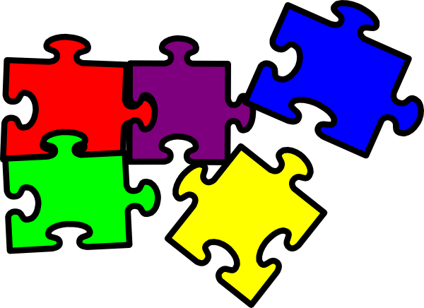

**……………… ……………….**

***Good Luck ..***