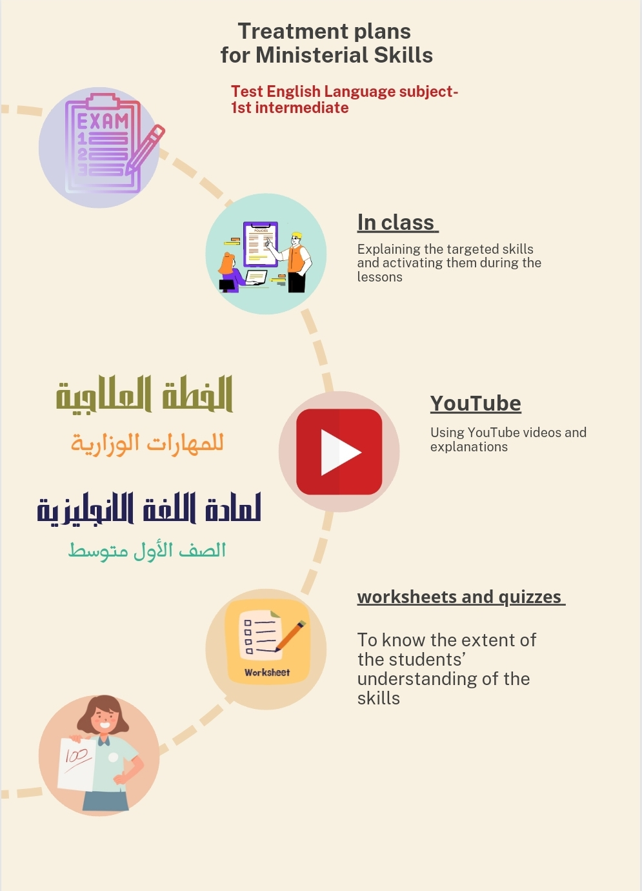

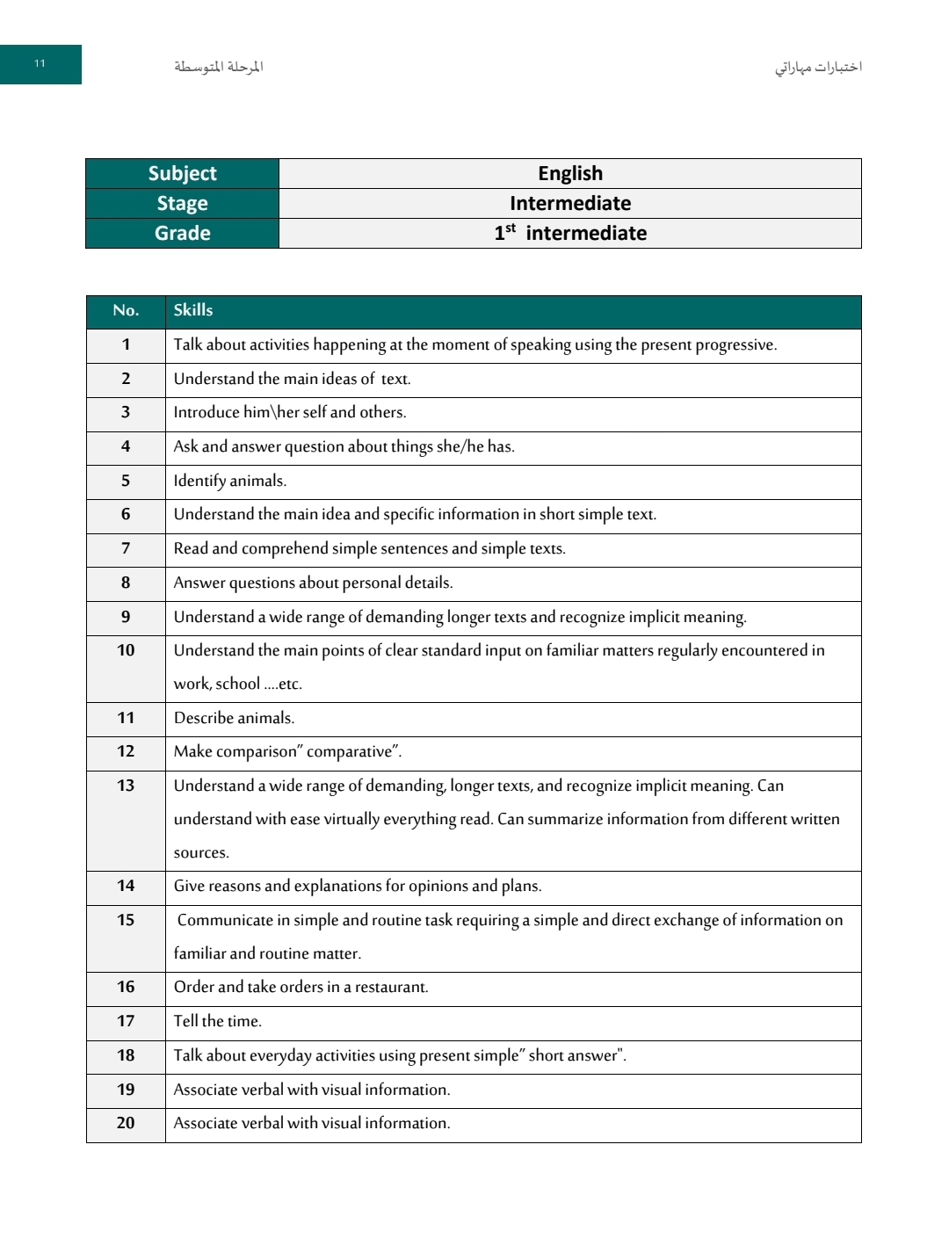

الإجراءات المتبعة لعلاج المهارات المفقودة

للصف الاول متوسط

|  |  |  |  |
| --- | --- | --- | --- |
| **Procedure 1** | **Procedure 1** | **Skills.** | **No** |
| **WORKSHEET** | ACTIVATE QUESTIONS AND CONVERSATIONS ABOUT INTRODUCING THEMSELVES AND  OTHERS DAILY IN CLASS | **INTRODUCE HIM HER SELF AND OTHERS.** | **Skill 3** |
| <https://www.liveworksheets.com/w/en/english-second-language-esl/1620180> | ACTIVATE QUESTIONS RELATED TO PERSONAL DETAILS AND ANSWER THEM DAILY IN CLASSES | **ANSWER QUESTIONS ABOUT PERSONAL DETAILS.** | **Skill 8** |
| <https://www.liveworksheets.com/w/en/english-second-language-esl/47390> | <https://www.youtube.com/watch?v=Rs-UA2jOry0&t=290s> | **MAKE COMPARISON" COMPARATIVE"** | **-Skill-12** |
| [**https://www.liveworksheets.com/w/en/english-second-language-esl/625733**](https://www.liveworksheets.com/w/en/english-second-language-esl/625733) | <https://www.youtube.com/watch?v=0DS4X7YDjeA> | **TELL THE TIME** | **Skill-17** |
| [**https://www.liveworksheets.com/w/en/english-second-language-esl/970938**](https://www.liveworksheets.com/w/en/english-second-language-esl/970938) | EXPLANATION OF THE  SIMPLE PRESENT TENSE RULE AND ITS USES  <https://www.youtube.com/watch?v=7nc03DZr1gY&t=1253s> | **TALK ABOUT EVERYDAY ACTIVITIES USING PRESENT SIMPLE" SHORT ANSWER** | **Skill-18** |

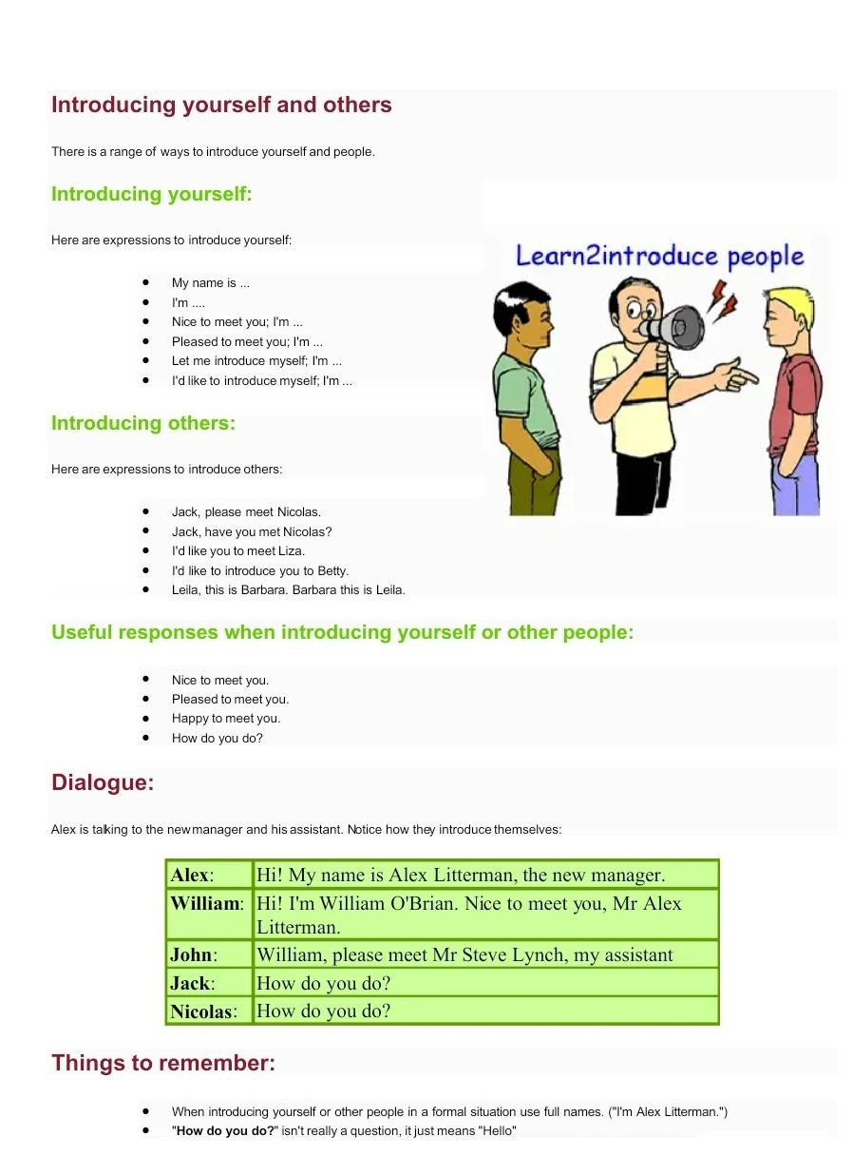

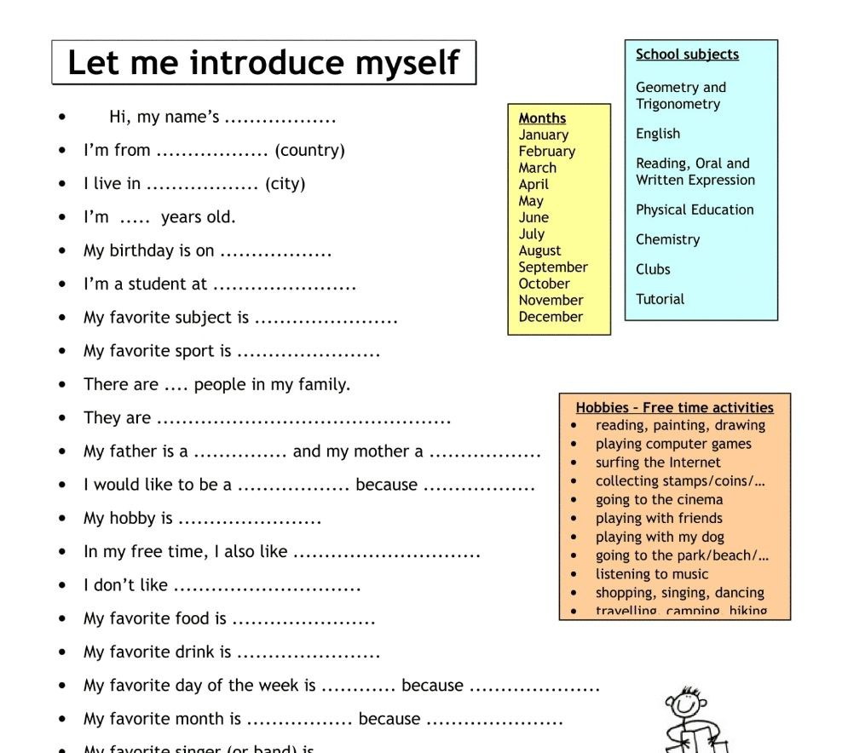

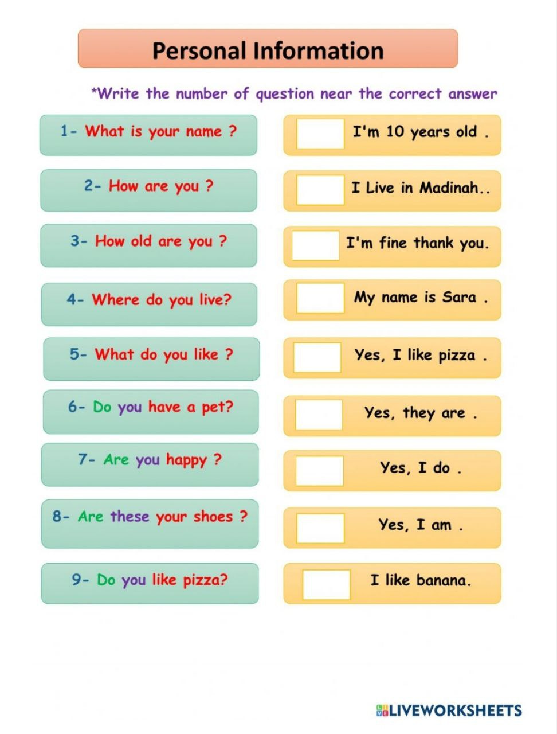

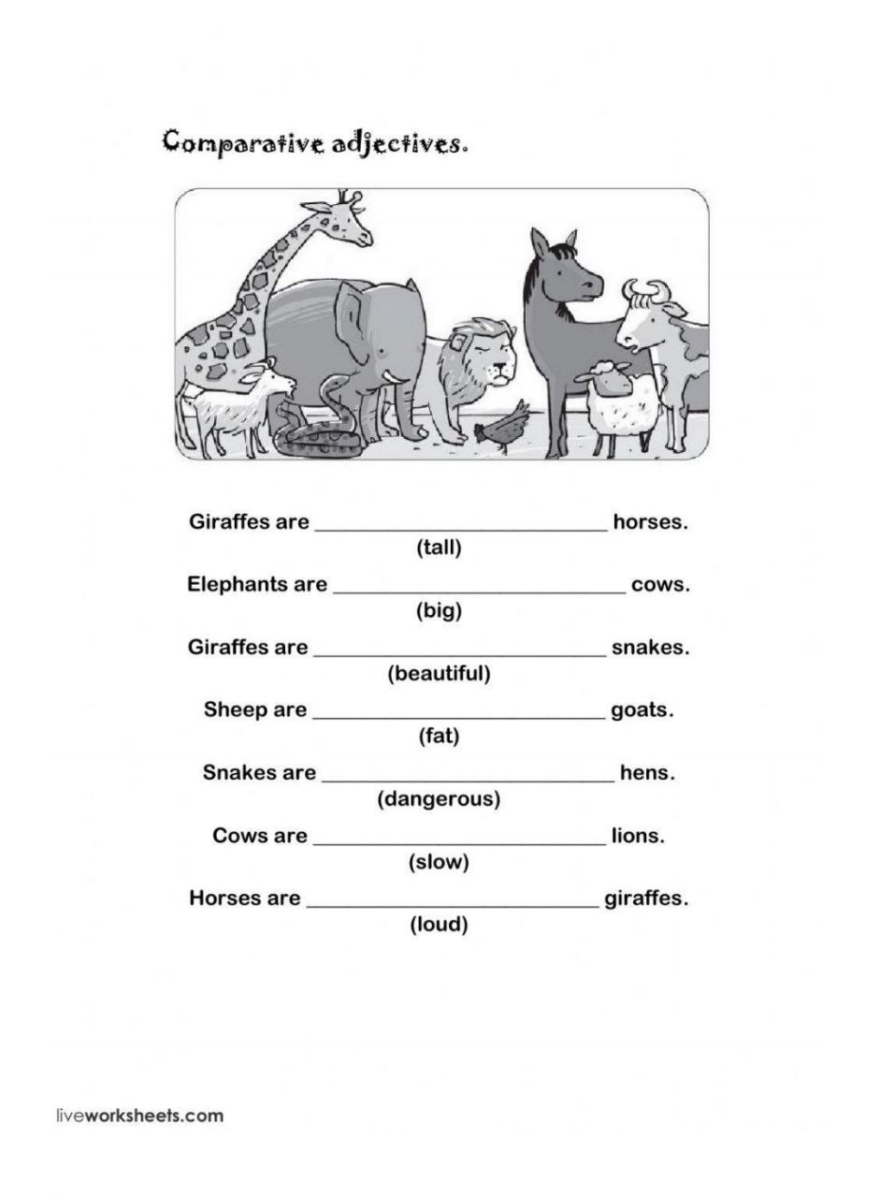

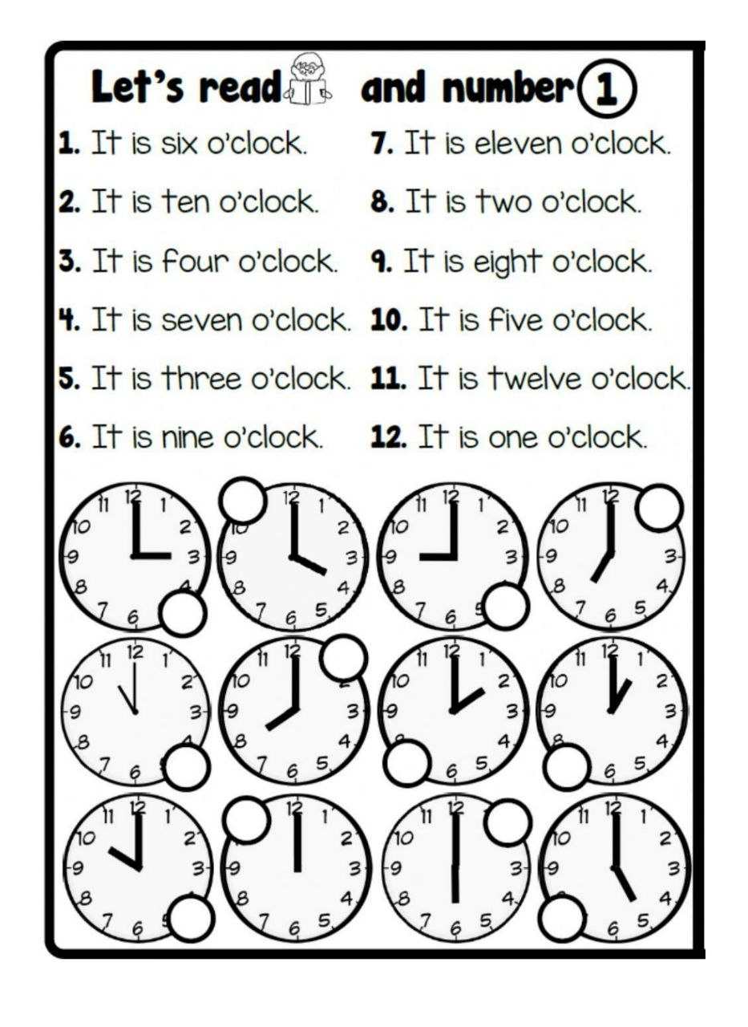

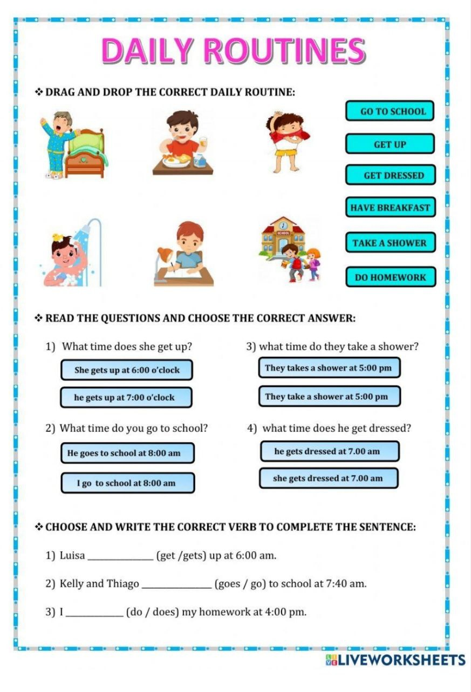

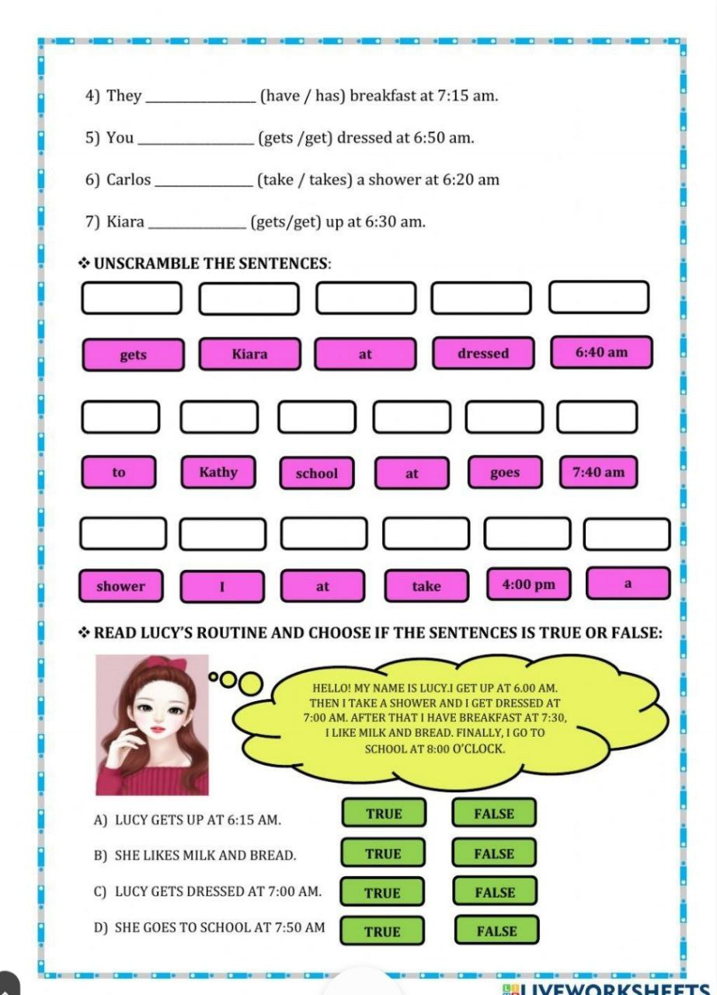

اختبار المهارات (المفقودة) لمهارتي الوزاري 1445-أول متوسط (10 نقطة)

خطة علاجية لرفع المستوى في المهارات المفقودة

<https://forms.office.com/Pages/ShareFormPage.aspx?id=mnR-H370zUOmdAWktpBqYrZsbjVcdSRFty2KZCpolmhUQlc5TUlQSjg0UVA1NUNaRVM1MjNBSVcxTi4u&sharetoken=Bx6tXoCikLz7dSHulpDg>

|  |  |
| --- | --- |
| اسم الطالبة | الدرجة |
|  |  |
|  |  |
|  |  |
|  |  |
|  |  |
|  |  |
|  |  |
|  |  |
|  |  |
|  |  |
|  |  |
|  |  |
|  |  |
|  |  |
|  |  |
|  |  |
|  |  |
|  |  |
|  |  |
|  |  |
|  |  |
|  |  |
|  |  |
|  |  |
|  |  |