**Unit 1-2 Exam Mega 1.1**

Name:………………………………………………… Class :…………

**A) Match the word with its meaning Vocabulary**

1. vibrant ( ) a- center
2. established ( ) b- be part of
3. fit in ( ) c- set up – start
4. hub ( ) d- active & strong

**B- Choose the correct answers :**

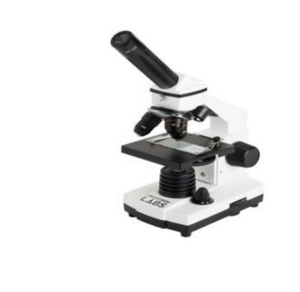( traffic - sculptor - economy - microscope )

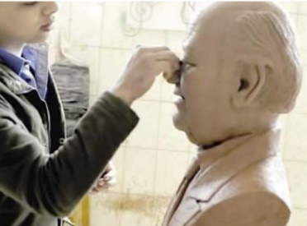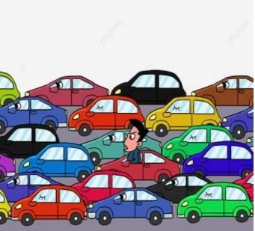

…………….

……………..………………..………………..

**Grammar A ) Choose :**

1-It is ( rain – rained – raining ) right now .

2-This is the boy ( who - which – when ) had an accident .

3-He is interested in ( read - reading – reads ) novels .

4- ( How long – How much – How many ) lessons has she explained ?

5-She ( clean - cleaned - cleaning ) her house yesterday .

6-Ahmed has ( eat - eats - eaten ) three burger .

**B - Rewrite using capitals :**

1- jack decided to fly to new york next monday.…………..………………………………………………….

2-my brother has never been to dubai . ……………………..……………………………………………………

3-riyadh is the capital of saudi arabia . …………………….………………………………………………………

GOOD LOOK

Sara Madkhali .