Revision Unit 2 – Sea Animals

AA

# Cute Cartoon Seahorse Stock Illustration - Download Image Now - Seahorse, Cute, Cartoon - iStockChoose

|  |
| --- |
| **1. What is that?**  **A** . **It's a seahorse. B** . **It's a seal.** |
| 1. **What do you think about sharks?**   **A**. **I like dolphins. B**. **I think they are scary.** |
| **3. Which of the following is a sea animal? A** . **seahorse**. **B**. **horse**. |

ة

# Shark Clipart Images – Browse 13,005 Stock Photos, Vectors, and Video | Adobe StockCircle the correct answer.

|  |  |  |
| --- | --- | --- |
| **1. This is a shark.** |  |  |
| **2. The dolphin is cute.** |  |  |
| **3.starfish has 6 arms.** |  |  |
| **4.octopus has 8 arms.** |  |  |

1. 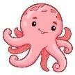**Unscramble and write**
   1. **think - I – whales – fast - are.**

**………………………………………………………………………………………………**

* 1. **a – the – There – is – chair – on – mouse**

**………………………………………………………………………………………………**

* 1. **s – l l – g – u – a – e .**

**………………………………………………………………………………………………**

# Choose.

1. Baby seals are (cute – cuter- the cutest) than seahorse.
2. Whales are ( big – bogger-the biggest).
3. As ( slow – slower – the slowest) as a seahorse.
4. A dolphin is the ( fast – faster – fastest) .
5. What ( is - are – am ) those?
6. Starfish ( has - have ) 5 arms.

## 5. Do as shown brackets.

1. A dolphin is cuter.

( correct)

1. I think sharks scary. ( complete)

# Write.

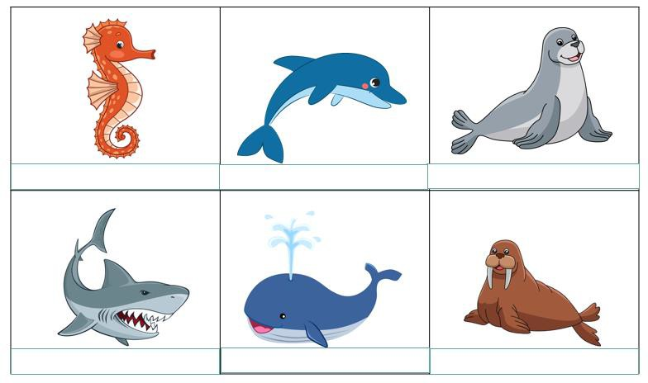

**seal - seahorse – walrus -shark -dolphin - whale**

1. **Match**

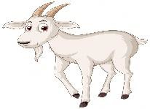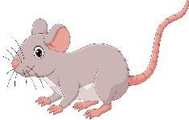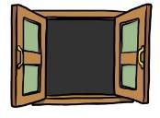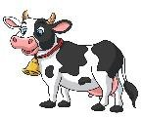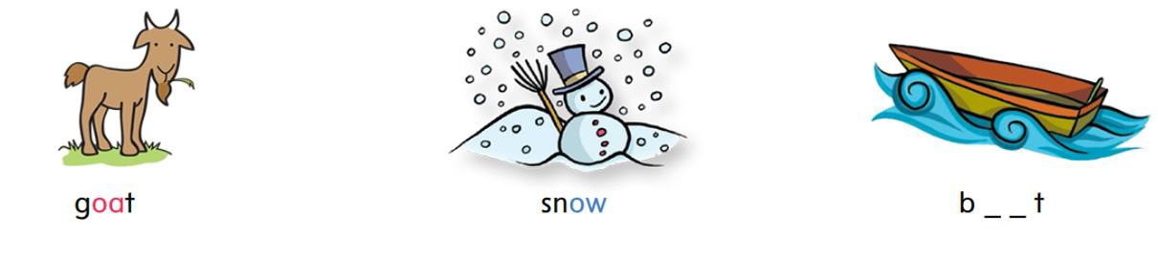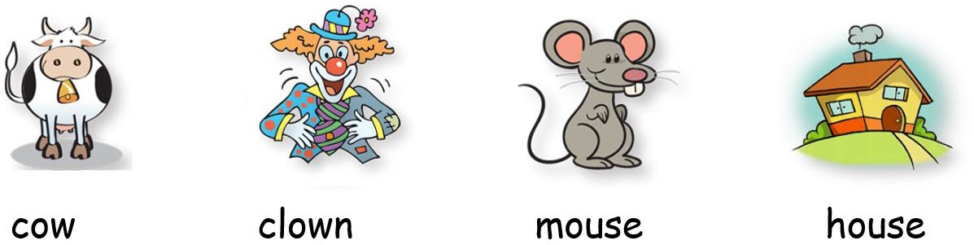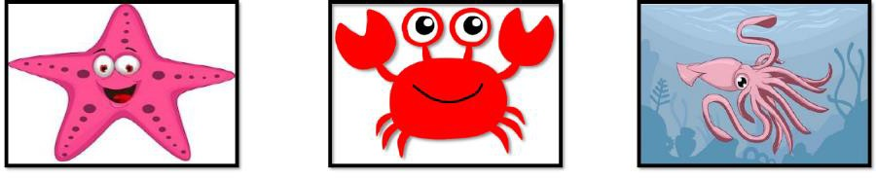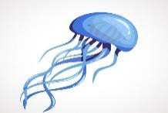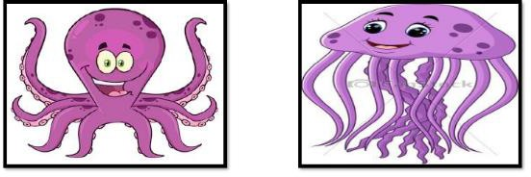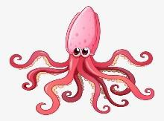

## Crab starfish squid jellyfish octopus



Choose the correct letter: **( ou - ow - oa )**

|  |  |  |  |  |
| --- | --- | --- | --- | --- |
|  |  |  |  |  |

g_ _t sn_ _ b_ _t

**h_ _se c_ _ m_ _se g _ _ t wind_ _**

c_ _ cl_ _n m_ _se h_ _se