

**اختبار مادة اللغة الإنجليزية- الصف السادس**

**Name: .......................****........ Class: .........**

**20**

1. Write each word under the correct picture :

Shoes-Bicycle – computer – meat – cheese – octopus – shark- T-shirt

|  |  |  |  |  |  |  |  |
| --- | --- | --- | --- | --- | --- | --- | --- |
| Swiss cheese with holes stock image. Image of yellow - 18911609 |  |  |  | Acer Aspire 7 A715-42G-R5C5 Black Gaming Laptop | Gaming | Computers and  Gadgets | Abenson.com |  | Tomahawk Steak with Grilled Brussels Sprouts and Sweet Potato Purée |  |
|  |  |  |  |  |  |  |  |

B ) Choose the correct answer:

1. Where do you live ?
2. I live in Makkah. b- I’m eleven years old. c- My name’s Ali.
3. Whose shoes are these?
4. They’re Steve’s. b- My name’s Hashim. c- Thank you.
5. How do you go to school?
6. I have one brother. b- I live in Makkah. c- by school bus.

C ) Rearrange the following sentences :

1. my - This - mother - is.

……………………………………………………..

D ) Match:

|  |  |
| --- | --- |
| A | B |
| 1. Hi, I'm Jack . What's your name? | ( ) I'm 12 years old. |
| 2. How old are you? | ( ) Nice to meet you, too. |
| 3. Nice to meet you. | ( ) My name's Hashim. |

E ) Choose the correct answer:

1. ………….sandals are these?
2. Who’s b- Whose c- Who
3. I ……………………a computer.
4. Have b- has c- is

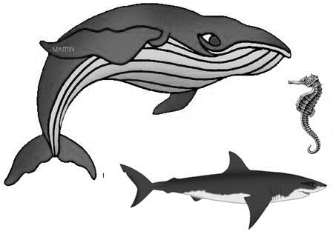F ) Make a comparison using

(big)

1-A shark is _____

2-A shark is _______ than seahorse.

3-A whale is the ________

G ) Read and answer the following questions:

Hello. My name’s Omar. I’m eleven years old and I live in Jeddah.

A- true or false or :

1. The boy’s name is Ahmed ( )
2. He is 15 years old. ( )

H ) Complete the missing letters: (ai - ie - ea )

****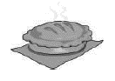

1-p……… 2- r……..d 3- r………n

1. **Answer the following questions:**

**1-What is your name?**

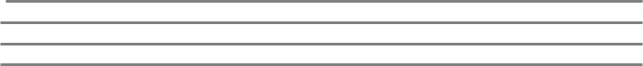

☺

**Good Luck**

**T.Wedad**