المملكة العربية السعودية المادة/ اللغة الانجليزية

وزارة التعليم

إدارة التعليم بـ........... اختبار الصف الثالث متوسط

متوسطة ................. عدد الأوراق :1

الفصل الدراسي الاول -العام الدراسي 1444هـ - فتري

**A ) Choose the correct answer**

1- She always ( drink – drank – drinks ) tea in the morning

2- How ( many – old -much) time do you spend in the shower?

3- (Neither – All _ both ) of them is a teacher.

4- Did you (live – lived – living) in Jeddah?

5- I asked my teacher a question (last – ago – yesterday).

6- ( Do – Does – Are ) Saad usually watch T.V in the morning?

7-King Salman was born ( in – on – at ) Riyadh.

**B ) Reorder:**

**1**-alwayes / I / play football**.** …………...

**C)Correct :**

1-She **were** born **on** Jeddah**.** ……………………………………

2-Neither of them **like** pizza**.** …………………………………

**B-Mach:**

|  |  |
| --- | --- |
| ( ) outstanding | 1-infant |
| ( ) donation | 2- encouraged |
| ( ) a baby | 3- gave to charity |
| ( ) supported someone to succeed | 4- excellent |

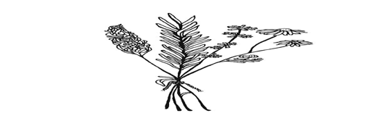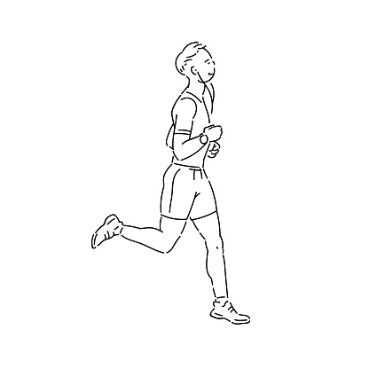**C: Write the correct word for each picture:**

|  |  |  |
| --- | --- | --- |
| **1-irritated** | **2-athlete** | **3-Herbal** |

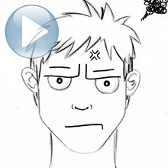

**D: Choose the correct letter:**

1-Saleh is really into fitn……ss   ( o – y – e )

2-They used to wo…k together   ( t – a – r )