**1-The man is ready for college because he has a smartphone, a credit card, and a ______.**

A) computer B) toothbrush C)backpack

**2-Last week, the man had a _________.**

A)stomachache B) cold C)fever

**3-Two weeks ago, the man was sick with _______.**

A)a toothache B)a headache C)the flu

**4-Right now, he has health insurance through ______.**

1. his work B)the government C) his father

**5-The cost of health insurance is ______ a month.**

A)$180 B) $118 C)$148

**6-The man is_______ old :**

1. 26 B)24 C)28

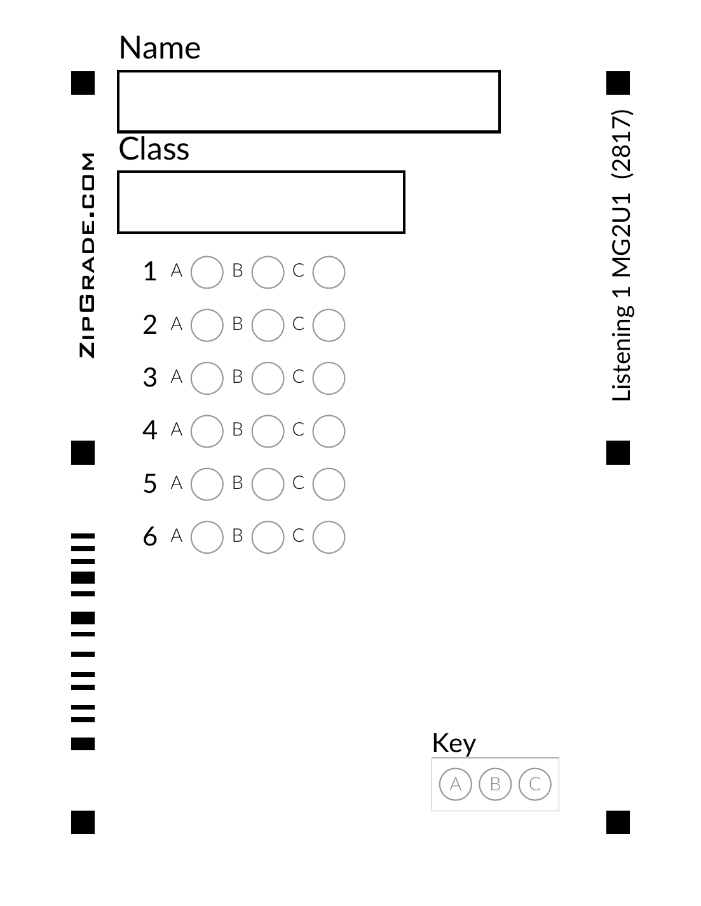



**1-The man is ready for college because he has a smartphone, a credit card, and a ______.**

A) computer B) toothbrush C)backpack

**2-Last week, the man had a _________.**

A)stomachache B) cold C)fever

**3-Two weeks ago, the man was sick with _______.**

A)a toothache B)a headache C)the flu

**4-Right now, he has health insurance through ______.**

1. his work B)the government C) his father

**5-The cost of health insurance is ______ a month.**

A)$180 B) $118 C)$148

**6-The man is_______ old :**

1. 26 B)24 C)28