**Term 1, We can 3**  **Name:** ………………………………………………….

**Unit 3 : Sports and Activities**

**_________General Questions الأسئلة العامة _______________________________________________________________**

1. **Choose:**

|  |
| --- |
| 1. **What sport do you like ?** 2. I like basketball. b- I want to try basketball. |
| 1. **What sport or activity do you want to try?** 2. I like ski diving. b- I want to try ski diving. |
| 1. **Tennis and golf are :** 2. Sports b- sea animals |

1. **Answer:**
2. What sport do you like? ……………………………………………………………………………………………………………………
3. Do like painting ? …………………………………………………………………………………………………………………………………

**________Reading short sentences قراءة الجمل القصيرة ______________________________________________________**

**Read and match:**

|  |  |  |
| --- | --- | --- |
| 1. I like horse riding. | 135 Fauconnier Vectores, Ilustraciones y Gráficos - 123RF | Free Pony Riding Clipart in AI, SVG, EPS or PSD |
| 1. I’d like to try falconing |

**________Controlled Writing الكتابة الموجهة________________________________________________________________**

1. 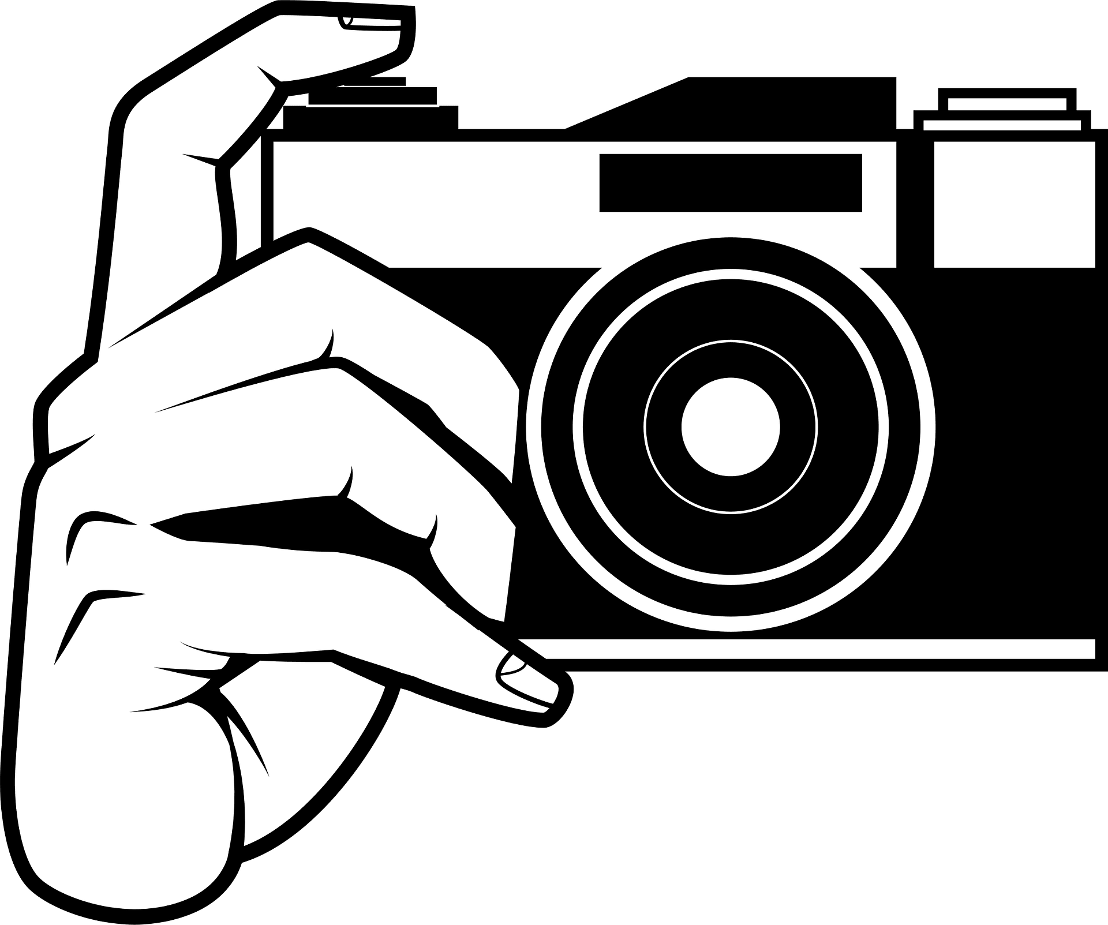**Complete:**
2. I’d like to try photography but I have no ………………………………

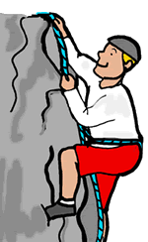

1. I’d like to try rock climbing but I have no ……………………………
2. **Write :**

doing - playing

1. I’m ……………………………… painting.
2. I 'm……………………………… golf.
3. **Unscramble:**

Computer / play / games / I ………………………………………………………………………………………………………………………………………………………………………………

1. **Copy:**

Roller skating is the most difficult.

**_________Grammar القواعد___________________________________________________________________________**

1. **Choose**:
2. He **( want - wants )** to try hang gliding.
3. She **( like - likes )** playing golf.
4. **( Do - Does )** you like sports?
5. Rock climbing is **( dangerous - more dangerous )** than jogging**.**
6. Ski diving is the  **( more - most )**  exciting sport.
7. **( Do - Does )** they like volleyball?

Do - Does

1. **Complete with:**
2. **…………………………** he want to try bungee jumping?3- **…………………………** she play tennis?
3. **…………………………** we play football? 4- **…………………………** they go shopping?

**_________Vocabulary المفردات________________________________________________________________________**

**Write the correct words under each picture:**

Hang gliding - scuba diving - tennis - pottery

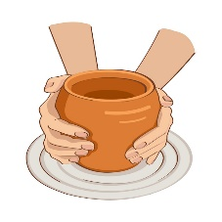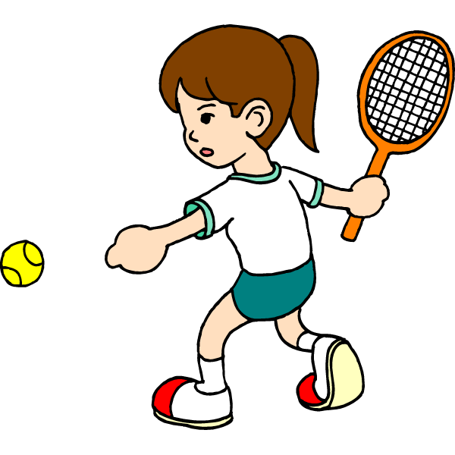

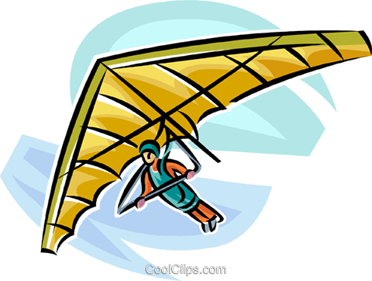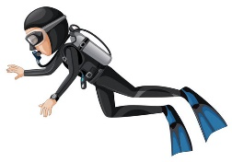

………………………………….………. …………………………………….. …………………………………………. ………………..……………………..

**_________Spelling الإملاء ____________________________________________________________________________**

**Choose the correct choice :**

|  |  |  |  |  |  |  |  |  |  |  |  |  |
| --- | --- | --- | --- | --- | --- | --- | --- | --- | --- | --- | --- | --- |
| Coins Gold Png Clip Art - Gold Coins Png Clipart, Transparent Png ,  Transparent Png Image - PNGitem | |  | | | Pointing - Clip Art Finger Point PNG Image | Transparent PNG Free Download  on SeekPNG | | Pear Clip Art Vector Illustration 8085925 Vector Art at Vecteezy | |  | |  | |
| c………n | | h………… | | | p………nt | | p……… | | Wh………? | | Ch……r | |
| oy | oi | | air | ere | oy | oi | ear | ere | air | ere | ea | ai |

**Good Luck ___________________________________________________________________________Tr. Sarah Alanazi**