**1- Composition**

|  |
| --- |
|  |
| **6** |

* Write a paragraph about ( How to make boil eggs ) use the answers of these questions :

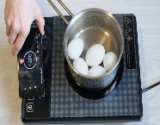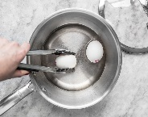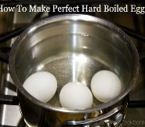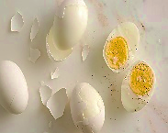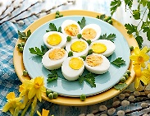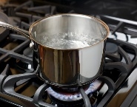

1-First…………………

a) peel three banana b) boil some water

2- Next……………………

a) Cut up the bananas b) put the eggs into the water

3- after that……………………….

a) white 3-5 minutes b) put the bananas into the blender

4- Then…………………….

a) remove the egg from the water b) pour the milk into the blender

5- Next………………….

a) turn on the blender b) add some salt

**6- Finally……………………….**

a) drink the banana milk shake b) serve the eggs

**How to make boil eggs**

...................................................................................................................................................................................................................................................................................................................................................................................................................................................................................................................................................................................................................................................................................................................................................................................................................................................................................................................................................................................................................................................................................................................................................................................................................................

( 2 ) اقلبي الصفحة

**2- Comprehension**

Read the passage then answer the questions*

Dentist

I am John and I am a dentist Check your teeth and gums. Some patient come to my office with very bad toothaches. I treat all my patients properly and tell them to smile always. In my free time l love to sing

---------------------------------------------------

|  |
| --- |
|  |
| **6** |

Answer the following questions:

A – Choose the correct answer:

1) John is……………

a- Doctor b- teacher c- dentist

2) What does John love in his free time?

a- dance b- sleep c- sing

3) His name is…………………..

a- John b- Jake c- Mole

4) he check your…………………..

a-  teeth and gums b- legs and hands c- eyes and ears

------------------------------------------------------

B- Choose the correct answers ( True) or ( False )

1) In his free time he love to sing

a- True b- False

2) he tell his patients to crying always

a-True B- False

---------------------------------------------------------------------------------------------------------------------------------------

**3- Grammar**

A – Choose the correct answer:

1- They .............work in school.

|  |
| --- |
|  |
| **7** |

a) don't b) doesn't c) isn't

2- Is there .........................juice ?

a) too b) any c) as

3- The neighbor..................................lives downstairs is a chef t?

a) who b) which c) when

-------------------------------------------------------

( 3 ) اقلبي الصفحة

4- Are you working ?

a) yes, they are b) yes, I am c) yes, he is

5- She ………cooking lunch now

a) is b) are c) was

6- I eat ......................................apples

a) to many b) to much c) alot

-------------------------------------------------------------

B- The present form from these verb :

|  |
| --- |
|  |
| **7** |

1- He ( go ) a) went b) was c) goes

-------------------------------------------------------------------------------------------------

**4- vocabulary**

A – Choose the correct word under each pictures:

--------------------------------------------------------------------------------------------------------

|  |  |  |  |  |  |
| --- | --- | --- | --- | --- | --- |
| صورة تحتوي على شخص, منضدة, جالس, نافذة  تم إنشاء الوصف تلقائياً | صورة تحتوي على عشب, خارجي, شخص, الأسلحة  تم إنشاء الوصف تلقائياً | صورة تحتوي على نص  تم إنشاء الوصف تلقائياً | Pasta in tomato sauce with ham and chorizo - Cookidoo® – the official  Thermomix® recipe platform | صورة تحتوي على شخص, عشب, لاعب  تم إنشاء الوصف تلقائياً | صورة تحتوي على سماء, خارجي, شخص, رجل  تم إنشاء الوصف تلقائياً |
| a- eating in restaurant  b- sleeping in hotel  c- swim | a- Director  b- Cameraman  C- actor | a- credit card  b- hotel  c-address | a-soup  b-pasta  c- fish | a- martial art  b-football  c-basketball | a-lawyer  b- civil engineer  c- teacher |

B- Choose the right opposite of these word :

1- ( **inside** )X ……………… a) in front b) outside c) read

------------------------------------------------------------------------------------------------------------------

**5- Orthography**

|  |
| --- |
|  |
| **4** |

C- Choose the correct litters :

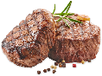1- nu.......s a) g b) r c) d

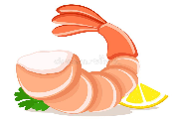 2- stea…………. a) r b) k c) h

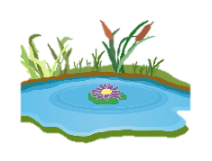3- shri….p a) m b) n c) w

4- po……d a) e b) n c) z

( 4 ) انتهت الأسئلة مع تمنياتي لكن بالتوفيق