|  |  |  |  |
| --- | --- | --- | --- |
| **متفوق** | **متقدم** | **متمكن** | **غير مجتاز** |
|  |  |  |  |

**67 _ 7 _ 33**

**رقم المهارة**

**التقييم**

|  |
| --- |
| **1 –Whose hat is this ?**  **A** . **It's mine thank you.** **B** . **I am fine, thank you .** |
| **2 – Who is wearing green today ?.**  **A**. **It's nice to meet you, too.** **B**. **I am wearing green .** |

**_______________________________________________________________________________________________________________________________________________________________________________________________________________________________**

**التقييم**

**رقم المهارة**

|  |  |  |  |
| --- | --- | --- | --- |
| **متفوق** | **متقدم** | **متمكن** | **غير مجتاز** |
|  |  |  |  |

**61_ 34**

|  |  |  |
| --- | --- | --- |
| 🗸 | 🗴 | Baseball Cap Cartoon Images – Browse 8,695 Stock Photos, Vectors, and Video  | Adobe Stock  **I am wearing a cap.** |
| 🗸 | 🗴 | Premium Vector | Pretty girl in pink dress with polka dot pattern**She is wearing a dress.** |
| 🗸 | 🗴 | Thobe Cartoon Images – Browse 3,009 Stock Photos, Vectors, and Video |  Adobe Stock**He is wearing a T-shirt.** |

_______________________________________________________________________________________________________________________________________________________________________________________________________

**رقم المهارة**

**التقييم**

|  |  |  |  |
| --- | --- | --- | --- |
| **متفوق** | **متقدم** | **متمكن** | **غير مجتاز** |
|  |  |  |  |

**64_ 65**

**61_ 34**

|  |  |  |  |
| --- | --- | --- | --- |
| **cap** | **sunglasses** | **hat** | Cartoon Sunglasses Images – Browse 149,328 Stock Photos, Vectors, and Video  | Adobe Stock **1 – I am wearing a ____. ( choose )** |
| **reading** | **have** | **wearing** | **2- I ______ a blue jacket. ( choose )** |

**16**

**رقم المهارة**

**التقييم**

|  |  |  |  |
| --- | --- | --- | --- |
| **متفوق** | **متقدم** | **متمكن** | **غير مجتاز** |
|  |  |  |  |

|  |  |  |  |
| --- | --- | --- | --- |
| **mine** | **am** | **my** | **1 – This is ___ hat .** |
| **mine** | **am** | **my** | **2- Whose book is this? It’s _____.** |

________________________________________________________________________________________________________________________________________________________________________________________________________

**رقم المهارة**

**التقييم**

|  |  |  |  |
| --- | --- | --- | --- |
| **متفوق** | **متقدم** | **متمكن** | **غير مجتاز** |
|  |  |  |  |

**64_34**

**shoes - jeans - hat**

|  |  |  |
| --- | --- | --- |
| Jeans Cartoon Images – Browse 39,162 Stock Photos, Vectors, and Video |  Adobe Stock | 509,651 Cartoon Hat Stock Photos and Images - 123RF | Sneakers. Orange cartoon sneakers isolated on white , #AFF, #cartoon,  #Orange, #Sneakers, #white, #isolated #ad | Sneakers drawing, Cartoon shoes,  Sneakers |
| --------- | --------- | --------- |

_______________________________________________________________________________________________________________________________________________________________________________________________________

**رقم المهارة**

**التقييم**

|  |  |  |  |
| --- | --- | --- | --- |
| **متفوق** | **متقدم** | **متمكن** | **غير مجتاز** |
|  |  |  |  |

**4_ 63**

Choose the correct letter: **( b , pl , bl , p )**

|  |  |  |  |
| --- | --- | --- | --- |
| Banana Cartoon Stock Illustrations – 34,840 Banana Cartoon Stock  Illustrations, Vectors & Clipart - Dreamstime | Parrot Cartoon Images | Free Vectors, Stock Photos & PSD | Airplane - Cartoon stock vector. Illustration of flight - 1301493 | Splat Black Splatter - Free vector graphic on Pixabay |
| **_anana** | **_arrot** | **_ _ane** | **_ _ ack** |

Controlled writing

_____________________________________________________________________________________

Good luck T.

|  |  |
| --- | --- |
| المهارة / رقمها | ترجمتها |
| Write short answers to written questions  67 | **الاجابة على الاسئلة المكتوبة** |
| Ask questions using What, Who, Where 7 | **اسأل باستخدام أدوات السؤال ( من _ ماذ _ أين )** |
| Ask and answer about possession using whose  33 | **اسأل وأجب عن الملكية باستخدام ( لمن )** |
| Read and comprehend simple sentences  61 | **قراءة وفهم الجمل البسيطة** |
| Identify and talk about clothes  34 | **التعرف على الملابس والتحدث عنها** |
| Write short simple words/phrases  64 | **كتابة الكلمات او الجمل البسيطة على حسب المطلوب** |
| Write short simple sentences to convey basic information  65 | **كتابة جمل بسيطة قصيرة لتوصيل المعلومات الأساسية** |
| Express possession using the verb to have my/your/his/her/our  16 | التعبير عن الملكية باستخدام my/your/his/her/our |
| Recognise and produce some consonant blends (pl, cl)  4 | **التعرف على بعض تركيبات الحروف الساكنة (pl,cl) وإنتاجها** |
| Spell a accurately small number of words  63 | **تهجئة عدد صغير من الكلمات بدقة** |

Good luck T.

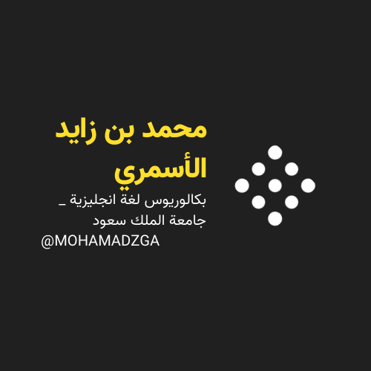

**لا تنسوني من صالح دعائكم**





M_zaid0