**رقم المهارة**

|  |  |  |  |
| --- | --- | --- | --- |
| **متفوق** | **متقدم** | **متمكن** | **غير مجتاز** |
|  |  |  |  |

**67 - 31**

|  |
| --- |
| **1 – Hello. Can I speak to Huda ?**  **A** . **Thank you .** **B** . **Speaking .** |
| **2 – What is your dad doing? .**  **A**. **I am eating.** **B**. **He is watching TV.** |
| **3- What are you doing ?**  **A** . **I am doing my homework** . **B**. **He is watching TV.** |

__________________________________________________________________________________________________________________________________________________________________________________________________

|  |  |  |  |
| --- | --- | --- | --- |
| **متفوق** | **متقدم** | **متمكن** | **غير مجتاز** |
|  |  |  |  |

**رقم المهارة**

**61 - 35**

|  |  |  |
| --- | --- | --- |
| **1. She is doing Karate .** | 🗸 | 🗴 |
| **2. I am eating snacks.** | 🗸 | 🗴 |

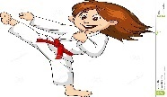

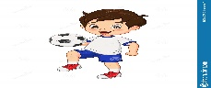

|  |  |  |  |
| --- | --- | --- | --- |
| **متفوق** | **متقدم** | **متمكن** | **غير مجتاز** |
|  |  |  |  |

**رقم المهارة**

**64 - 65**

|  |  |  |  |
| --- | --- | --- | --- |
| **___________________** | | | **1 – playing – is –he -games – computer. (Rearrange)** |
| **playing** | **watching** | **doing** | **2- I am ______ TV .** |

|  |  |  |  |
| --- | --- | --- | --- |
| **are** | **am** | **is** | **1 – I ___ doing Karate .** |
| **?** | **.** | **!** | **2- What are you doing___** |
| **?** | **.** | **!** | **3- He is watching TV ___** |

|  |  |  |  |
| --- | --- | --- | --- |
| **متفوق** | **متقدم** | **متمكن** | **غير مجتاز** |
|  |  |  |  |

**66 - 11**

**رقم المهارة**

__________________________________________________________________________________________________________________________________________________________________________________________________

**رقم المهارة**

|  |  |  |  |
| --- | --- | --- | --- |
| **متفوق** | **متقدم** | **متمكن** | **غير مجتاز** |
|  |  |  |  |

**64**

**karate -snacks – ring -wing – phone - elephant**

|  |  |  |  |  |  |
| --- | --- | --- | --- | --- | --- |
| Karate Kick Cartoon Images – Browse 3,612 Stock Photos, Vectors, and Video  | Adobe Stock | Set Of 6 Cute Cartoon Fast Food Snack Characters Isolated On White Stock  Illustration - Download Image Now - iStock | Cartoon elephant isolated on white | Download on Freepik | Cartoon angel wing stock vector. Illustration of sketch - 38061240 | Premium Vector | Diamond engagement ring marriage proposal wedding doodle  line cartoon | Mobile Phone Thumbs Up Cartoon Mascot Stock Vector - Illustration of arms,  screen: 156284748 |
| ---------- | ---------- | --------- | --------- | --------- | --------- |

**رقم المهارة**

|  |  |  |  |
| --- | --- | --- | --- |
| **متفوق** | **متقدم** | **متمكن** | **غير مجتاز** |
|  |  |  |  |

**63 – 6 – 5**

Choose the correct letter: **( d, t , tr , dr )**

|  |  |  |  |
| --- | --- | --- | --- |
| Cartoon tiger on white background 5161881 Vector Art at Vecteezy | Open door. Cartoon style. stock vector. Illustration of input - 40473222 | How To Draw A Cartoon Dress For A Special Occasion | Cartoon tree stock vector. Illustration of sign, nature - 8412489 |
| **_ iger** | **_oor** | **_ess** | **_ _ ee** |

Controlled writing

____________________________________________________________________________________

Good luck T.

|  |  |
| --- | --- |
| المهارة / رقمها | ترجمتها |
| Write short answers to written questions  67 | **الاجابة على الاسئلة المكتوبة** |
| Read and comprehend simple sentences  61 | **قراءة وفهم الجمل البسيطة** |
| Ask about activities happening at the moment of speaking  31 | **اسأل وأجب عن الانشطة وما يحدث وقت الكلام** |
| Follow a short simple text while listening to the recording audio  35 | **تتبع الجمل وفهمها بعد الاستماع لمقطع او جملة معينة** |
| Write short simple words/phrases  64 | **كتابة الكلمات او الجمل البسيطة على حسب المطلوب**  **لتكملة الجملة** |
| Write short simple sentences to convey basic information  65 | **كتابة جمل بسيطة قصيرة لتوصيل المعلومات الأساسية** |
| Identify and talk about people using the verb to be  11 | **التحدث عن الناس باستخدام افعال**  **am – is – are ))** |
| Apply basic rules of punctuation (e.g. use capital letters, full stops, commas, question mark  66 | **استخدام قواعد الكتابة حرف كبير و**  **فاصلة , استفهام ونقطة وهكذا** |
| Recognise and produce some consonant blends (tr, dr)  6 , 5 | **التعرف على بعض تركيبات الحروف الساكنة (فtr,dr) وإنتاجها** |
| Spell a accurately small number of words  63 | **تهجئة عدد صغير من الكلمات بدقة** |

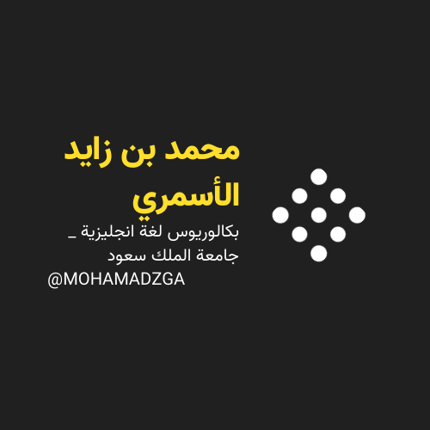

**لا تنسوني من صالح دعائكم**





M_zaid0