|  |  |  |  |
| --- | --- | --- | --- |
| **متفوق** | **متقدم** | **متمكن** | **غير مجتاز** |
|  |  |  |  |

**رقم المهارة**

**التقييم**

**9 - 6**

|  |
| --- |
| **1 – Who is this ?**  **A** . **Thank you .** **B** . **He is my father .** |
| **2 – Nice too meet you .**  **A**. **Nice to meet you , too B**. **Good morning .** |

**رقم المهارة**

25 **.**

|  |  |  |  |
| --- | --- | --- | --- |
| **متفوق** | **متقدم**  **التقييم** | **متمكن** | **غير مجتاز** |
|  |  |  |  |

|  |  |  |
| --- | --- | --- |
| **1.** **Monkeys are jumping on the bed .** | 🗸 | 🗴 |
| **2 – She is my mother .** | 🗸 | 🗴 |

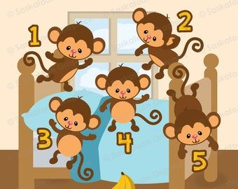

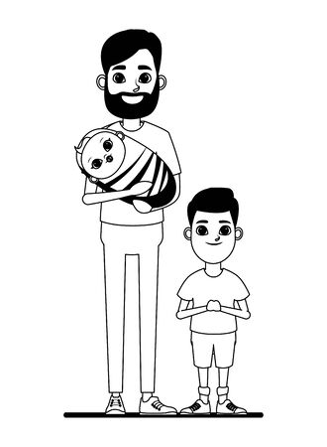

**رقم المهارة**

**التقييم**

|  |  |  |  |
| --- | --- | --- | --- |
| **متفوق** | **متقدم** | **متمكن** | **غير مجتاز** |
|  |  |  |  |

31

|  |  |
| --- | --- |
|  | **R** |
|  | **S** |

|  |  |
| --- | --- |
| **t** |  |
| **u** |  |

|  |  |
| --- | --- |
|  | **V** |
| **w** |  |

**Rewrite the letters**

-------------------------------------------------------------------------------------------------------------------------------------------------------------------------------------------------------------------------------------------------------------------------------------------------------------------------------------------------------------------------------------------------------------------------------------------------------------------------------------

**_____________________________________________________________________________________________________________________________________________________________________________________________**

**رقم المهارة**

**28 - 30**

|  |  |  |  |
| --- | --- | --- | --- |
| **متفوق** | **متقدم** | **متمكن** | **غير مجتاز** |
|  |  |  |  |

**التقييم**

**My sister**

------------------------------------------------------------------------------------------------------------------------------------------------------------------------------------------------------------------------------------------------------------

------------------------------------------------------------------------------------------------------------------------------------------------------------------------------------------------------------------------------------------------------------

_______________________________________________________________________________________________________________________________________________________________________________________________________

**التقييم**

|  |  |  |  |
| --- | --- | --- | --- |
| **متفوق** | **متقدم** | **متمكن** | **غير مجتاز** |
|  |  |  |  |

**رقم المهارة**

**5**

**Listen to the word and match with letters :**

|  |  |  |  |
| --- | --- | --- | --- |
| **d** | **b** | **o** | Free Bear Cartoon Black And White, Download Free Bear Cartoon Black And  White png images, Free ClipArts on Clipart Library  **1 –** |
| **k** | **c** | **p** | Cute Black and White Cow - Free Clip Art | Free clip art, Clip art, Cow  clipart  **2-** |
| **b** | **r** | **d** | Black and White Cartoon Illustration of Funny Duck Farm Bird Animal for  Coloring Book Stock Photo - Alamy  **2-** |

_____________________________________________________________________________________________________________________________________________________________________________________________________

|  |  |  |  |  |  |
| --- | --- | --- | --- | --- | --- |
| Grandma Clipart and Stock Illustrations. 1,951 Grandma vector EPS  illustrations and drawings available to searc… | Stock illustration,  Illustration, Cartoon grandma | Black And White Cartoon Illustration Of Father With His Cute Baby For  Coloring Book Royalty Free SVG, Cliparts, Vectors, and Stock Illustration.  Image 28877880. | icon of boy in style of vector black and white and manga cartoon 23257229  Vector Art at Vecteezy | Sister Sibling, white, child png | PNGEgg | Single mother with children cartoon in black and white Stock Vector Image &  Art - Alamy | simple black and white grandpa cartoon Stock Vector Image & Art - Alamy |
| Grandpa | Father | Sister | Sister | Father | Grandpa |
| Grandma | Mother | Brother | Brother | Mother | Grandma |

|  |  |  |  |
| --- | --- | --- | --- |
| **متفوق** | **متقدم** | **متمكن** | **غير مجتاز** |
|  |  |  |  |

**17**

**رقم المهارة**

Good luck T.

Controlled writing

|  |  |
| --- | --- |
| المهارة / رقمها | ترجمتها |
| Ask and respond to basic questions about personal information Using verb to be (am, is, are), and wh. questions (what, where, who, how)  9 | **يسأل ويجيب باستخدام ( (IS , AM , ARE**  **وباستخدام انواع الاسئلة**  **( من – ماذا – اين – كيف )** |
| Participate verbally and non-verbally in short simple activities: greeting, giving and receiving commands and instructions  6 | **المشاركة لفظيًا وغير لفظيًا في أنشطة بسيطة وقصيرة: التحية وإعطاء وتلقي الأوامر والتعليمات** |
| Write upper/lower case letters correctly.  31 | **كتابة الحروف الكبيرة والصغيرة** |
| Copy words, numbers and simple short sentences  30 | **نسخ كلمات / ارقام / جمل بسيطة** |
| Recognize and apply directionality in writing English  28 | **معرفة وتطبيق التجاه المناسب عند الكتابة باللغة الانجليزية _ (من اليسار لليمين , أعلى , أسفل )** |
| Recognise and match sounds to letters  5 | **التعرف على الأصوات ومطابقتها مع الحروف** |
| Identify recognize and talk about family members  17 | **معرفة وتحدث عن افراد العائلة** |

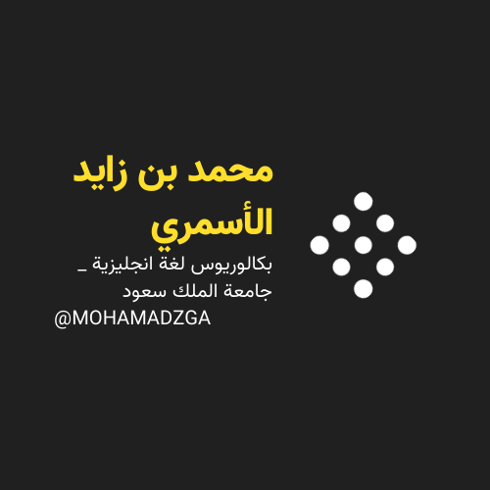

**لا تنسوني من صالح دعائكم**





M_zaid0