**المملكة العربية السعودية المرحلة: المتوسطة**

**وزارة التعليم الصف: الأول المتوسط**

**مكتب التعليم بشمال جدة الفصل الدراسي: الأول 1445هـ**

**Name : …………………………. Class : …………………..**

**Total Mark /20**

**5**

**A) Comprehension**

**Read the passage to answer the questions below:**

**Max** is my little cat. He is one year old. He is **brown**. He is very cute. He likes to play around the house. He loves to play with me. He is very smart. His favourite place to sleep is under my desk, but sometimes he sleeps in the kitchen. He loves to eat **hot dogs** a lot. He is a very good and funny cat. I love him.

1. **Choose the correct answer:**

**1- This text is about ………………**

**a-** The writer’s family **b-** The writer’s cat **c-** The writer’s house

1. **Check ( T ) or ( F ) :**
2. Max’s favourite food is hot dogs ( )
3. Max likes to sleep under the bed ( )
4. **Find from the passage:**
5. **A color:** ………………….
6. **A name:** ………………….

**B) Grammar**

**5**

**Choose the best answer:**

1. This is ____**old** house.

a) an b) the c) a d) none

2. I **can** _______ you a pencil.

a) to give b) give c) gives d) giving

3. She is ………….Saudi Arabia.

a) from b) at c) on d) under

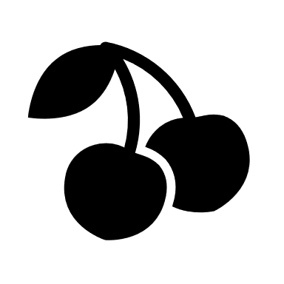

4. _______ **are** cherries. --------------→

1. these b) those c) this d) that

5. _______ **sun** rose at 6:17 this morning.

a) an b) the c) a d) none

**C) Vocabulary**

**5**

1. **Tourists** often bought ___________in this shop.

a) fossil b) souvenirs c) television d) poster

2. This **lamp** gives off a soft

a) radio b) sofa c) light d) museum

3.**Spanish** is her first___________.

a) e-mail b) address c) nationality d) language

4. He made a **journey** around the___________.

a) world b) street c) people d) home

5. What’s your ___________? I’m from **Brazil**.

a) name b) party c) language d) nationality

**D) Orthography**

**1**

**Write the missing letters:**

1. Ph ne. 2) Sculp ure. 3) Air lane. 4) Coun ry.

**E) Writing**

**4**

**Write a paragraph about yourself.**

* Who are you?
* How old are you?
* Where were you born?
* What's your favourite ( colours, hobbies, subjects )

______________________________________________________________________________________________________________________________________________________________________________________________________________________________________________________________________________________________________________________________________________________________________________________________________________________________________________________________________________________________________________________________________________________________________________________________________________________________________________________________________________________________________________________________________________________________________________________________________________________________________________________________________________________________________________________________________________________________________________________________________________________________________________________________________________________________________________________________________________________________________________________________________________________________________________________________________________________________________________________________________________________________________________

Good luck 😊