المملكة العربية السعودية الصف الرابع الابتدائي

وزارة التعليم الفصل الدراسي الثالث

مدرسة : ........................................... الزمن : ____ ساعة

الاختبار النهائي لمادة اللغة الإنجليزية للصف الرابع الابتدائي الفصل الدراسي الثالث للعام الدراسي __________ هـ

-Choose the correct answer:

1. He is -------- 
2. Happy b- Scared c – hungry d- angry

__________________________________________________________

1. He is -----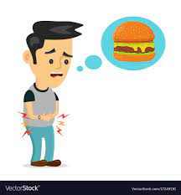

a-Happy b- Scared c – hungry d- angry

_______________________________________________________

1. Do you have a pet?
2. Yes, I have a fish . b- I like English c- I am hungry d- No, thanks.

_________________________________________________________

1. What is the matter?

a- I like Friday b- I like English c- I am hungry d- No, thanks.

______________________________________________**_______________**

1. It is -------- to day. 

a – sunny b- rainy c-cloudy d- snowy

**______________________________________________________________________**

1. Sunday., Monday , Tuesday ---------

a- Friday b- Saturday c- Thursday d- Wednesday

**______________________________________________________________________**

1. ---eep 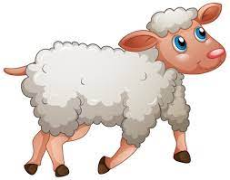
2. Sh b- S c- R d- M

8-The sound of bird is----------

Cluck ,cluck b- Tweet,tweet c- Moo,moo d- Baaa,baaa

**______________________________________________________________________**

9- What day do you like ?

1. I like pizza b- I like Sunday c- I like orange d- I like English

**______________________________________________________________________**

**10- -****---- iger**

1. T b- M c- F d- N

__________________________________________________________ 11- 20 – 21 - ------ - 23

1. 22 b- 24 c- 26 d- 28

__________________________________________________________ 12- 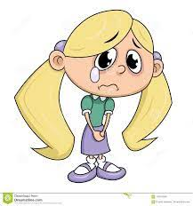She is ------

1. Happy b- sad c- thirsty d—scared

__________________________________________________________ 13- These are 2 ---------- 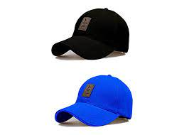

1. Cap b- caps c- shoes d- skirt

__________________________________________________________

14-Those T-shirts ------ blue.

1. Is b- are c- am d- on

__________________________________________________________

15- This is a ----------- 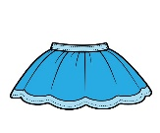

1. Glasses b- shoes c- cap d- skirt

__________________________________________________________

16- This is a -------------------------- 

A- fan b- van c – tap d- bear

17- The weather today is -------------------------------

a- sunny b- cloudy c- rainy d- snowy

__________________________________________________________

18- This is a ----------------------------------------- 

a- van b- vase c- laptop d-umbrella

__________________________________________________________

19 – The weather today is ---------------- 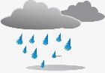

a- sunny b- cloudy c- rainy d- snowy

_________________________________________________________

20 - How many circles? 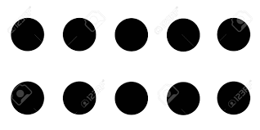

1. 10 b-20 c-30 d-40

_________________________________________________________

21 – This is a ------------------------- 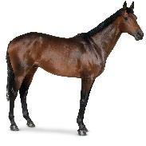

1. Zebra b- wolf c- fox d- horse

**______________________________________________________________________**

22- Are these your shoes?

a- Yes, Iam. b- Yes, she is. c- Yes, it is. c- Yes they are.

**____________________________________________________________________**

23 – Are you happy? 

1. Yes, I am. b- Yes,she is. c- Yes, he is. d-Yes, it is.

24- How many stars ? 

**a- 10 b- 20 c- 30 d- 40**

**____________________________________________________________________**

25- I ------------ scared.

A- is b- am c- are d- it.

**____________________________________________________________________**

26- He ------- a farmer.

a- am b- is c- are d-have

**____________________________________________________________________**

27- ------ icken 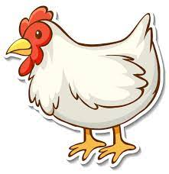

a- s b-ch c- k d- th

**____________________________________________________________________**

28- The capital letter of ( r) is:

1. V b- G c- R d- M

**____________________________________________________________________**

29- The capital letter of (g) is:

1. N b- G c- D d- F

**____________________________________________________________________**

30- Who is sleepy? 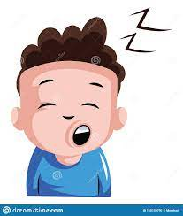

A-They are sleepy b-You are sleepy c- He is sleepy. c-We are sleepy.

**____________________________________________________________________**

Best wishes ...