Super Goal  ثالث متوسط |  |  |  | Unit 5  Since When
A-Choose the correct form in brackets
1-I have ……………………. football since I was 10
a | Play | B | playing |  | c | played
2-She has ……….……… English for five years.
a | Study | B | studied |  | c | studying
3-Sami has had the same TV ……………..15 years.
a | For | B | since |  | c | to
4-How long has Ali ……………….…his friend?
A | Know | B | knows |  | c | known
5-The fish has been …………….…by the cat.
a | Eat | B | Eaten |  | c | ate
6- We have worked on this project________ a month
a | For | B | Since |  | c | to

B-Do as shown between brackets
1-Correct
a-I’ve had my laptop for last June. ………………………………………………

b-The room is clean by Sara ………………………………………………
c-They have been working for Monday. ………………………………………………
2-Use How long
a-Omar / go / to this dentist
………………………………………………………………………………………………………………………………………………………………..……………………………………….?
b-They / use / this laptop
………………………………………………………………………………………………………………………………………………………………..……………………………………….?
3-Change to passive:
a-The boys broke the window.
…………………………………………………………………………………………………………………………………………………………………………………………………………..……………………………
b-Sami bought a car
…………………………………………………………………………………………………………………………………………………………………………………………………………..……………………………
4-Make yes or No question then answer.
a-They have met George.
…………………………………………………………………………………………………………………………………………………………….………………………………………………….?
-yes, ………………………………………………

2-Vocabulary
A. Choose as directed below.
The opposite of near is…… |  | The odd word is…… |  | The odd word is……
a. here | c. next | a. camera | c. Edison | a. Toy Story | c. spiderman
b. far | d. close | b. printer | d. cellphone | b. king Kong | d. stop trick
B. Choose the correct word to complete the sentence:
congratulation - serious - settle down - accounting
1-What's up - why does everyone look so ……………………….………………………?
2-One day I’ll want to ………………………………………………… and make a family.
3-…………………………………….……………, you won the first prize in the drawing competition.
4-The …………………………………….…… office checked off each worker’s dues every month.
C. Match the words with their meanings.
- Long time no see |  | Get married
- Interrupt |  | Center
- settle down |  | I haven’t seen you for a long time
 |  | stop in the middle

D. Write the correct word for each picture:
Effects - scream- interrupt -audience - camera- screen- audience- printer- brick

 |  | 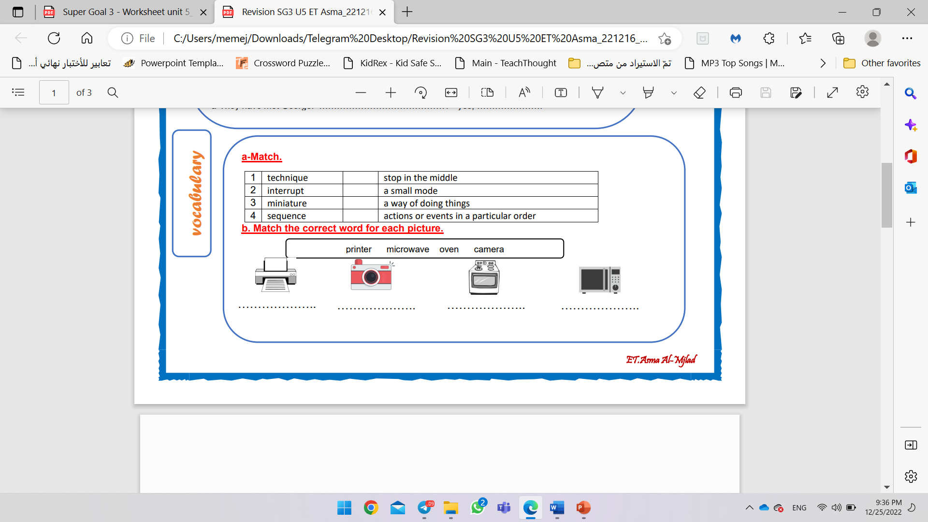 | 
 |  |  | 
3 Orthography
A-Choose the correct letter:
B- Write the missing letter:
1-our teacher use a special techni ……… ue.
A | K | B | G | c | q
2-I love riding my bi…… e.
A | K | B | G | c | q

 | 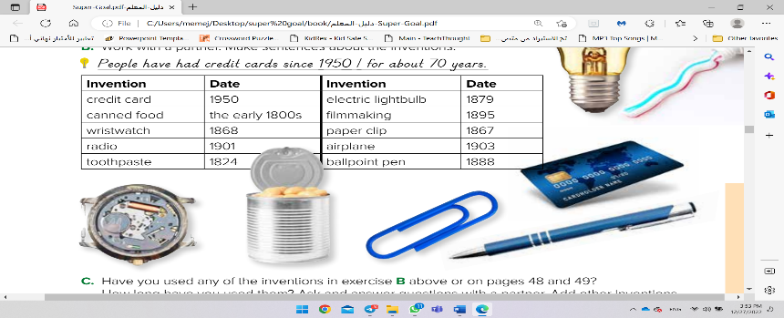
Paper c __ ip | Can __ ed food

