Name :………………………………………………………………………… Class:…….……….

**Reading**

6

* **Read the text and answer the questions below.**

**Every Thursday, Mr. Saleh goes shopping. He likes to buy things from the supermarket near his house. It is a big supermarket. He buys meat, fruit, milk and vegetables for the week. Today, two of his children are going with him, Maram and Basil. Maram wants to buy biscuits for her sister Hanan. Basil wants to buy ice-cream. Basil does not have much money. He asks his father to give him some money**

**A-Questions :**

**1 / Where does Saleh go every thursday ?**

**……………………………………………..**

**2 / Is it a big supermarket ?**

**………………………………………………………………**

**B – Choose the correct word :**

**1 – the supermarket ( near – next to – far ) his house .**

**2 – Maram wants to buy ( chocolate - biscuits – chips ) for her sister .**

**c- Put ( T ) or ( F )**

**1- Basil has much money ( )**

**2 – He asks his father to give him some clothes ( )**

**Grammar**

4

* **Choose the best answer to fill in the blank in each question.**

1. **Have you ever ………………. The Eiffel Tower .**

**a. seen b. saw c.are seeing d. see**

1. **John …………. used the dictionary yet .**

**a. hasn't b. haven't c. don't d. doesn't**

1. **He ………………. The special needs center already .**

**a. has visited b. are visiting c. visit d. visited**

1. **They have been at our house ……………… 5 hours .**

**a. for b. since c. when d. to**

1. **Nada as ……………….. as Huda .**

**a. tall b. taller c. tallest d. more tall**

1. **Salma's mark is the ………………. In class .**

**a. worst b . worse c. bad d. less**

1. **Look at ……………. Moon , it's so beautiful .**

**a. the b. an c. a d. all**

1. **Noura is ………………… than Batoul .**

**a. smarter b. smart c. smartest d. most smart .**

* **complete with ( since ) or ( for ) :**

2

1. Sara has lived in Riyadh ________ 10 years .
2. Yousef has tried to learn English _________ 2007 .
3. I have baked a cake already . **( Change to passive )**

**………………………………………………………………**

1. She has known her friend *for 8 years* . **( Ask question )**

**………………………………………………………………..**

**Vocabulary**

**Match a word in Column ( 1 ) with it's meaning in Column( 2 ).**

|  |  |  |
| --- | --- | --- |
| ***Column 1*** | | ***Column 2*** |
| 1. **technique** |  | **protects** |
| **2 - interrupt** |  | **an unbroken series** |
| **3 – a complish** |  | **features** |
| **4 - aspects** |  | **Succeed in doing something** |
| **5 - consecutive** |  | **Stop in the middle** |
|  |  | **A way of doing things** |

* ***Write the correct word under the picture.***

6

{**cell phone - stove -printer – screen – microwave – fountain - skyscrapers }**

  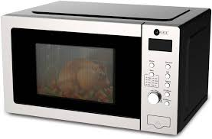 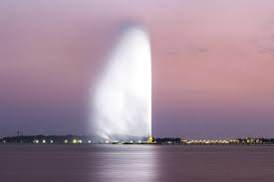

**……………………… ……………………………. …………………………. …………………………**

 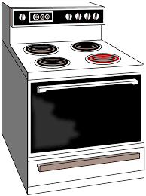 

**………………………….. …….………………… ………………………**

* **Choose the correct letter.**

2

**1 – com __uter ( p – v -n ) 2 – re __ovate ( c – n – k )**

**3 – ov __ n ( s – e – z ) 4 – stad __um ( m – i – r )**

**Good Luck / T: Latifa**